Week 11
Period 43

Unit 6: Our school
Lesson 3 (4, 5, 6)
By the end of the lesson, Ss will be able to:
- read and write about a school;
- make a poster to introduce their school to a new pupil.
PROCEDURES:
Teacher’s activities | Students’ activities
Activity 1. Read and complete:  *Aims: Ss will be able to read and choose the words to complete the text.  *Procedure:  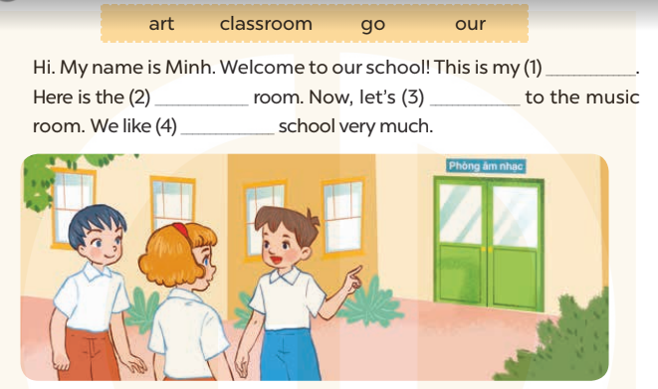  - Elicit and introduce the context.  + Minh is introducing his school to his friends.  - Have Ss read aloud the words to fill in.  - Model the first blank with Ss to make sure that they know how to do the task.  - Give Ss enough time to complete the text.  - Check the answers as a class.  - Have Ss read the text aloud.  Key: 1. classroom 2. art  3. go 4. our | - Ss look at the pictures and answer  -Ss read the words  -Ss fill in the gap  -Ss complete the text  -Ss check their answer  -Ss read aloud  -Ss listen and answer
D. ADJUSTMENTS (if necessary):
………………………………………………………………………………………….…..……………………………………………………………………………...…………
Week 11
Period 44

Unit 7: Classroom instructions
Lesson 1 (1, 2, 3)
By the end of the lesson, Ss will be able to:
-use the words open, close, stand up, sit down and please in relation to the topic “Classroom instructions”
-use …………. please! to give instructions;
C. PROCEDURES:
Teacher’s activities | Students’ activities
Activity 1. Vocabulary.  *Aims: Ss will be able to know the vocabulary in front of starting the new lesson.  *Procedure:  -T elicits the new words  + open : mở (mime)  + close : đóng (mime)  + stand up :đứng lên (mime)  + sit down : ngồi xuống (mime)  + please : xin mời (translation)  - T models (3 times).  - T writes the words on the board.  - Checking: Rub out and remember  Activity 2. Look, listen and repeat:  *Aims: Ss will be able to understand and correctly repeat the sentences in two communicative contexts (pictures) focusing on classroom instructions.  *Procedure:  - Have Ss look at Pictures a and b and identify names of the speakers in the pictures.  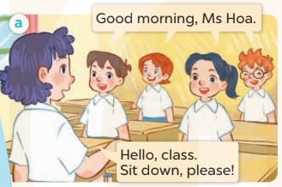  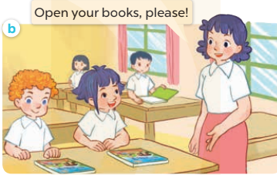  - Play the audio twice (sentence by sentence). Correct their pronunciation where necessary.  - Have Ss to practice the dialogue  - T invites a few pairs to the front of the class to practice.  - T checks pronunciation for ss. | -Ss listen and answer  - - Ss listen and repeat  + Choral repetition (3 times).  + Individual repetition (3 ss)  - Ss take note  - Ss look, remember and write  -Look at the pictures and say  + In picture a: Class says: Good morning, Ms Hoa. Lucy answers: Hello, class. Sit down, please!  + In picture b: Ms Hoa says: Open your books, please!  -Ss listen and repeat in chorus (twice)  -Ss work in pairs to practice  -Ss practice the dialogue  -Ss listen  -Ss look at the picture and answer.  -Ss listen  -Ss listen and repeat  -Ss repeat to the place
D. ADJUSTMENTS (if necessary):
………………………………………………………………………………………….…..……………………………………………………………………………...………………………………………….…..……………………………………………………………………………….……………………………………………………………………...

