Week 9
Period 33

Unit 5: My hobbies
Lesson 3 (1, 2, 3)
By the end of the lesson, Ss will be able to:
- correctly repeat the sounds of the letters p and r in isolation, the words painting and running, and the sentences I like painting. and I like running. with the correct pronunciation and intonation.
- identify the target words painting and running while listening.
- say the chant with the correct rhythm and pronunciation.
PROCEDURES:
Teacher’s activities | Students’ activities
Activity 1. Listen and repeat:  *Aims: Ss will be able to correctly pronounce the sounds of the letters p and r in isolation, in the words painting and running, and in the sentences I like painting. and I like running with correct pronunciation and intonation.  *Procedure:  - T gives instruction to the letter p and r, painting and running, and in the sentences I like painting. and I like running  - Play the recording for the letter p, r.  - Encourage Ss to point at the letter/ word/ sentence while listening.  - Play the recording again and encourage Ss to listen and repeat.  - Do this several times until Ss feel confident.  - T calls some Ss to practice.  - T gives feedbacks.  Activity 2. Listen and circle.  *Aims: Ss will be able to identify the target words painting and running while listening.  *Procedure:  - Elicit the sentences and the gap-fill options.  - T ask Ss to guess the answers.  + T writes Ss’guessing on the board.  - Listen to the tape:  + Play the recording  + Play the recording again and get Ss to swap books with their partners.  + Play the recording again to check answers together as a class.  + Write the answers on the board for Ss to correct their answers. Then checks Ss’ guessing.  - Play the recording, sentence by sentence, for the class to listen and repeat in chorus.  - Invite one or two Ss to stand up and read the completed sentences.  Key: 1.b 2.a | - Ss recognize the differences about color of letter  - - Ss listen  - Ss listen and point  - Ss listen again and repeat  -Ss listen again and repeat  -Ss practice  -Ss listen  -Ss listen and say:  + Number 1: It’s….!  + Number 2: I like…..!  -Ss guess the answers  - Ss listen to the tape and circle  - Ss listen again, circle and swap books with their partners.  - Ss check their answers and guessing  -Ss listen and repeat.  -Ss read the sentences

D. ADJUSTMENTS (if necessary):
………………………………………………………………………………………….…..……………………………………………………………………………...………………………………………….…..……………………………………………………………………………….……………………………………………………………………...

Week 9
Period 34

Unit 5: My hobbies
Lesson 3 (4, 5, 6)
By the end of the lesson, Ss will be able to:
- read a communicative context and complete a table about hobbies.
- read and complete gapped sentences with personal information.
- reinforce and extend pupils’ language knowledge and competences by making a hobby show.
PROCEDURES:
Teacher’s activities | Students’ activities
Activity 1. Read and tick:  *Aims: Ss will be able to read a communicative context and complete a table about hobbies.  *Procedure:  - T models with Ben.  + Get Ss to read the dialogue  + Ask Ss to read the first sentence and tick the correct hobby  -Have Ss work in pairs and complete the table by ticking the correct boxes.  - Tell Ss to swap books with a partner, then check answers together as a class.  - Write the correct answers on the board for pupils to correct their answers.  - Invite pairs of Ss to stand up and say the characters’ hobby.  -T gives feedbacks.  Key:  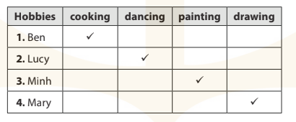 | - Ss read and answer  -Ss read and tick  -Ss swap books and check  -Ss check the correct their answers  -Ss say  -Ss listen
D. ADJUSTMENTS (if necessary):
………………………………………………………………………………………….…..……………………………………………………………………………...…………
Week 9
Period 35, 36
Teaching date: November 1st, 2023

Review 1
Parts 1, 2, 3, 4, 5
By the end of the lesson, Ss will be able to:
- correctly use the following sentence patterns:
+ Hello. / Hi. I’m ………. – Hello , / Hi, I’m ……..
+ How are you? − …….., thank you.
+ What's your name? − My name's ……...
+ How old are you? – I’m ……..years old.
+ Is this / that ? − Yes, it is. / No, it isn't. It's ……...
+ What's your hobby? − It's ………...
+ What do you like? – I like …….
PROCEDURES:
Teacher’s activities | Students’ activities
Activity 1. Listen and tick:  *Aims: Ss will be able to listen to and understand five communicative contexts  *Procedure:  - Elicit the names of the characters in each picture and what they say.  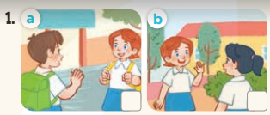    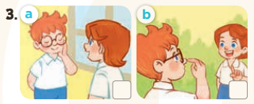  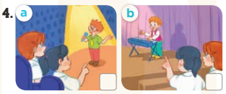  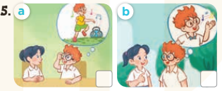  - T ask Ss to guess the answers.  + T writes Ss’guessing on the board.  - Listen to the tape:  + Play the recording  + Play the recording again and get Ss to swap books with their partners.  + Play the recording again to check answers together as a class.  + Write the answers on the board for Ss to correct their answers. Then checks Ss’ guessing.  - Play the recording, sentence by sentence, for the class to listen and repeat in chorus.  Key: 1. b 2. b 3. a 4. b 5. b | -Look at the pictures and say:  + Picture 1a. Minh and Lucy first meet each other  + Picture 1b. Lucy and Mai first meet each other.  + Picture 2a. a birthday cake with number 6 on it  + Picture 2b. a birthday cake with number 8 on it  + Picture 3a. Lucy tells Ben to touch his face.  + Picture 3b. Lucy tells Ben to touch his nose.  + Picture 4a. Ben is singing on the stage.  + Picture 4b. Bill is playing music on the stage.  + Picture 5a. Ben tells Mai he likes dancing.  + Picture 5b. Ben tells Mai he likes singing.  -Ss guess the answers  - Ss listen to the tape and tick  - Ss listen again, tick and swap books with their partners.  - Ss check their answers and guessing  -Ss listen and repeat.
D. ADJUSTMENTS (if necessary):
………………………………………………………………………………………….…..……………………………………………………………………………...…………

