Week 10
Period 37

Fun time 1
By the end of the lesson, Ss will be able to:
- take part in three fun activities relating to their language knowledge and competences.
PROCEDURES:
Teacher’s activities | Students’ activities
Find, circle and match:  *Aims: Ss will be able to revise learnt vocabulary by doing the word search.  *Procedure:  - Have Ss look at the pictures and ask +What’s this?  + What do you see in the pictures?  - Write the words or stick the flash cards of the words, one by one, on the board.  - Point at each word on the board and have Ss say the word as a class.  - Point at the picture of an ear, and match the word “ear” that has been circled as an example.  - Tell Ss to find the rest of the words in the word search.  - Have Ss match the words in the word search with the pictures.  - Have Ss check and correct their answers in pairs  - Have Ss work in pairs, one points at the pictures and the other points at the circled words in the word search and say them aloud.  Key:  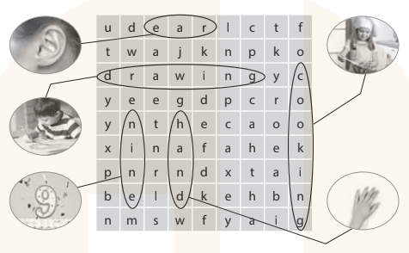 | -Ss look at the picture and answer  - - Ss note  - Ss say the word  - Ss look and match  -Ss find the words  -SS match the words with pictures  -Ss check their answer  -Ss say aloud

D. ADJUSTMENTS (if necessary):
………………………………………………………………………………………….…..……………………………………………………………………………...………………………………………….…..……………………………………………………………………………….……………………………………………………………………...

Week 10
Period 38

Unit 6: Our school
Lesson 1 (1, 2, 3)
By the end of the lesson, Ss will be able to:
- use the words school, classroom, library, playground in the sentence pattern: Is this our ……………? – Yes, it is. / No, it isn’t.
- use Is this our………… ? – Yes, it is. / No, it isn’t. to ask and answer questions about their school.
PROCEDURES:
Teacher’s activities | Students’ activities
Activity 1. Vocabulary.  *Aims: Ss will be able to know the vocabulary in front of starting the new lesson.  *Procedure:  -T elicits the new words  + school : trường học (picture)  + library : thư viện (picture)  + classroom :phòng học (picture)  + playground : sân chơi (picture)  - T models (3 times).  - T writes the words on the board.  - Checking: Matching  Activity 2. Look, listen and repeat:  *Aims: Ss will be able to understand and correctly repeat the sentences in two communicative contexts (pictures) to ask and answer questions about their school.  *Procedure:  - Have Ss look at Pictures a and b and identify names of the speakers in the pictures.  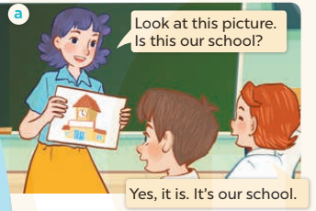  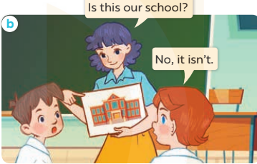  - Play the audio twice (sentence by sentence). Correct their pronunciation where necessary.  - Have Ss to practice the dialogue  - T invites a few pairs to the front of the class to practice.  - T checks pronunciation for ss. | -Ss listen and answer  - - Ss listen and repeat  + Choral repetition (3 times).  + Individual repetition (3 ss)  - Ss take note  - Ss look, remember and match  -Look at the pictures and say  + In picture a: Ms Hoa says: Look at this picture. Is this our school? Lucy answers: Yes, it is. It’s our school.  + In picture b: Ms Hoa asks: Is this our school? Lucy answers: No, it isn’t.  -Ss listen and repeat in chorus (twice)  -Ss work in pairs to practice  -Ss practice the dialogue  -Ss listen
D. ADJUSTMENTS (if necessary):
………………………………………………………………………………………….…..……………………………………………………………………………...………………………………………….…..……………………………………………………………………………….……………………………………………………………………...
Week 10
Period 39

Unit 6: Our school
Lesson 1 (4, 5, 6)
By the end of the lesson, Ss will be able to:
- listen to and understand four communicative contexts in which pupils ask and answer questions about their school
- read and complete three target sentence patterns with the help of picture cues.
- sing the song Our school with the correct pronunciation and melody.
PROCEDURES:
Teacher’s activities | Students’ activities
Activity 1. Listen and tick:  *Aims: Ss will be able to listen to and understand two communicative contexts to ask and answer questions about a school.  *Procedure:  - Elicit the word for the place in each picture  - Point at the pictures respectively to explain the context.  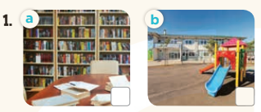  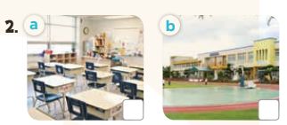  - T ask Ss to guess the answers.  + T writes Ss’guessing on the board.  - Listen to the tape:  + Play the recording  + Play the recording again and get Ss to swap books with their partners.  + Play the recording again to check answers together as a class.  + Write the answers on the board for Ss to correct their answers. Then checks Ss’ guessing.  - Play the recording, sentence by sentence, for the class to listen and repeat in chorus.  Key: 1. b 2. a  Activity 2. Look, complete and read  *Aims: Ss will be able to complete three target sentence patterns with the help of picture cues.  *Procedure:  - Get Ss to look at the pictures and identify the places in the pictures.  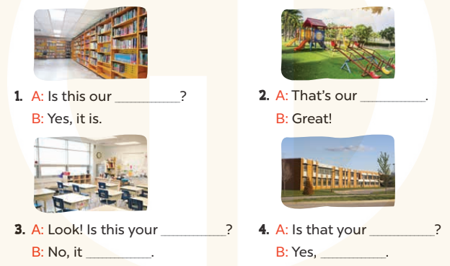  - Have Ss look at the four dialogue and the pictures. Elicit and model with picture 1  + Ask Ss to read the sentence 1 in chorus.  + Ask them what is missing in the question (library). Then have them complete the gap (Is this our library?).  -Have Ss work in pairs and complete the dialogue 2, 3, 4.  - Ask a few Ss to stand up and read the sentences aloud.  -T gives feedbacks.  Key:  1. library 2. playground  3. classroom; isn’t  4. school; it is | -Look at the pictures and say:  + Picture 1a: a library + Picture 1b: a playground  + Picture 2a: a classroom  + Picture 2b: a school  -Ss guess the answers  - Ss listen to the tape and tick  - Ss listen again, tick and swap books with their partners.  - Ss check their answers and guessing  -Ss listen and repeat.  -Ss look at the picture and say  -Ss look and answer  -Ss read  -Ss say and complete  -Ss work in pairs and complete  -Ss read aloud
D. ADJUSTMENTS (if necessary):

Week 10
Period 40

Unit 6: Our school
Lesson 2 (1, 2, 3)
By the end of the lesson, Ss will be able to:
- use the words school, classroom, library, playground, computer room, art room, music room and gym in the sentence pattern Let’s go to the ……….
- use Let’s go to the ……. – OK, let’s go. to make suggestions to go to a place at school and express agreement;
PROCEDURES:
Teacher’s activities | Students’ activities
Activity 1. Vocabulary.  *Aims: Ss will be able to know the vocabulary in front of starting the new lesson.  *Procedure:  -T elicits the new words  + art room : phòng mĩ thuật  (picture)  + computer room: phòng tin học  (picture)  + music room : phòng âm nhạc (picture)  + gym : nhà thể chất (picture)  - T models (3 times).  - T writes the words on the board.  - Checking: What and where  Activity 2. Look, listen and repeat:  *Aims: Ss will be able to understand and correctly repeat the sentences in two communicative contexts (pictures) to make suggestions to go to a place at school and express agreement.  *Procedure:  - Have Ss look at Pictures a and b and identify the characters in the pictures.  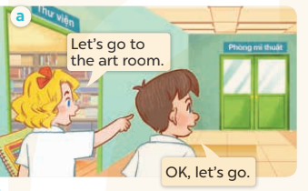  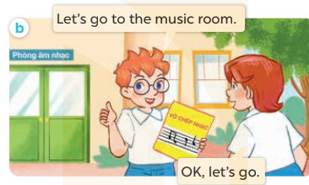  - Play the audio twice (sentence by sentence). Correct their pronunciation where necessary.  - Have Ss to practice the diaguage  - T invites a few pairs to the front of the class to practice.  - T checks pronunciation for ss. | -Ss listen and answer  - - Ss listen and repeat  + Choral repetition (3 times).  + Individual repetition (3 ss)  - Ss take note  - Ss look, remember and slap  -Look at the pictures and get to know the characters in the pictures.  + In picture a: Mary says: Let’s go to the art room. And Minh says: OK, let’s go.  – In picture b: Ben says: Let’s go to the music room. And Lucy says: OK, let’s go.  -Ss listen and repeat in chorus (twice)  -Ss work in pairs to practice  -Ss practice the diaguage  -Ss listen
D. ADJUSTMENTS (if necessary):
………………………………………………………………………………………….…..……………………………………………………………………………...……………

