Week 23 Preparing date: February 14th ,2025
Period 92 Teaching date: February 17th , 2025

Unit 14: Staying healthy
Lesson 1 (4, 5, 6)
A. OBJECTIVES:
By the end of the lesson, Ss will be able to:
1. Knowledge:
- listen to and understand four communicative contexts in which speakers ask and answer questions about a family member’s lifestyle and match the characters with the activities they do to stay healthy
- complete four gapped exchanges with the help of picture cues
- listen to and complete the song Staying healthy and sing it with the correct pronunciation, rhythm and melody.
- Vocabulary: Review
- Skills: speaking, listening, reading and writing.
2. Competences:
- Communication and collaboration: work in pairs and groups to complete the learning tasks.
- Self-control and independent learning: perform listening and reading tasks.
3. Attitude/ Qualities:
- Raise their knowledge of using healthy food and drink.
- Show their awareness of doing morning exercise regularly.
B. TEACHING AIDS:
- Teacher: Teacher’s guide Pages 225, 226, 227; audio Tracks 33, 34; website hoclieu.vn, posters, laptop, pictures, textbook, lesson plan, TV or projector.
- Students: Student’s book Page 25, notebooks, workbooks, school things.
C. PROCEDURES:
Stages/  Time | Teacher’s activities | Students’ activities
1.Warm- up and review: (5’)  2.Practice: (25’)  3. Fun corner and wrap- up (5’) | Game: Lucky fruits  *Aims: to revise the learned sentence structures.  *Procedure:  - Tell ss they are going to look at the pictures and ask and answer the questions about how someone stays healthy.  - Divide the class into two groups.  - Have two ss from each group take turns to choose a fruit and ask and answer the question.  - If the group chooses a lucky fruit, they will get points and continue the next turn.  - Continue the game with the other pupils.  - The group that gets the most points wins. Praise the winner.  - Say “Open your book page 25” and look at “Unit 14, Lesson 1 (4,5,6)”.  Activity 1. Listen and match:  *Aims: Ss will be able to listen to and understand four communicative contexts in which speakers ask and answer questions about a family member’s lifestyle and match the characters with the activities they do to stay healthy.  *Procedure:  - Elicit and ask questions to elicit the characters and the activities in the pictures.  + What can you see in this picture?  + Where are they?  + What do they do?  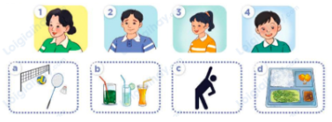  - T ask Ss to guess the answers.  + T writes Ss’guessing on the board.  - Listen to the tape:  + Play the recording  + Play the recording again for ss to do the task.  + Play the recording a third time for pupils to check their answers.  - Get Ss to swap books with their partner, then check answers as a class.  + Write the answers on the board for Ss to correct their answers. Then checks Ss’ guessing.  - If time allows, play the recording, sentence by sentence, for Ss to listen and repeat individually and in chorus Key: 1. b 2. c 3. b 4. d  Activity 2. Read and complete.  *Aims: Ss will be able to complete four gapped exchanges with the help of picture cues.  *Procedure:  - Have Ss read the question and answer, and guess the missing word  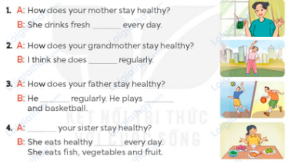  - Have Ss look at the four incomplete exchanges and elicits the missing words in the sentences.  - T models with sentence 1  + Have Ss look at the picture and identify the needed information (juice).  - Have Ss work in groups and complete the exchanges 2, 3 and 4.  - Get Ss to swap books with a partner and check their answers before checking as a class.  - Invite four pairs of Ss to act out the four completed exchanges in front of the class  Key:  1. juice  2. morning exercise  3. plays sports; volleyball  4. How does; food  Activity 3. Listen, complete and sing.  *Aims: Ss will be able to listen to and complete the song Staying healthy and to sing it with the correct pronunciation, rhythm and melody.  *Procedure:  - Introduce the title and lyrics of the song: “Staying healthy”  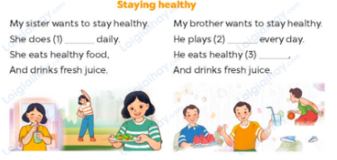  - Tell ss the aim of the activity  - Draw ss’ attention to the gapped sentences and guess the missing words and complete the sentences.  - Play the recording all the way through for ss to listen to the whole song.  - Play the recording again for them to fill in the gaps with the missing words.  - Check answers together as a class.  - Play the recording line by line for ss to listen and repeat.  - Invite a few groups to the front of the class to sing the song.  Key: 1. morning exercise  2. sports 3. fruit  Game: Pass the ball  - T gives Ss a ball.  - T asks Ss to listen to music and transfer a ball around the class.  - When the music stops, Ss who keep a ball have to answer the question using: How does he/ she stay healthy? and he/ she………..  - T gives feedback. | - Ss listen  - Ss play the game  - Ask and answer the question  Ex:  A: How does your sister stay healthy?  B: She drink fresh juice  - Continue playing the game.  - Ss open their books  -Look at the pictures and say:  a. a mother  b. a father  c. a sister  d. a brother  1. sports  2. fresh juice  3. morning exercise  4. healthy food  -Ss guess the answers  - Ss listen to the tape  - Ss listen again and do the task.  - Ss listen and check their answers  - Ss swap books with their partner, then check answers as a class  - Ss check the guessing  -Ss listen and repeat  -Ss look at the picture and read and guess  -Ss look and follow the teacher demonstrating the exchange 1.  -Ss answer: (She drinks fresh juice every day.  -Ss complete the sentences  -Ss swap books and check their answers before checking as a class.  -Ss read the completed exchanges aloud.  - Ss listen  -Ss listen to the song  - Ss look at the gapped sentences and guess and complete the sentences.  - Ss listen to the song  - Ss listen and fill in the gaps with missing words.  - Ss check answers together  - Ss listen to the recording, line by line, and repeat.  - Ss come to the front of the class to sing the song.  -Ss listen  -Ss play a game  - Ss continue playing the game.  -Ss praise the winner
D. ADJUSTMENTS (if necessary):
………………………………………………………………………………………….…..……………………………………………………………………

