Week 25 Preparing date: March 1st , 2025
Period 100 Teaching date: March 3rd , 2025

Unit 15: Our health
Lesson 2 (4, 5, 6)
A. OBJECTIVES:
By the end of the lesson, Ss will be able to:
1. Knowledge:
- listen to and understand the communicative contexts in which characters talk about health problems in the correct pictures.
- complete the target sentence patterns in two conversations about health problems and advice for them with the help of picture cues.
- role-play by asking and giving advice about health problems
- Vocabulary: Review
- Skills: speaking, listening, reading and writing.
2. Competences:
- Communication and collaboration: work in pairs and groups to complete the learning tasks.
3. Attitude/ Qualities:
- Show pupils how to give advice about health problems.
B. TEACHING AIDS:
- Teacher: Teacher’s guide Pages 245, 246; audio Tracks 47; website hoclieu.vn, posters, laptop, pictures, textbook, lesson plan, TV or projector.
- Students: Student’s book Page 33, notebooks, workbooks, school things.
C. PROCEDURES:
Stages/  Time | Teacher’s activities | Students’ activities
1.Warm- up and review: (5’)  2.Practice: (25’)  3. Fun corner and wrap- up (5’) | Play a game: Quiz Time  *Aims: to revise the sentence structure  *Procedure:  - Place some gapped sentences and pictures.  - Have ss play the game individually.  - Show a gapped sentence, a picture and three options A, B or C.  Ex: picture of “headache”/ You should ____. - Thanks for your advice.  A. play football B. take a rest C. watch TV  - Invite a student to give the answer.  - Continue with other sentences.  - Say “Open your book page 33” and look at “Unit 15, Lesson 2 (4,5,6)”.  Activity 1. Listen and tick:  *Aims: Ss will be able to listen to and understand the communicative contexts in which characters talk about health problems in the correct pictures  *Procedure:  - Have ss look at the pictures and ask  + What health problems can you see in each picture?  + What advice can you see in each picture?  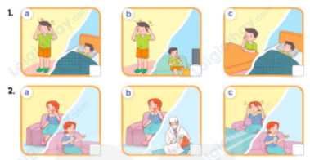  - T ask Ss to guess the answers.  + T writes Ss’guessing on the board.  - Listen to the tape:  + Play the recording  + Play the recording again and get Ss to swap books with their partners.  + Play the recording again to check answers together as a class.  + Write the answers on the board for Ss to correct their answers. Then checks Ss’ guessing.  - Play the recording, sentence by sentence, for the class to listen and repeat in chorus.  Key: 1.a 2. b  Activity 2. Read and complete  *Aims: Ss will be able to complete the target sentence patterns in two conversations about health problems and advice for them with the help of picture cues.  *Procedure:  - Ask Ss to look at the pictures and identify the health problems that the characters have 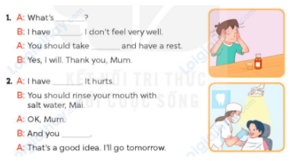  - Have Ss look at the 2 incomplete exchanges and elicits the missing words in the sentences.  - T models with the first sentence  + Ask Ss what is missing in the sentence (the matter).  + Have Ss look at the picture and identify the needed information (What’s the matter?)  - Have Ss work in pairs and complete  - Get Ss to swap books with a partner and check their answers before checking as a class.  Key:  1. the matter; a headache; some medicine  2. toothache; should go to the dentist  Activity 3. Let’s play.  *Aims: Ss will be able to role-play by asking and giving advice about health problems  *Procedure:  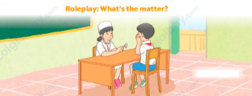  - Tell ss to role- play in pairs as a doctor and a patient within 3 minutes. Encourage them to ask and give advice about health problems.  - When the time is up, ask 3 pairs to perform their roles in front of the class. Ask the class to vote for the best performance.  - Reward the pair with the most votes.  Game: Pass the balls  - Give two different colored balls to two pupils, a red ball (ask the question) and a yellow ball (answer the question).  - Ask ss to listen to music and pass the balls.  - Stop music suddenly.  - Have the student with a red ball make a question. Have the student with a yellow ball answer the question.  - Praise ss if they do the activity well. | - Ss pay attention.  -Ss play the game  - Ss congratulate to the winner  - Ss open their books  - Look at the pictures and say:  1. a. Nam with a headache and Nam having a rest in a bed  1.b. Nam with a headache and Nam watching TV  1.c. Nam with toothache and Nam having a rest in a bed  2. a. Lucy with toothache and Lucy taking some medicine  2.b. Lucy with toothache and Lucy having her teeth checked by the dentist  2.c. Lucy with a headache and Lucy taking some medicine  -Ss guess the answers  - Ss listen to the tape  - Ss listen again, tick and swap books with their partners.  - Ss check their answers and guessing  - Ss answer and check  -Ss listen and repeat.  -Ss look at the picture and say  -Ss follow the teacher.  -Ss read and answer  -Ss work in pairs and fill in the gaps  - Ss swap books and check  -Ss listen and pay attention  - Ss ask and give advice about health problems  - Ss perform their roles  -Ss listen to the teacher  -Ss play the game  Ex:  A: You should take a rest.  B: Thanks for your advice.  -Ss congratulate

D. ADJUSTMENTS (if necessary):
………………………………………………………………………………………….…..……………………………………………………………………………...……

