Week 22 Preparing date: February 7th , 2025
Period 88 Teaching date: February 12th , 2025

Unit 13: Our special days
Lesson 2 (4, 5, 6)
A. OBJECTIVES:
By the end of the lesson, Ss will be able to:
1. Knowledge:
- use What food / drinks will you have at the party? – We’ll have ___. to ask and answer questions about the food and drinks someone will have at an event
- listen to and demonstrate understanding of simple communicative contexts in relation to the topic “Our special days”.
- Vocabulary: Review
- Skills: speaking, listening, reading and writing.
2. Competences:
- Communication and collaboration: work in pairs and groups to complete the learning tasks.
3. Attitude/ Qualities:
- Enhance understanding of what people eat and drink on special occasions.
- Express their preferences for food and drinks.
B. TEACHING AIDS:
- Teacher: Teacher’s guide Pages 216, 217; audio Tracks 27; website hoclieu.vn, posters, laptop, pictures, textbook, lesson plan, TV or projector.
- Students: Student’s book Page 21, notebooks, workbooks, school things.
C. PROCEDURES:
Stages/ Time | Teacher’s activities | Students’ activities
1.Warm- up and review: (5’)  2.Practice: (25’)  3. Fun corner and wrap- up (5’) | Play a game: “Run to the corner”  *Aims: to revise the sentence structure *Procedure:  - Draw ss’ attention to the pictures and say the name of food and drinks.  - Ask 2 ss to come to the front and ask about their food and drinks they want at their parties.  + When they finish answering the questions, other players (1 from each team) will run to the pictures mentioned and say the name of that food/ drinks.  + Who faster is the winner and get 1 point for that round.  - Say “Open your book page 21” and look at “Unit 13, Lesson 2 (4,5,6)”.  Activity 1. Listen and tick:  *Aims: Ss will be able to listen to and understand two communicative contexts in which characters talk about food and drinks they will have at an event and tick the correct pictures  *Procedure:  - Elicit the names of the food and drinks  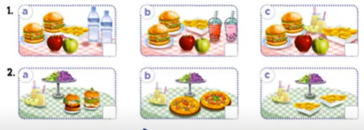  - T ask Ss to guess the answers.  + T writes Ss’guessing on the board.  - Listen to the tape:  + Play the recording  + Play the recording again and get Ss to swap books with their partners.  + Play the recording again to check answers together as a class.  + Write the answers on the board for Ss to correct their answers. Then checks Ss’ guessing.  - Play the recording, sentence by sentence, for the class to listen and repeat in chorus.  Key: 1.b 2. a  Activity 2. Read and complete  *Aims: Ss will be able to complete two gapped exchanges with the help of picture cues.  *Procedure:  - Ask Ss to identify the food and drinks someone will have at a meal / party. 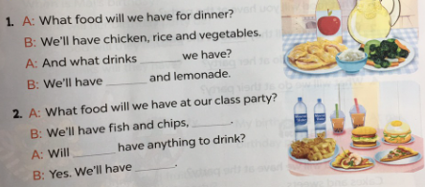  - Have Ss look at the 2 incomplete exchanges and elicits the missing words in the sentences.  - T models with the first sentence  + Ask Ss what is missing in the sentence (will).  + Have Ss look at the picture and identify the needed information (And what drinks will we have)  - Have Ss work in pairs and complete  - Get Ss to swap books with a partner and check their answers before checking as a class.  Key:  1. will, apple juice  2. burgers and pizza, we, mineral water and milk tea  Activity 3. Let’s play.  *Aims: Ss will be able to practise the target vocabulary and sentence patterns by playing the game Our Children’s Day party menu  *Procedure:  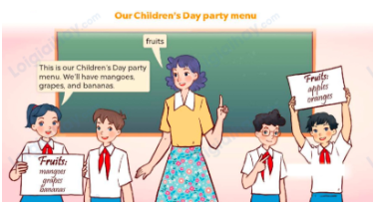  - Tell the class that the game will be played in groups of three. Ss in each group will discuss as many names of fruit, food and drinks as possible in the menu for their Children’s Day party  - Invite two or three groups to the front of the class.  - Let Ss have a time limit to make a menu (including fruit, food and drinks).  - Each group shows and tells the menu to the class. The group that says the most sentences about their menu with correct grammar will be given five points / stars.  Game: Lucky Food (ppt)  - Divides the class into 3 teams.  - Each team takes turns choosing a food/ drink and answering the question.  - T checks the answer with the whole class.  - Ss collect the points if they answer the question correctly.  - The team with the most points is the winner. | - Ss pay attention.  -Ss play the game  - Ss congratulate to the winner  - Ss open their books  - Look at the pictures and say:  1a. Two burgers, some chips, two apples and two bottles of mineral water  1b. Two burgers, some chips, two apples and two glasses of milk tea  1c. Two burgers, some chips, two apples and two glasses of apple juice  2a. Two burgers, some grapes and two glasses of apple juice  2b. Two pizzas, some grapes and two glasses of apple juice  2c. Some chips, some grapes and two glasses of apple juice  -Ss guess the answers  - Ss listen to the tape and match  - Ss listen again, match and swap books with their partners.  - Ss check their answers and guessing  - Ss answer and check  -Ss listen and repeat.  -Ss look at the picture and say  -Ss follow the teacher.  -Ss read and answer  -Ss work in pairs and fill in the gaps  - Ss swap books and check  -Ss listen and pay attention  - Ss play the game  -Ss play the game  -Ss play the game  -Ss play the game

D. ADJUSTMENTS (if necessary):
………………………………………………………………………………………….…..……………………………………………………………………………...……

