Week 22 Preparing date: February 7th , 2025
Period 86 Teaching date: February 10th , 2025

Unit 13: Our special days
Lesson 1 (4, 5, 6)
A. OBJECTIVES:
By the end of the lesson, Ss will be able to:
1. Knowledge:
- listen to and understand two communicative contexts in which pupils ask and answer questions about what someone will do for a special day.
- listen to and demonstrate understanding of simple communicative contexts in relation to the topic “Our special days”.
- Vocabulary: Review
- Skills: speaking, listening, reading and writing.
2. Competences:
- Communication and collaboration: work in pairs and groups to complete the learning tasks.
- Self-control and independent learning: perform listening and reading tasks.
3. Attitude/ Qualities:
- Show their pride in their personal information and what someone will do for a special day.
B. TEACHING AIDS:
- Teacher: Teacher’s guide Pages 210, 211, 212; audio Tracks 23, 24; website hoclieu.vn, posters, laptop, pictures, textbook, lesson plan, TV or projector.
- Students: Student’s book Page 19, notebooks, workbooks, school things.
C. PROCEDURES:
Stages/ Time | Teacher’s activities | Students’ activities
1.Warm- up and review: (5’)  2.Practice: (25’)  3. Fun corner and wrap- up (5’) | Game: Pass the teddy bears  *Aims: to revise the learned structures.  *Procedure:  - Give two different colored teddy bears to two pupils, a black teddy bear (ask the question) and a white teddy bear (answer the question).  - Ask ss to listen to music and pass the teddy bears.  - Stop music suddenly. Have the student with a black teddy bear make a question. Have the student with a white teddy bear answer the question.  - Repeat the game several times.  - Say “Open your book page 19” and look at “Unit 13, Lesson 1 (4,5,6)”.  2.Practice: (25’)  Activity 1. Listen and tick or cross:  *Aims: Ss will be able to listen to and understand four communicative contexts in which speakers ask and answer questions about what someone will do on / at a special day.  *Procedure:  - Have ss look at the picture and elicit the activities in the pictures.  +What will they do?  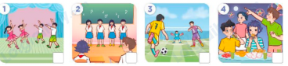  - T ask Ss to guess the answers.  + T writes Ss’guessing on the board.  - Listen to the tape:  + Play the recording  + Play the recording again for pupils to do the task.  + Play the recording a third time for pupils to check their answers.  - Get Ss to swap books with their partner, then check answers as a class.  + Write the answers on the board for Ss to correct their answers. Then checks Ss’ guessing.  - Have ss explain the answers.  Key: 1. x 2. x 3.v 4.v  Activity 2. Read and complete.  *Aims: Ss will be able to complete four gapped exchanges with the help of picture cues.  *Procedure:  - Get Ss to look at the pictures and identify the activities.  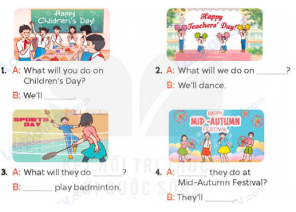  - Have Ss look at the four incomplete exchanges and elicits the options  - T models with sentence 1  + Have Ss circle the correct answer (have a party)  + Have Ss look at the picture and identify the needed information (have a party).  - Have Ss work in groups and complete the sentences 2, 3 and 4.  - Get Ss to swap books with a partner and check their answers before checking as a class.  -T gives feedbacks.  Key:  1. have a party  2. Teachers’ Day  3. on Sports Day, We’ll  4. What will, sing and dance  Activity 3. Listen, complete and sing  *Aims: Ss will be able to listen and complete the song What will you do on Children’s Day? and sing it with correct pronunciation, rhythm and melody.  *Procedure:  - Introduce the title and lyrics of the song:What will you do on Children’s Day?  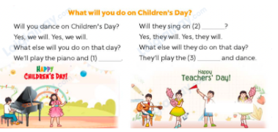  - Tell ss the aim of the activity  - Draw ss’ attention to the gapped sentences and guess the missing words and complete the sentences.  - Play the recording all the way through for ss to listen to the whole song.  - Play the recording again for them to fill in the gaps with the missing words.  - Check answers together as a class.  - Play the recording line by line for pupils to listen and repeat.  - Invite a few groups to the front of the class to sing the song.  Game: Guessing game  - Draw ss’ attention to the screen.  - Explain the rules of the game: Ss look at the clue and guess  + 1 open-picture: get 3 points  + 2 open -pictures: get 2 points  + All pictures left: 1 point . | - Ss listen to the teacher’s instruction  - Ss play the game  Ex:  A: What will you do on Teacher’s Day?  B: We’ll sing and dance.  - Continue playing the game.  - Ss open their books  -Look at the pictures and say:  + Picture 1: A group of children dancing  + Picture 2: A group of children singing  + Picture 3: Some boys playing football  + Picture 4: A group of children having a party in the moon  -Ss guess the answers  - Ss listen to the tape  - Ss listen again and do the task.  - Ss listen and check their answers  - Ss swap books with their partner, then check answers as a class and guessing  -Ss explain the answers  -Ss look at the picture and identify the activities.  -Ss look at the exchanged and pay attention  -Ss look and say the correct answer  -Ss listen and pay attention  -Ss complete the sentences  -Ss swap books with a partner and check their answers before checking as a class.  -Ss listen  - Ss listen and pay attention  - Ss listen to the teacher’s instruction.  - Ss look at the gapped sentences and guess the missing words and complete the sentences.  - Ss listen to the song  - Ss listen and fill in the gaps with missing words.  - Ss check answers together as a class.  - Ss listen to the recording, line by line, and repeat.  - Ss come to the front of the class to sing the song.  - Ss follow the teacher’s instructions.  - Ss look at the screen and guess what the word is.
D. ADJUSTMENTS (if necessary):
………………………………………………………………………………………….…..……………………………………………………………

