Week 24 Preparing date: February 20th, 2025
Period 96 Teaching date: February 25th , 2025

Unit 14: My bedroom
Lesson 3 (4, 5, 6)
A. OBJECTIVES:
By the end of the lesson, Ss will be able to:
1. Knowledge:
- read the text and complete the gapped sentences.
- read the text and complete the gapped sentences.
- complete a gapped paragraph with the help of the picture cue.
- Vocabulary: Review
- Skills: speaking, listening, reading and writing.
2. Competences:
- Co-operation: ready to help friends in pair work/ group work.
- Self-control and independent learning: perform reading tasks.
3. Attitude/ Qualities:
- Kindness: Help partners to complete learning tasks.
- Honesty: tell the truth about feelings and emotions.
- Diligence: complete learning tasks.
B. TEACHING AIDS:
- Teacher: Teacher’s guide Pages 181, 182, website sachmem.vn, posters, laptop, pictures, textbook, lesson plan, TV or projector.
- Students: Pupil’s book Page 29, notebooks, workbooks, school things.
C. PROCEDURES:
Stages/Time | Teacher’s activities | Students’ activities
1.Warm- up:  (5’)  2.Practice: (8’)  3.Production: (19’)  4. Homework. (3’) | Game: Brainstorming  *Aims: to review the vocabulary and structure about greet and respond to greetings.  *Procedure:  - Divide the class into four groups.  - Each group chooses one pupil to be the 'runner'. The runners go to the teacher's desk and read the category.  Ex: Find objects/things in your bedroom/living room.  - The runners then go back to their group and tell their group members the category. Their group brainstorm words from that category and write them down.  - The first group to finish shouts 'stop' and then calls out their answers. If their answers are correct, they score one point for each word in the category.  - The group with the highest score at the end of the game wins.  - Say “Open your book page 29” and look at “Unit 14, Lesson 3 (4, 5, 6)”.  Activity 1. Read and complete:  *Aims: Ss will be able to read the text and complete the gapped sentences  *Procedure:  - Tell Ss how to complete the task.  - Point at the table and elicit the type of information they need to find in the texts.  - Ask Ss attend to the blank in number 1 and find the missing word.  - Write the missing word on the board and get the class to read the completeed sentence together.  - Have Ss work in pairs and complete  - Tell Ss to swap books with a partner, then check answers together as a class.  - Write the correct answers on the board for pupils to correct their answers.  - Invite Ss to read the complete text aloud  -T gives feedbacks.  Key: 1. desk 2. Chairs  3. big 4. small  Activity 2. Let’s write  *Aims: Ss will be able to complete a gapped paragraph with the help of the picture cue.  *Procedure:  - Explain to the class the goal of this activity.  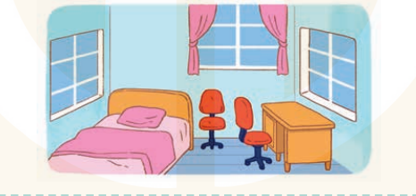  - Ask Ss to read each gapped sentence, look at the picture and fill in the gap.  - Give Ss time to write their answers  - Ask Ss to swap and correct their answers in pairs.  - Check the answers as a class.  Key: first gap: small  second gap: bed / desk  third gap: small / old  fourth gap: chairs  fifth gap: old / new  Activity 3. Project.  *Aims: Ss will be able to find a picture of a bedroom and tell the class about things in the room.  *Procedure:  - Tell Ss to find a photo of a bedroom in a newspaper or a magazine as homework. They should bring their photos to class.  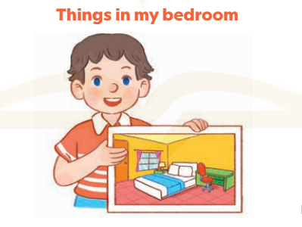  - Have Ss work in groups. Each member introduces the picture of the bedroom using the structures they have learnt in the unit.  - Invite one or two Ss to show their photos and describe them in front of the class.  +Example: Hello, everyone. My name’s Huong. I’m nine years old. This is my bedroom. There is a bed. It is bag. There are two windows. They are new.  - Create a class display of the projects and organise a vote to find the most beautiful ones.  *Consolidation  *Aims: Ss will be able consolidate and wrap up the content of the lesson.  *Procedure:  - T asks ss to answer the following questions:  + What have you learnt from the lesson today?  +What are the core values of the lesson?  - T praises some Ss who are hardworking / active/ good…. as well as encourage others to try more.  - Prepare the new lesson: Unit 15: Lesson 1 (1,2,3). | - Ss listen  -Ss play game  - Ss open their books  -Ss listen  - Ss read and answer  -Ss read and complete  -Ss write the first word  -Ss work in pairs  -Ss swap books and check  -Ss check the correct their answers  -Ss read  -Ss listen  -Ss listen  -Ss read and answer  -Ss write  This is my bedroom. It is……..  There is a…………………….  It is……..There are two……….  They are……………………..  -Ss swap books and check their answers  -Ss check  -Ss listen  -Ss work in groups  -Ss show the picture and say.  -Ss perform in front of the class.  -Ss vote the most beautiful ones  -Ss answer the questions  -Ss listen and clap their hands  -Ss listen and take note
D. ADJUSTMENTS (if necessary):
………………………………………………………………………………………….…..……………………………………………………………………………...…………

