Week 24 Preparing date: February 20th, 2025
Period 94 Teaching date: February 24th ,2025

Unit 14: My bedroom
Lesson 2 (4, 5, 6)
A. OBJECTIVES:
By the end of the lesson, Ss will be able to:
1. Knowledge:
- listen to and understand four communicative contexts in which characters introduce and describe things in a bedroom and number the correct pictures.
- complete four gapped sentences with the help of picture cues.
- sing the song My bedroom with the correct pronunciation, rhythm and melody.- Vocabulary: Review
- Skills: speaking, listening, reading and writing.
2. Competences:
- Co-operation: ready to help friends in pair work/ group work.
- Self-control and independent learning: perform listening tasks.
3. Attitude/ Qualities:
- Kindness: Help partners to complete learning tasks.
- Honesty: tell the truth about feelings and emotions.
- Diligence: complete learning tasks.
B. TEACHING AIDS:
- Teacher: Teacher’s guide Pages 178, 179; audio Tracks 37, 38; website sachmem.vn, posters, laptop, pictures, textbook, lesson plan, TV or projector.
- Students: Pupil’s book Page 27, notebooks, workbooks, school things.
C. PROCEDURES:
Stages/Time | Teacher’s activities | Students’ activities
1.Warm- up:  (5’)  2.Practice: (27’)  3. Homework. (3’) | Sing a song: “throw the ball”  *Aims: to create a friendly and active atmosphere in the class to beginning the lesson.  *Procedure:  - Divide the class into 2 teams.  - Stick the pictures of things in the room on the board.  + T says a word, a pupil from each team has to point/throw the ball to the right picture and says the word three times.  + The one says faster will get points.  - Encourage Ss to take part in the game.  - Give points for Ss.  - Say “Open your book page 27” and look at “Unit 14, Lesson 2 (4,5,6)”.  Activity 1. Listen and number:  *Aims: Ss will be able to listen to and understand four communicative contexts in which characters introduce and describe things in a bedroom and number the correct pictures  *Procedure:  - Have Ss look at the pictures and ask them some questions such as What is this? and What are these? 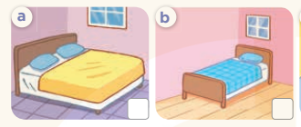  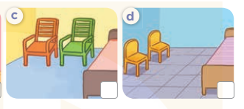  - T ask Ss to guess the answers.  + T writes Ss’guessing on the board.  - Listen to the tape:  + Play the recording  + Play the recording again and get Ss to swap books with their partners.  + Play the recording again to check answers together as a class.  + Write the answers on the board for Ss to correct their answers. Then checks Ss’ guessing.  - Play the recording, sentence by sentence, for the class to listen and repeat in chorus.  Key: 1.b 2. a 3. c 4. d  Activity 2. Look, complete and read.  *Aims: Ss will be able to complete four gapped dialogues with the help of picture cues.  *Procedure:  - Have Ss look at the pictures and ask identify things in the room in the pictures.  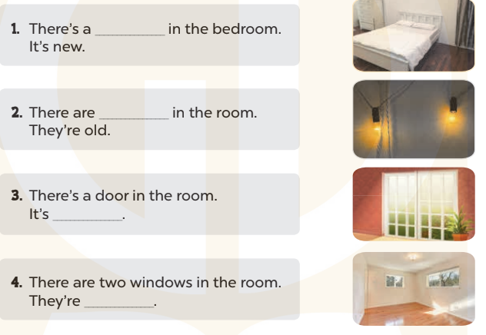  - T models with sentence 1.  + Have Ss look at the sentence.  + Ask them what is missing in the answer ( bed ).  + Have Ss complete the gap.  + Have Ss read the completed sentence in chorus.  -Have Ss work in pairs and complete the sentences 2, 3 and 4.  - Invite pairs of pupils to stand up and read aloud the sentences.  -T gives feedbacks.  Key: 1. bed 2. two lamps 3. big 4. small  Activity 3. Let’s sing.  *Aims: Ss will be able to sing the song My bedroom with the correct pronunciation, rhythm and melody *Procedure:  - Introduce the title and lyrics of the song: “My bedroom? ” song.  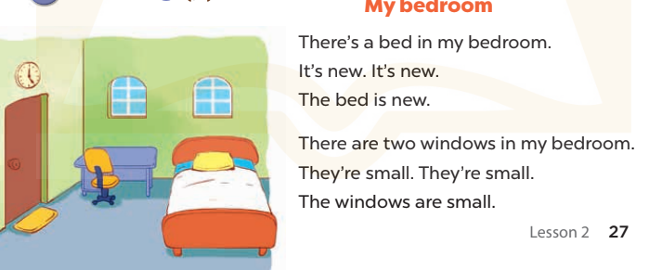  - Play the recording for Ss to listen to the whole song.  + Have them repeat the title and lyrics line by line.  + Tell Ss to point at the relevant character while singing his or her name.  - Play the recording all the way through for Ss to listen to pronunciation and melody of the song.  - Play the recording line by line for Ss to listen, repeat and point at the relevant character.  - Play the recording for Ss to sing and do actions.  - Ask Ss to practice singing and doing actions in pairs or groups.  - Invite groups to the front of the classroom to perform the song  -T gives feedback.  *Consolidation  *Aims: Ss will be able consolidate and wrap up the content of the lesson.  *Procedure:  - T asks ss to answer the following questions:  + What have you learnt from the lesson today?  +What are the core values of the lesson? (if the teacher can take from the lesson).  - T praises some Ss who are hardworking / active/ good…. as well as encourage others to try more.  - Prepare the new lesson: Unit 14, Lesson 3 (1,2,3). | - Ss listen and play the game  - Ss open their books  -Look at the pictures and say:  + Picture a: a big bed in a bedroom  + Picture b: a small bed in a bedroom  + Picture c: two big chairs in a bedroom  + Picture d: two small chairs in a bedroom  -Ss guess the answers  - Ss listen to the tape and write number  - Ss listen again, write number and swap books with their partners.  - Ss check their answers and guessing  -Ss listen and repeat.  -Ss look at the pictures and say  -Ss listen and answer  -Ss read and complete  -Ss work in pairs  -Ss read  - Ss look and listen.  -Ss listen to the song  - Ss listen and repeat line by line without the action.  -Ss point to the character while singing  -Ss listen to melody of the song  - Ss listen and sing line by line.  - Ss sing and do actions.  + Ss work in groups (two groups) to sing.  -Ss perform in front of the class.  -Ss listen  -Ss listen and answer  -Ss listen and take note

D. ADJUSTMENTS (if necessary):
………………………………………………………………………………………….…..……………………………………………………………………………...………………………………………….…..……………………………………………………………………………….……………………………………………………………………...

