Week 25 Preparing date: March 1st ,2025
Period 100 Teaching date: March 4th , 2025

Unit 15: At the dining table
Lesson 2 (4, 5, 6)
A. OBJECTIVES:
By the end of the lesson, Ss will be able to:
1. Knowledge:
- listen to and understand four communicative contexts in relation to food and drinks.
- look, complete and read four target sentences with the help of picture cues.
- revise target words about food and drinks by playing the game Board race.
- Vocabulary: Review
- Skills: speaking, listening, reading and writing.
2. Competences:
- Critical Thinking: talk about rooms in a house and things in a room.
- Co-operation: ready to help friends in pair work/ group work.
- Self-control and independent learning: perform listening tasks.
3. Attitude/ Qualities:
- Kindness: Help partners to complete learning tasks.
- Honesty: tell the truth about feelings and emotions.
- Diligence: complete learning tasks.
B. TEACHING AIDS:
- Teacher: Teacher’s guide Pages 188; audio Tracks 48; website sachmem.vn, posters, laptop, pictures, textbook, lesson plan, TV or projector.
- Students: Pupil’s book Page 33, notebooks, workbooks, school things.
C. PROCEDURES:
Stages/Time | Teacher’s activities | Students’ activities
1.Warm- up:  (5’)  2.Practice: (27’)  3. Homework. (3’) | Sing a song: “My house”  *Aims: to create a friendly and active atmosphere in the class to beginning the lesson.  *Procedure:  - Show the song on the screen.  https://www.youtube.com/watch?v=qZyJPZxsmZk  - Ask pupils to listen, sing and dance the song.  - Say “Open your book page 33” and look at “Unit 15, Lesson 2 (4,5,6)”.  Activity 1. Listen and number:  *Aims: Ss will be able to listen to and understand four communicative contexts in relation to food and drinks.  *Procedure:  - Elicit the names and ages of the characters in the pictures.  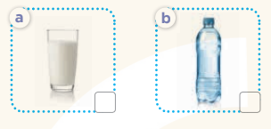  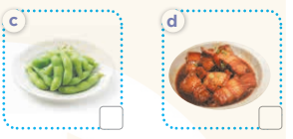  - T ask Ss to guess the answers.  + T writes Ss’guessing on the board.  - Listen to the tape:  + Play the recording  + Play the recording again and get Ss to swap books with their partners.  + Play the recording again to check answers together as a class.  + Write the answers on the board for Ss to correct their answers. Then checks Ss’ guessing.  - Play the recording, sentence by sentence, for the class to listen and repeat in chorus.  Key: 1.c 2. d 3. a 4. b  Activity 2. Look, complete and read.  *Aims: Ss will be able to look, complete and read four target sentences with the help of picture cues.  *Procedure:  - Have Ss look at the pictures and identify food and drink in the pictures. 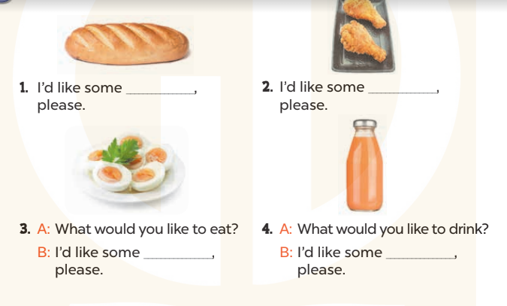  - T models with sentence 1.  + Have Ss look at the sentence.  + Ask them what is missing in the answer (bread)  + Have Ss circle the correct options  + Have Ss read the completed sentence in chorus.  -Have Ss work in pairs and circle the sentences 2, 3 and 4.  - Invite pairs of pupils to stand up and read aloud the sentences.  -T gives feedbacks.  Key: 1. b 2. b 3. a 4. b  Activity 3. Let’s play.  *Aims: Ss will be able to revise target words about food and drinks by playing the game Board race.  *Procedure:  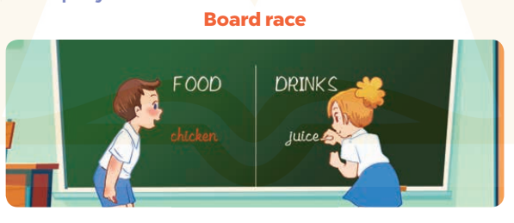  - Tell Ss that they are going to play the game Board race. Write Food and Drinks on opposite sides of the board.  - Have two teams play the game. When you say “Go”, the teams have to race to write the name of a food or drinks. Each pupil writes one word at a time, before passing the marker /chalk to the next pupil and going to the back of the line.  - Explain that a pupil who makes spelling mistakes or writes a word of food or drink under the wrong category will be out of the game.  - At the end of the game, announce the winner for the team that has written more correct words.  *Consolidation  *Aims: Ss will be able consolidate and wrap up the content of the lesson.  *Procedure:  - T asks ss to answer the following questions:  + What have you learnt from the lesson today?  +What are the core values of the lesson? (if the teacher can take from the lesson).  - T praises some Ss who are hardworking / active/ good…. as well as encourage others to try more.  - Prepare the new lesson: Unit 15, Lesson 3 (1,2,3). | - Sing and dance the song in chorus.  - Ss open their books  -Look at the pictures and say:  + Picture a: a glass of milk + Picture b: a bottle of water  + Picture c: some beans + Picture d: some meat  -Ss guess the answers  - Ss listen to the tape and write number  - Ss listen again, write number and swap books with their partners.  - Ss check their answers and guessing  -Ss listen and repeat.  -Ss look at the pictures and say  -Ss listen and answer  -Ss read and complete  -Ss work in pairs  -Ss read  - Ss listen  -Ss play the game  - Ss play the game  -Ss listen and answer  -Ss listen and take note

D. ADJUSTMENTS (if necessary):
………………………………………………………………………………………….…..……………………………………………………………………………...………………………………………….…..……………………………………………………………………………….……………………………………………………………………...

