Week 25 Preparing date: March 1st, 2025
Period 99 Teaching date: March 4th ,2025

Unit 15: At the dining table
Lesson 2 (1, 2, 3)
A. OBJECTIVES:
By the end of the lesson, Ss will be able to:
1. Knowledge:
- use What would you like to eat/drink? – I’d like some…….., please. To ask and answer questions about food and drinks
- understand and correctly repeat the sentences in two communicative contexts (pictures). focusing on what someone would like to eat or drink.
- correctly use What would you like to eat / drink? - I’d like some ……, please. to ask and answer questions about what someone would like to eat or drink.
- enhance the correct use of What would you like to eat / drink? – I’d like some ….., please. to ask and answer questions about what someone would like to eat or drink.
- Vocabulary: egg, chicken, water, milk, bread, eat, drink.
- Model sentences:
A: What would you like to eat / drink?
B: I’d like some bread/ milk, please
- Skills: speaking and listening
2. Competences:
- Critical Thinking: talk about someone
- Co-operation: ready to help friends in pair work/ group work.
- Oral Communication: speak about someone, ask and answer the questions
3. Attitude/ Qualities:
- Kindness: Help partners to complete learning tasks.
- Honesty: tell the truth about feelings and emotions
B. TEACHING AIDS:
- Teacher: Teacher’s guide Pages 187 audio Tracks 46, 47, website sachmem.vn, posters, laptop, pictures, textbook, lesson plan, TV or projector.
- Students: Pupil’s book Page 32, notebooks, workbooks, school things.
C. PROCEDURES:
Stages/Time | Teacher’s activities | Students’ activities
1.Warm- up:  (3’)  2. Presentation  (16’)  3.Practice: (7’)  4.Production: (7’)  5. Homework. (2’) | Game: Board Race!  *Aims: to create a friendly and active atmosphere in the class to beginning the lesson.  *Procedure:  - Divide the class into two teams  - Give each team a colored marker.  - Draw a line down the middle of the board and write a topic at the top.  - Have Ss write as many words related to the topic in a relay.  - The first pupil will write the first word and pass the colored marker to the one next in line.  - Score each team with one point for each correct word.  - Unreadable or misspelled words are not counted.  - Say “Open your book page 32” and look at “Unit 13, Lesson 2 (1,2,3)”.  Activity 1. Vocabulary.  *Aims: Ss will be able to know the vocabulary in front of starting the new lesson.  *Procedure:  -T elicits the new words  + bread : bánh mì (realia)  + milk : sữa (realia)  + egg : trứng (realia)  + chicken : thịt gà (visual)  + water : nước (realia)  + eat : ăn (mime)  + drink : uống (mime)  - T models (3 times).  - T writes the words on the board.  - Checking: Rub out and remember  Activity 2. Listen, point and repeat:  *Aims: Ss will be able to understand and correctly repeat the sentences in two communicative contexts (pictures). focusing on what someone would like to eat or drink.  *Procedure:  - Have Ss look at Pictures a and b and identify the characters in the pictures.  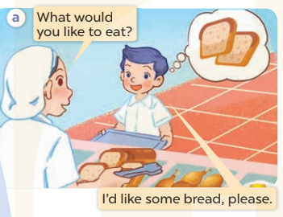  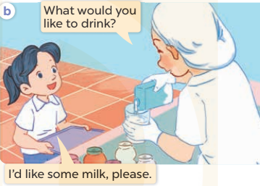  - Play the audio twice (sentence by sentence). Correct their pronunciation where necessary.  - Have Ss to practice the diaguage  - T invites a few pairs to the front of the class to practice.  - T checks pronunciation for ss.  Activity 3. Listen, point and say.  *Aims: Ss will be able to correctly use What would you like to eat / drink? - I’d like some ………,, please. to ask and answer questions about what someone would like to eat or drink.  *Procedure:  * Model sentences:  - T asks Ss look at picture b and helps Ss know the structure from the dialogue.  - T introduces new structure for Ss.  - T explains, models and gives meaning.  - Have Ss repeat the model sentences.  A: What would you like to eat / drink?  B: I’d like some bread/ milk, please  *Drill pictures  - Elicit and check comprehension the name of each character.  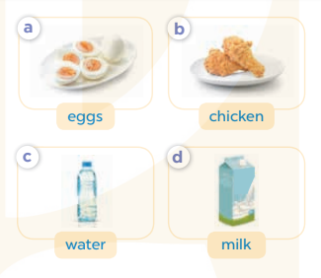  - Run through all the pictures.  - Run through model sentences.  +Run through the question sentences  +Run through the answer sentences  - Have Ss to practise:  + T asks, Ss answer picture a  + Ss ask, T answers picture b  + Group A ask, group B answer picture c  + Group B ask, group A answer picture d  - Ask Ss to work in pairs.  - T controls and corrects.  - Invite a few pairs to come to the front of the classroom, point at the relevant character in each picture, and act out his/her role.  - T gives feedbacks.  Activity 4. Let’s talk.  *Aims: Ss will be able to enhance the correct use of What would you like to eat / drink? – I’d like some …., please. to ask and answer questions about what someone would like to eat or drink.  *Procedure:  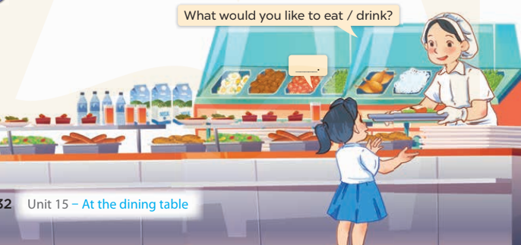  - T asks ss to attend to the picture.  + What can you see in the picture?  +Where are they?  + What would she like to eat/ drink?  - T fills the gaps and writes the sentences on the board.  - T models  - T asks Ss use of What would you like to eat / drink? – I’d like some …., please. to ask and answer (groups of four)  - Invite some groups to perform.  - Give feedbacks  *Consolidation  *Aims: Ss will be able consolidate and wrap up the content of the lesson.  *Procedure:  - T asks ss to answer the following questions:  + What have you learnt from the lesson today?  +What are the core values of the lesson? (if the teacher can take from the lesson).  - T review the vocabulary and model sentences.  - T praises some Ss who are hardworking / active/ good…. as well as encourage others to try more.  - Learn the vocabulary by heart  - Prepare the new lesson: Unit 15, Lesson 2 (4,5,6). | - Ss listen  - Ss play the game  - Ss open their books  -Ss listen and answer  - - Ss listen and repeat  + Choral repetition (3 times).  + Individual repetition (3 ss)  - Ss take note  - Ss look, remember and write  -Look at the pictures and get to know the characters in the pictures.  + In picture a: Staff asks What would you like to eat?  Nam answers I’d like some bread, please.  + In picture b: Staff asks What would you like to drink? And Mai answers I’d like some milk, please.  -Ss listen and repeat in chorus (twice)  -Ss work in pairs to practice  -Ss practice the diaguage  -Ss listen  -Ss look at the picture and answer.  -Ss listen  -Ss listen and repeat  -Ss repeat  - Ss look, listen and answer  + Picture a: some eggs  + Picture b: some chicken  + Picture c: a bottle of water  + Picture d: a box of milk  -Ss practice in chorus  - Ss practice in chorus  -Ss work in pairs to practice  -Ss listen  -Ss go to the board and role play.  -Ss listen  -Ss look at the picture and answer  + Mai is at the school canteen. A member of staff serves food like rice, bread, fish, chicken, meat, eggs, beans, and some drinks like water, milk and juice. Mai wants something to eat or drink.  -Ss note  - Ss say the completed sentences.  -Ss work in groups  -Ss perform in front of the class.  -Ss answer the questions  - Ss listen  -Ss listen and clap their hands  -Ss listen and take note

D. ADJUSTMENTS (if necessary):
………………………………………………………………………………………….…..……………………………………………………………………………...………………………………………….…..……………………………………………………………………………….……………………………………………………………………...

