Week 25 Preparing date: March 1st, 2025
Period 97 Teaching date: March 3rd, 2025

Unit 15: At the dining table
Lesson 1 (1, 2, 3)
A. OBJECTIVES:
By the end of the lesson, Ss will be able to:
1. Knowledge:
- use the words bean, fish, meat, juice in relation to the topic “Food and drinks”
- use Would you like some ………? – Yes, please. / No, thanks. To offer someone food or drinks and accept or decline someone’s offer.
-understand and correctly repeat the sentences in two communicative contexts (pictures) focusing on offering someone food or drinks and accepting or declining someone’s offer.
-correctly use Would you like some ……..? – Yes, please. / No, thanks. to offer someone food or drinks and accept or decline someone’s offer.
-enhance the correct use of Would you like some ……..? – Yes, please. / No, thanks. to offer someone food or drinks and accept or decline someone’s offer.
- Vocabulary: bean, fish, meat, juice, rice, would like
- Model sentences:
A: Would you like some rice?
B: Yes, please. / No, thanks.
- Skills: speaking and listening
2. Competences:
- Critical Thinking: talk about friends
- Co-operation: ready to help friends in pair work/ group work.
- Sociability: Talk to each other, say good words to others.
3. Attitude/ Qualities:
- Kindness: Help partners to complete learning tasks.
- Honesty: tell the truth about feelings and emotions
B. TEACHING AIDS:
- Teacher: Teacher’s guide Pages 183, audio Tracks 42, 43, website sachmem.vn, posters, laptop, pictures, textbook, lesson plan, TV or projector.
- Students: Pupil’s book Page 30, notebooks, workbooks, school things.
C. PROCEDURES:
Stages/Time | Teacher’s activities | Students’ activities
1.Warm- up:  (3’)  2. Presentation  (16’)  3.Practice: (7’)  4.Production: (7’)  5. Homework. (2’) | Game: jigsaw puzzle  *Aims: to create a friendly and active atmosphere in the class to beginning the lesson.  *Procedure:  - Divide class into 4 groups: Doreamon, Nobita, Xuka and Xeko.  - Ask Ss look at the pieces of picture.  - Ask Ss go to the board and jigsaw puzzle into the correct picture  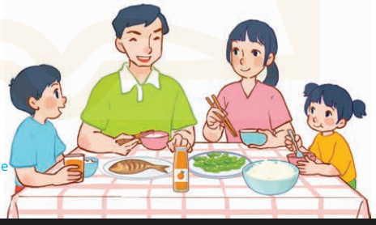  -T checks who’s the winner?  - Ask Ss look at the pieces of picture  - Say “Open your book page 30” and look at “Unit 15, Lesson 1 (1,2,3)”.  Activity 1. Vocabulary.  *Aims: Ss will be able to know the vocabulary in front of starting the new lesson.  *Procedure:  -T elicits the new words  + rice : cơm (realia)  + beans : đậu quả, hạt đậu (realia)  + fish : cá (visual)  + meat : thịt (picture)  + juice : nước hoa quả (picture)  + would like : muốn (situation)  - T models (3 times).  - T writes the words on the board.  - Checking: Rub out and remember  Activity 2. Listen, point and repeat:  *Aims: Ss will be able to understand and correctly repeat the sentences in two communicative contexts (pictures) focusing on offering someone food or drinks and accepting or declining someone’s offer.  *Procedure:  - Have Ss look at Pictures a and b and identify the characters in the pictures.  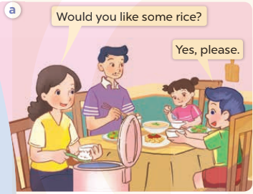  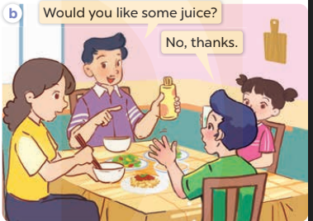  - Play the audio twice (sentence by sentence). Correct their pronunciation where necessary.  - Have Ss to practice the dialogue  - T invites a few pairs to the front of the class to practice.  - T checks pronunciation for ss.  Activity 3 Listen, point and say.  *Aims: Ss will be able to correctly use Would you like some ……? – Yes, please. / No, thanks. to offer someone food or drinks and accept or decline someone’s offer.  *Procedure:  * Model sentences:  - T asks Ss look at picture a , b and helps Ss know the structure from the dialogue.  - T introduces new structure for Ss.  - T explains, models and gives meaning.  -Have Ss repeat the model sentences.  A: Would you like some rice?  B: Yes, please. / No, thanks.  *Drill pictures  - Elicit and check comprehension the name of the rooms.  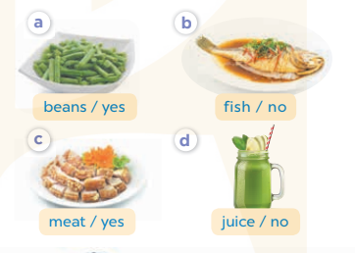  - Run through all the pictures.  - Run through model sentences.  + Run through the questions.  + Run through the answers  - Have Ss to practise:  + T says asks and Ss answer (change role).  + Ss – Ss (change role).  - Ask Ss to work in pairs.  - T controls and corrects.  - Invite a few pairs to come to the front of the classroom, point at the relevant character in each picture, and act out his/her role.  - Encourage Ss to practise speaking English.  - T gives feedbacks.  Activity 4. Let’s talk.  *Aims: Ss will be able to enhance the correct use of Would you like some ……..? – Yes, please. / No, thanks. to offer someone food or drinks and accept or decline someone’s offer.  *Procedure:  - T asks ss to guess each character and what the children say.  + What can you see in the picture?  +What food and drinks can you see on the table?  - T fills the gaps and writes the sentences on the board.  - T models  - T asks Ss to work in pairs to ask and answer  - Invite some pupils to the front of the class to present their exchanges.  - Give feedbacks  *Consolidation  *Aims: Ss will be able consolidate and wrap up the content of the lesson.  *Procedure:  - T asks ss to answer the following questions:  + What have you learnt from the lesson today?  - T review the vocabulary and model sentences.  - T praises some Ss who are hardworking / active/ good…. as well as encourage others to try more.  - Learn the number by heart  - Prepare the new lesson: Unit 15, Lesson 1 (4,5,6). | - Ss listen  - Ss play the game  - Ss open their books  -Ss listen and answer  - - Ss listen and repeat  + Choral repetition (3 times).  + Individual repetition (3 ss)  - Ss take note  - Ss look, remember and write  -Look at the pictures and get to know the characters in the pictures.  + Mother asks Would you like some rice? Nam answers Yes, please. in picture a.  + F ather asks Would you like some juice? Nam answers No, thanks. in picture b.  -Ss listen and repeat in chorus (twice)  -Ss work in pairs to practice  -Ss practice the dialogue  -Ss listen  -Ss look at the picture and answer.  -Ss listen  -Ss listen and repeat  -Ss repeat  - Ss look, listen and answer  + Picture a: beans/ yes  + Picture b: fish/ no  + Picture c: meat/ yes  + Picture d: juice/ no  -Ss practice in chorus  -Ss work in pairs to practice  -Ss point and say  -Ss listen.  -Ss listen  -Ss look at the picture and answer  +I can see a family at the dining table: father, mother, their son and daughter are having lunch.  + There some food and drinks on the table such as rice, fish, beans and juice.  -Ss note  - Ss say the completed sentences.  -Ss work in pairs  -Ss perform in front of the class.  -Ss answer the questions  - Ss listen  -Ss listen and clap their hands  -Ss listen and take note

D. ADJUSTMENTS (if necessary):
………………………………………………………………………………………….…..……………………………………………………………………………...………………………………………….…..……………………………………………………………………………….……………………………………………………………………...

