Week 21 Preparing date: January 30th , 2025
Period 82 Teaching date: February 3rd , 2025

Unit 12: Our Tet holiday
Lesson 2 (4, 5, 6)
A. OBJECTIVES:
By the end of the lesson, Ss will be able to:
1. Knowledge:
- listen to and understand four communicative contexts about where someone will go at Tet, and number the pictures
- complete two gapped exchanges with the help of picture cues
- revise the target vocabulary items and structures by playing the game Board race.
- Vocabulary: Review
- Skills: speaking, listening, reading and writing.
2. Competences:
- Communication and collaboration: work in pairs and groups to complete the learning tasks.
- Self-control and independent learning: perform listening and reading tasks.
3. Attitude/ Qualities:
- Show their pride in the traditional holiday in their country.
B. TEACHING AIDS:
- Teacher: Teacher’s guide Pages 200, 201, 202; audio Tracks 17; website hoclieu.vn, posters, laptop, pictures, textbook, lesson plan, TV or projector.
- Students: Student’s book Page 15, notebooks, workbooks, school things.
C. PROCEDURES:
Stages/ Time | Teacher’s activities | Students’ activities
1.Warm- up and review: (5’)  2.Practice: (25’)  3. Fun corner and wrap- up (5’) | Game: Pass the teddy bears  *Aims: to revise the learned sentence structures.  *Procedure:  - Give two different coloured teddy bears to two ss, a black teddy bear (ask the question) and a white teddy bear (answer the question).  - Ask ss to listen to music and pass the teddy bears.  - Stop music suddenly. Have the student with a black teddy bear make a question. Have the student with a white teddy bear answer the question.  - Repeat the game several times.  - Say “Open your book page 15” and look at “Unit 12, Lesson 2 (4,5,6)”.  Activity 1. Listen and number:  *Aims: Ss will be able to listen to and understand four communicative contexts about where someone will go at Tet and number the correct pictures.  *Procedure:  - Elicit and ask questions to elicit the home in the pictures  + What can you see in this picture?  + Where are they?  + What do they do?  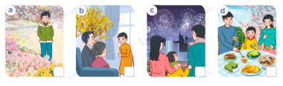  - T ask Ss to guess the answers.  + T writes Ss’guessing on the board.  - Listen to the tape:  + Play the recording  + Play the recording again for pupils to do the task.  + Play the recording a third time for pupils to check their answers.  - Get Ss to swap books with their partner, then check answers as a class.  + Write the answers on the board for Ss to correct their answers. Then checks Ss’ guessing.  - If time allows, play the recording, sentence by sentence, for Ss to listen and repeat individually and in chorus  Key: 1. b 2. a 3. d 4. c  Activity 2. Read and complete.  *Aims: Ss will be able to complete two gapped exchanges with the help of picture cues.  *Procedure:  - Have ss look at the pictures and identify the activities in the pictures.  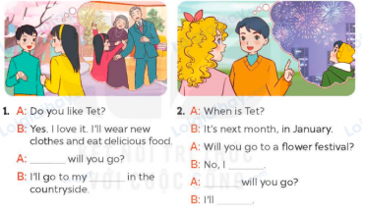  - Have Ss look at the two incomplete exchanges and elicits the missing words in the sentences.  - T models with the first gap  + Have Ss look at the picture and identify the needed information (where).  - Have Ss work in groups and complete  - Get Ss to swap books with a partner and check their answers before checking as a class.  - Invite two pairs of Ss to act out the two completed exchanges in front of the class  Key:  1. Where; grandparents’ house  2. won’t; Where; go to a fireworks show  Activity 3. Let’s play  *Aims: Ss will be able to revise the target vocabulary items and structures by playing the game Board race. *Procedure:  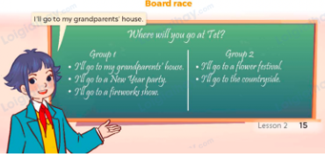  - Tell ss that they are going to play the game Board race using the language learnt in Lesson 2.  - Divide the board into two columns for Groups 1 and 2. Divide the class into two teams. Give each team a task: each member of the team should take turns to run to the board and write about where he / she will go at Tet.  - Set a time limit for ss to play the game. The team that writes the most correct sentences within the time wins.  Game: Make banh chung  - Divide the class into 2 teams: Boys and Girls  - Draw ss’ attention to the questions on the screen.  - In teams, they take turns choosing the number and looking at the picture then answer the questions. Read the question aloud and answer it. If they have the correct ones, they roll the dice and get the points.  - The team with more points wins the game. | - Ss listen  - Ss play the game  Ex:  A: Where will you go at Tet?  B: I will go to a New Year party.  - Continue playing the game.  - Ss open their books  -Look at the pictures and say:  + Picture a: a boy going to a flower festival  + Picture b: a boy visiting his grandparents at Tet  + Picture c: a boy watching a fireworks show with his parents  + Picture d: a boy having a party with his parents at Tet.  -Ss guess the answers  - Ss listen to the tape  - Ss listen again and do the task.  - Ss listen and check their answers  - Ss swap books with their partner, then check answers as a class  + Ss check the answer and the guessing  -Ss listen and repeat  -Ss look at the picture and identify the activities  -Ss look and follow the teacher demonstrating the exchange 1.  -Ss answer: (Where will you go?)  -Ss complete the sentences  -Ss swap books with a partner and check their answers before checking as a class.  -Ss read the completed exchanges aloud.  - Ss follow the teacher’s instructions  - Ss play the game  - Ss continue playing the game.  -Ss praise the winner  -Ss listen  -Ss play a game  - Ss continue playing the game.  -Ss praise the winner
D. ADJUSTMENTS (if necessary):
………………………………………………………………………………………….…..……………………………………………………………………………...…..…

