Week 14 Preparing date: December 12th, 2024
Period 57 Teaching date: December 13th, 2024

Unit 9: Our sports day
Lesson 1 (4,5,6)
A. OBJECTIVES:
By the end of the lesson, Ss will be able to:
1. Knowledge:
- use the words and phrase December, July, June, November, October, September, sports day in relation to the topic "Our sports day"
- use Is your sports day in ……..? – Yes, it is. / No, it isn’t. It’s in ……. to ask and answer questions about sports days;
- listen to and demonstrate understanding of simple exchanges in relation to the topic "Our sports day"
- Vocabulary: June, July, August.
- Skills: speaking and listening
2. Competences:
- Self-control and independent learning: perform listening tasks.
- Communication and collaboration: work in pairs or groups.
3. Attitude/ Qualities:
- Kindness: Help partners to complete learning tasks.
- Honesty: tell the truth about feelings and emotions
B. TEACHING AIDS:
- Teacher: Teacher’s guide Pages 125,126,127, audio Tracks 87, 88, website hoclieu.vn, posters, laptop, pictures, textbook, lesson plan, TV or projector.
- Students: Pupil’s book Page 62, notebooks, workbooks, school things.
C. PROCEDURES:
Stages/Time | Teacher’s activities | Students’ activities
1.Warm- up:  (5’)  2. Presentation  (16’)  3.Practice: (7’)  4.Production: (7’)  5. Homework. (2’) | Sing a song  *Aims: to create a friendly and active atmosphere in the class to beginning the lesson.  *Procedure:  https://www.youtube.com/watch?v=Fe9bnYRzFvk  - Have pupils listen and sing the song “Months of the Year”  - Say “Open your book page 62” and look at “Unit 9, Lesson 1 (1,2,3)”.  Activity 1. Vocabulary.  *Aims: Ss will be able to know the vocabulary in the new lesson.  *Procedure:  -T elicits the new words  + June : tháng 6 (situation)  + July : tháng 7 (translation)  + August :tháng 8 (situation)  - T models (3 times).  - T writes the words on the board.  - Checking: Rub out and remember  Activity 2. Look, listen and repeat:  *Aims: Ss will be able to understand and correctly repeat the sentences in two communicative contexts focusing on asking and answering questions about sports days  *Procedure:  - Have pupils look at Pictures a and b and identify the characters in the pictures.  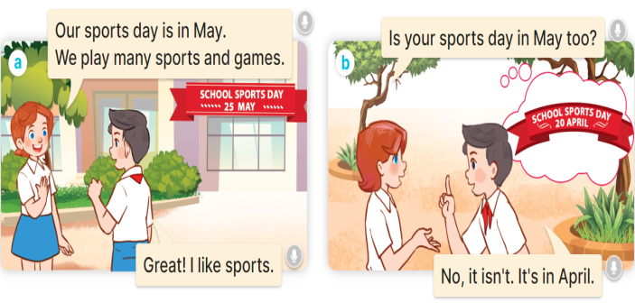  - Play the audio twice (sentence by sentence). Correct their pronunciation where necessary.  - Have Ss to practice the dialogue  - T invites a few pairs to the front of the class to practice.  - T checks pronunciation for ss.  Activity 3 Listen, point and say.  *Aims: Ss will be able to correctly say the words and use Is your sports day in …….? – Yes, it is. / No, it isn’t. It’s in …... to ask and answer questions about sports days.  *Procedure:  * Model sentences:  - T asks Ss look at picture b and helps Ss know the structure from the dialogue.  - T introduces new structure for Ss.  - T explains, models and gives meaning.  - Have Ss repeat the model sentences.  A: Is your sports day in May?  B: Yes, it is. / No, it isn’t. It’s in June  *Drill pictures  - Have pupils look at the pictures and elicit the names of the months in the pictures.  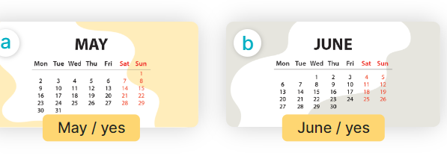  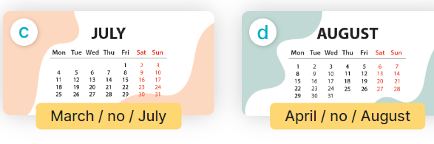  - Run through all the pictures.  - Run through model sentences.  +Run through question sentence  +Run through answer sentence  - Have Ss to practise:  + T asks, Ss answer picture a  + Ss asks, T answers picture b  + Group A ask, group B answer picture c  + Group B ask, group A answer picture d  - Ask Ss to work in pairs.  - T controls and corrects.  - Invite a few pupils to stand up, point at each school thing in the picture and say the sentence aloud.  - T gives feedbacks.  Activity 4. Let’s talk.  *Aims: Ss will be able to enhance the correct use of Is your sports day in ………? – Yes, it is. / No, it isn’t. It’s in ……... to ask and answer questions about sports days  *Procedure:  - Have Ss look at the picture and say the names of the months in the picture.  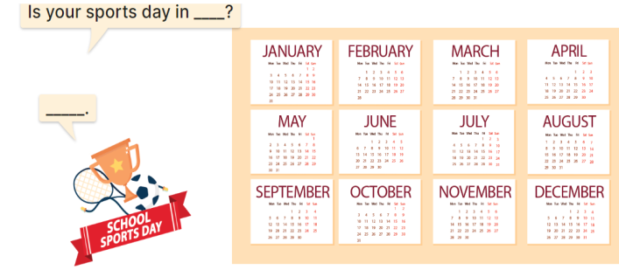  - Have pupils look at the bubbles to understand how the sentence pattern is used. - Have pupils role-play to practise asking the questions and giving their answers in pairs, using picture cues.  - Invite some pupils to practise asking and answering questions in front of the class.  - Have pupils ask and answer questions about what their friend(s) do on school sports day, using the structure learnt.  ex: What do you do on sports day? – I ……..  *Consolidation  *Aims: Ss will be able consolidate and wrap up the content of the lesson.  *Procedure:  - T asks ss to answer the following questions:  + What have you learnt from the lesson today?  +What are the core values of the lesson? (if the teacher can take from the lesson).  - T review the vocabulary and model sentences.  - T praises some Ss who are hardworking / active/ good…. as well as encourage others to try more.  - Learn the vocabulary and model sentences by heart  - Prepare the new lesson: Unit 9, Lesson 1 (4,5,6). | - Ss listen  -Ss sing and dance  -Ss open the books  -Ss listen and answer  - - Ss listen and repeat  + Choral repetition (3 times).  + Individual repetition (3 ss)  - Ss take note  - Ss look, remember and write  -Look at the pictures and say  + In picture a:  Lucy: Our sports day is in May. We play many sports and games.  Nam: Great! I like sports.  + In picture b:  Lucy: Is your sports day in May too?  Nam: No, it isn't. It's in April.  -Ss listen and repeat in chorus (twice)  -Ss work in pairs to practice  -Ss practice the dialogue  -Ss listen  -Ss look at the picture and answer.  -Ss listen  -Ss listen and repeat  -Ss repeat  - Ss look, listen and answer  + Picture a: a calendar sheet of April  + Picture b: a calendar sheet of May  + Picture c: a calendar sheet of June  + Picture d: a calendar sheet of July  -Ss listen and repeat  -Ss practice in chorus, individuals.  -Ss practice in chorus, individuals.  -Ss work in pairs  -Ss point and say  -Ss listen.  -Ss look at the picture and answer  + a picture of a sports day and calendar sheets of the months of the year.  -Ss look at the bubbles and say  -Ss work in pairs, point and ask and answer  -SS practice to ask amd amswer  -Ss ask and answer about what their friend(s) do on school sports day  -Ss answer the questions  - Ss listen  -Ss listen and clap their hands  -Ss listen and take note
D. ADJUSTMENTS (if necessary):
………………………………………………………………………………………….…..……………………………………………………………………………...………………………………………….…..……………………………………………………………………………….……………………………………………………………………...

