Week 13 Preparing date: December 4th, 2024
Period 53 Teaching date: December 6th, 2024

Unit 8: My favourite subjects
Lesson 2 (4,5,6)
A. OBJECTIVES:
By the end of the lesson, Ss will be able to:
1. Knowledge:
- – use the words and phrases art, music, PE, IT, an English teacher, a maths teacher, a painter and a singer in relation to the topic “My favourite subjects”.
– use Why do you like ……..? – Because I want to be ……... to ask for and give reasons for liking a school subject.
– listen to and demonstrate understanding of simple communicative contexts in relation to the topic “My favourite subjects”.
- Vocabulary: English teacher, maths teacher, painter
- Skills: speaking and listening
2. Competences:
- Critical Thinking: self-introduce
- Co-operation: ready to help friends in pair work/ group work.
- Sociability: Talk to each other, say good words to others.
3. Attitude/ Qualities:
- Kindness: Help partners to complete learning tasks.
- Honesty: tell the truth about feelings and emotions
B. TEACHING AIDS:
- Teacher: Teacher’s guide Pages 116, 117, 118, audio Tracks 81, 82, website hoclieu.vn, posters, laptop, pictures, textbook, lesson plan, TV or projector.
- Students: Pupil’s book Page 58, notebooks, workbooks, school things.
C. PROCEDURES:
Stages/Time | Teacher’s activities | Students’ activities
1.Warm- up:  (3’)  2. Presentation  (16’)  3.Practice: (7’)  4.Production: (7’)  5. Homework. (2’) | Pass the subjects  *Aims: to create a friendly and active atmosphere in the class to beginning the lesson.  *Procedure:  - Review the previous lesson by having the class pass the school things with the music.  - When the music stops, who have subjects have to say the sentence: I like music.  - Say “Open your book page 52” and look at “Unit 8, Lesson 2 (1, 2, 3)”.  Activity 1. Vocabulary.  *Aims: Ss will be able to know the vocabulary in the new lesson.  *Procedure:  -T elicits the new words  + English teacher : giáo viên tiếng anh (example)  + maths teacher: giáo viên Toán (example)  + painter :họa sĩ (example)  - T models (3 times).  - T writes the words on the board.  - Checking: Rub out and remember  Activity 2. Look, listen and repeat:  *Aims: Ss will be able to understand and correctly repeat the sentences in two communicative contexts focusing on asking for and giving reasons for liking a school subject, English.  *Procedure:  - Have Ss look at Pictures a and b and identify the characters and the reason why Nam likes English. 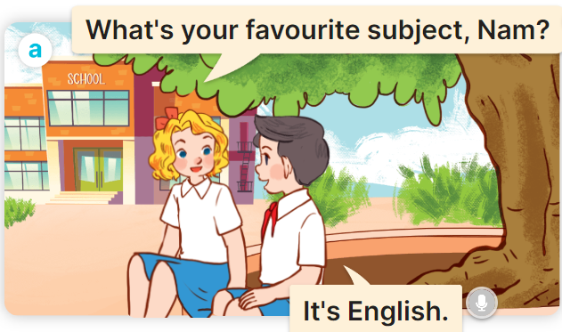  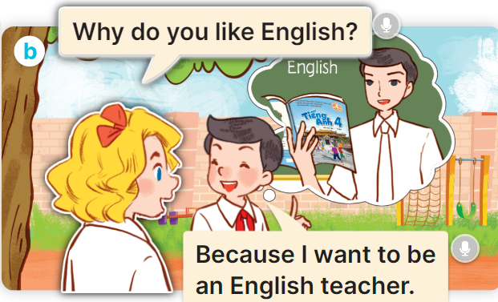  - Play the audio twice (sentence by sentence). Correct their pronunciation where necessary.  - Have Ss to practice the dialogue  - T invites a few pairs to the front of the class to practice.  - T checks pronunciation for ss.  Activity 3 Listen, point and say.  *Aims: Ss will be able to correctly say the words and phrases and use Why do you like …….? – Because I want to be ……. to ask for and give reasons for liking a school subject, English.  *Procedure:  * Model sentences:  - T asks Ss look at picture b and helps Ss know the structure from the dialogue.  - T introduces new structure for Ss.  - T explains, models and gives meaning.  -Have Ss repeat the model sentences.  A: Why do you like English.?  B: Because I want to be an English teacher  *Drill pictures  - Have Ss look at the pictures and elicit the reason why each pupil likes his / her favourite subject.  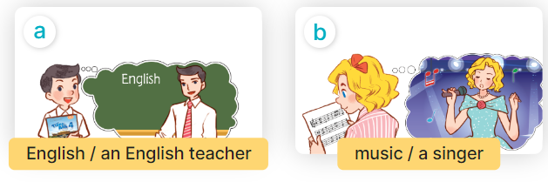  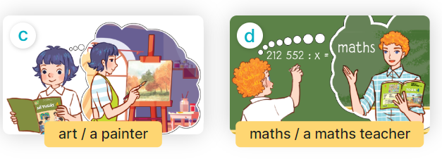  - Run through all the pictures.  - Run through model sentences.  +Run through question sentence  +Run through answer sentence  - Have Ss to practise:  + T asks, Ss answer picture a  + Ss asks, T answers picture b  + Group A ask, group B answer picture c  + Group B ask, group A answer picture d  - Ask Ss to work in pairs.  - T controls and corrects.  - Invite a few pairs to come to the front of the classroom and point at the pictures and say the questions and answers in front of the class.  - T gives feedbacks.  4.Production: (7’)  Activity 4. Let’s talk.  *Aims: Ss will be able to enhance the correct use of Why do you like …….? – Because I want to be …….. ask for and give reasons for liking a school subjects in a freer context.  *Procedure:  - Have pupils look at the picture and explain that a group of four pupils are in the playground  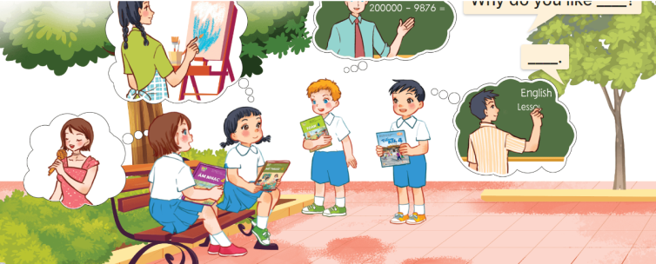  - Ask pupils to look at the first girl with black hair with the art textbook and ask pupils to identify her favourite subject (art) and what she want to be in the future (painter).  - Divide the class into two groups to role-play the girls/ boys and an interviewer.  - Have pupils work in pairs to practise asking and answering the question  Why do you like……? – ……...  - Invite pairs of pupils to the front of the classroom to take turns asking for and giving reasons why they like the subject.  *Consolidation  *Aims: Ss will be able consolidate and wrap up the content of the lesson.  *Procedure:  - T asks ss to answer the following questions:  + What have you learnt from the lesson today?  +What are the core values of the lesson? (if the teacher can take from the lesson).  - T review the vocabulary and model sentences.  - T praises some Ss who are hardworking / active/ good…. as well as encourage others to try more.  - Learn the vocabulary and model sentences by heart  - Prepare the new lesson: Unit 8, Lesson 2 (4,5,6). | - Ss listen  - Ss play game  -Ss open their books  -Ss listen and answer  - - Ss listen and repeat  + Choral repetition (3 times).  + Individual repetition (3 ss)  - Ss take note  - Ss look, remember and write  -Look at the pictures and say  + In picture a:  Mary: What’s your favourite subject, Nam?  Nam: It’s English  + In picture b:  Mary: Why do you like English?  Nam: Because I want to be an English teacher.  -Ss listen and repeat in chorus (twice)  -Ss work in pairs to practice  -Ss practice the dialogue  -Ss listen  -Ss look at the picture and answer.  -Ss listen  -Ss listen and repeat  -Ss repeat  - Ss look, listen and answer  + Picture a: English / an English teacher  + Picture b: music / a singer  + Picture c: art / a painter  + Picture d: maths / a maths teacher  -Ss listen and repeat  -Ss practice in chorus  -Ss practice in chorus  -Ss work in pairs to practice  -Ss point and say  -Ss listen.  -Ss look at the picture and answer  + Four pupils with textbooks in hand asking each other for and giving reasons for liking a school subject  -Ss look at the picture and answer  -Ss work in groups to ask and answer.  -SS ask and answer  -Ss answer the questions  - Ss listen  -Ss listen and clap their hands  -Ss listen and take note
D. ADJUSTMENTS (if necessary):
………………………………………………………………………………………….…..……………………………………………………………………………...…………

