Week 17 Preparing date: January 1st, 2025
Period 69 Teaching date: January 3rd, 2025
Review 2
Parts 1, 2
A. OBJECTIVES:
By the end of the lesson, Ss will be able to:
1. Knowledge:
- correctly use the following sentence patterns:
Where’s your school? – It’s in the …...
How many ….. are there at your school? – There is / are …………
What subjects do you have today? – I have ………..
When do you have……….. – I have it on ………..
What’s your favourite subject? – It’s ………
Why do you like ……….? – Because I want to be ………..
Is your sports day in ……….? – Yes, it is. / No, it isn't. It's in ……………
When's your sports day? – It's in ………..
Were you ……..last weekend? – Yes, I was. / No, I wasn't.
Where were you last summer? – I was in ………
- Vocabulary: Review
- Skills: speaking, listening, reading and writing.
2. Competences:
- Co-operation: ready to help friends in pair work/ group work.
- Self-control and independent learning: perform listening tasks.
3. Attitude/ Qualities:
- Kindness: Help partners to complete learning tasks.
- Diligence: complete learning tasks.
B. TEACHING AIDS:
- Teacher: Teacher’s guide Pages 151,152; Track 107, website hoclieu.vn, posters, laptop, pictures, textbook, lesson plan, TV or projector.
- Students: Pupil’s book Page 74, notebooks, workbooks, school things.
C. PROCEDURES:

Stages/Time | Teacher’s activities | Students’ activities
1.Warm- up: (5’)  2.Practice: (27’)  3. Homework. (3’) | Game: Whispering  *Aims: to review the vocabulary and structure about greet and respond to greetings.  *Procedure:  - Divide class into 2 groups.  -Ask 5 Ss in each group stand in a straight line.  - T says a word or phrase to the first pupil in this line.  - Then, the first pupil whispers what she/ he hear to the second person in line; the second one whispers what he/ she hears to the third one and so on until the last pupil in group hears the word or phrase.  - The last pupil says the word or phrase out loud.  - The faster group has correct word or phrase is the winner.  - Say “Open your book page 74” and look at Review 2.  Activity 1. Listen and tick:  *Aims: Ss will be able to listen to and understand five communicative contexts in which characters talk about familiar topics such as our school, our timetable, my favourite subjects, our sports day, our summer holidays and tick the correct pictures.  *Procedure:  - Elicit the words or phrases to describe the pictures in each option.  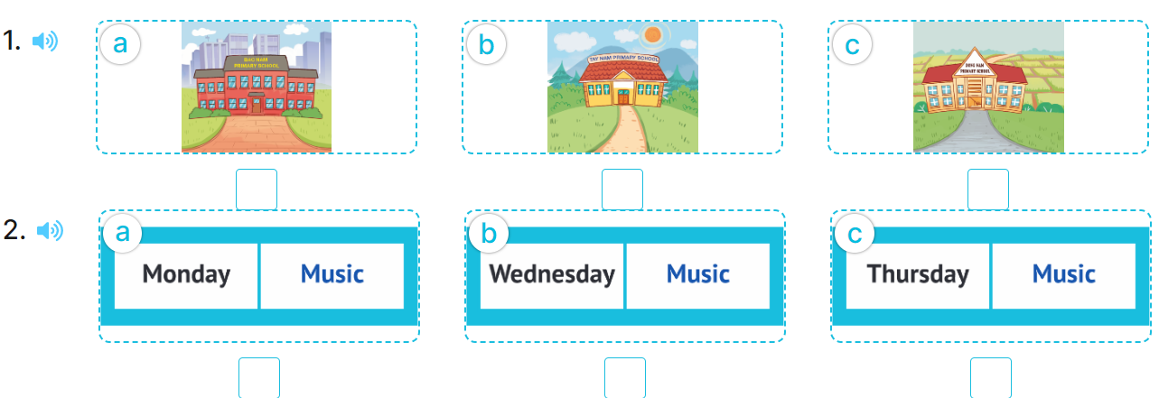  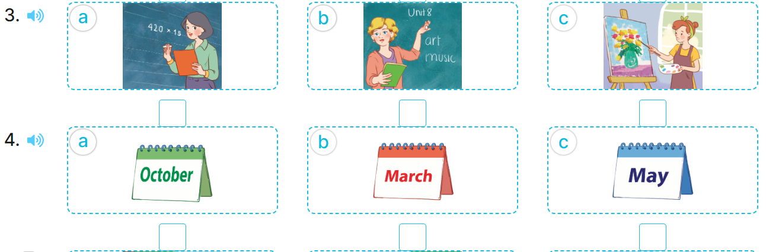  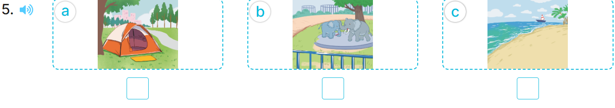  - T ask Ss to guess the answers.  + T writes Ss’guessing on the board.  - Listen to the tape:  + Play the recording  + Play the recording again and get Ss to swap books with their partners.  + Play the recording again to check answers together as a class.  + Write the answers on the board for Ss to correct their answers. Then checks Ss’ guessing.  - Play the recording, sentence by sentence, for the class to listen and repeat in chorus.  Key: 1. b 2. c 3. b 4. c 5. b  Activity 2. Ask and answer  *Aims: Ss will be able to ask and answer questions using picture cues or personal information.  *Procedure:  - Elicit the content and context of each picture.  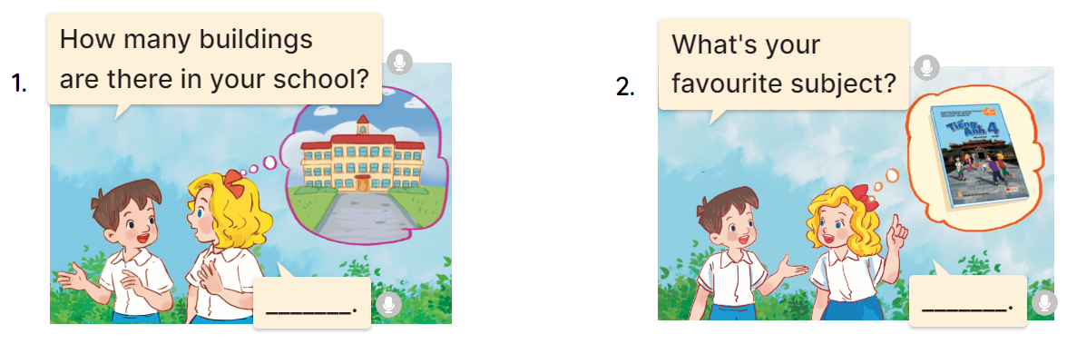  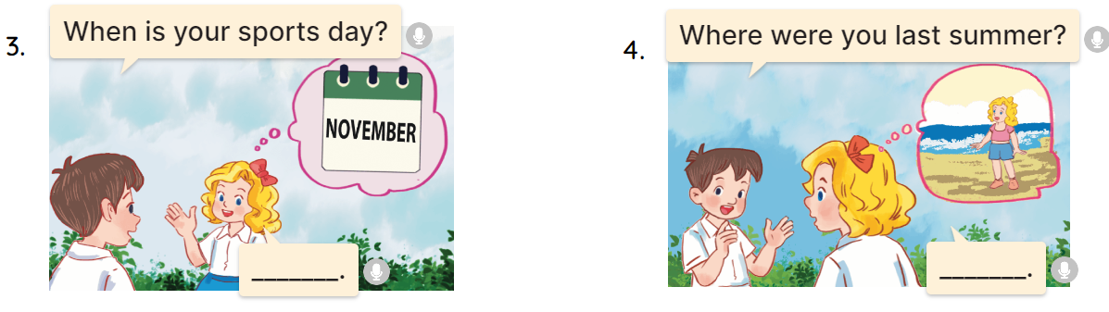  - Draw pupils’ attention to the first question and read it in chorus.  - Elicit the answer and give feedback.  - Have pupils to role-play the exchange.  - Give pupils role-play the four exchanges.  - Invite a few pairs of pupils to stand up and take it in turns to role-play the target exchanges.  * Game: Play game (ppt)  - Play the game “chain game”.  + Divide the class into a lot of groups. There are four or five pupils in each group.  + T says a sentence. Then, the first pupil repeats teacher’s sentence and adds to it. Next, the second pupil repeats what the first pupil has said and adds to it, ect.  - T gives feedback by a game  *Consolidation  *Aims: Ss will be able consolidate and wrap up the content of the lesson.  *Procedure:  - T asks ss to answer the following questions:  + What have you learnt from the lesson today?  +What are the core values of the lesson?  - T praises some Ss who are hardworking / active/ good…. as well as encourage others to try more.  - Prepare the new lesson: review 2 (3,4,5) | - Ss listen  -Ss play game  - Ss open their books  -Look at the pictures and say:  + Picture 1a. a school in a city  + Picture 1b. a school in the mountains  + Picture 1c. a school in a village  + Picture 2a. a timetable having music on Monday  + Picture 2b. a timetable having music on Wednesday  + Picture 2c. a timetable having music on Thursday  + Picture 3a. a Math teacher  + Picture 3b. an English teacher  + Picture 3c. a painter  + Picture 4a. a calendar of October  + Picture 4b. a calendar of March  + Picture 4c. a calendar of May  + Picture 5a. a tent  + Picture 5b. a zoo  5c. a beach  -Ss guess the answers  - Ss listen to the tape and tick  - Ss listen again, tick and swap books with their partners.  - Ss check their answers and guessing  -Ss listen and repeat.  -Look at the pictures  -Ss pay attention and read  - Ss answer the question  - Ss ask and answer  - Ss ask and answer  -Ss role play  -Ss listen and play game  -Ss listen and answer  -Ss listen and clap their hands  -Ss listen and take note
D. ADJUSTMENTS (if necessary):
………………………………………………………………………………………….…..………………………………………………………

