Week 17 Preparing date: December 29th, 2024
Period 66 Teaching date: December 30th, 2024

Unit 10: Our summer holidays
Lesson 2 (4, 5, 6)
A. OBJECTIVES:
By the end of the lesson, Ss will be able to:
1. Knowledge:
- use the phrases Bangkok, London, Sydney and Tokyo in relation to the topic “Our summer holidays”
- someone was in the past; listen to and demonstrate understanding of simple communicative contexts in relation to the topic “Our summer holidays”.
- Vocabulary: Review
- Skills: speaking, listening, reading and writing.
2. Competences:
- Critical Thinking: look, complete and read
- Co-operation: ready to help friends in pair work/ group work.
- Self-control and independent learning: perform listening tasks.
3. Attitude/ Qualities:
- Honesty: tell the truth about feelings and emotions.
- Diligence: complete learning tasks.
B. TEACHING AIDS:
- Teacher: Teacher’s guide Pages 145, 146; audio Tracks 103; website hoclieu.vn, posters, laptop, pictures, textbook, lesson plan, TV or projector.
- Students: Pupil’s book Page 71, notebooks, workbooks, school things.
C. PROCEDURES:
Stages/Time | Teacher’s activities | Students’ activities
1.Warm- up:  (5’)  2.Practice: (27’)  3. Homework. (3’) | Game: Who says fast?  *Aims: to create a friendly and active atmosphere in the class to beginning the lesson.  *Procedure:  - Hold a places card, then reveal it slowly.  - Ask Where was you last summer?  - Ask the Ss guess the answer as fast as possible.  - Then have Ss do the same with the rest.  - This can be played in groups to make it more interesting.  - Say “Open your book page 71” and look at “Unit 10, Lesson 2 (4,5,6)”.  Activity 1. Listen and match:  *Aims: Ss will be able to listen to and understand four communicative contexts about where someone was in the past and match the correct pictures.  *Procedure:  - Elicit the action of the character in each picture.  + Who are they?  + Which places are they?  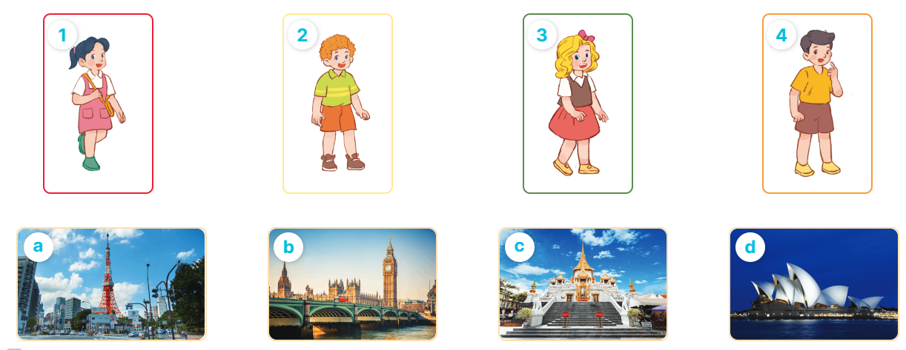  - T ask Ss to guess the answers.  + T writes Ss’guessing on the board.  - Listen to the tape:  + Play the recording  + Play the recording again and get Ss to swap books with their partners.  + Play the recording again to check answers together as a class.  + Write the answers on the board for Ss to correct their answers. Then checks Ss’ guessing.  - Play the recording, sentence by sentence, for the class to listen and repeat in chorus.  Key: 1. d 2. c 3. a 4. b  Activity 2. Look, complete and read  *Aims: Ss will be able to complete two gapped dialogues with the help of picture cues.  *Procedure:  - Get Ss to look at the pictures and identify the characters and the places in the pictures.  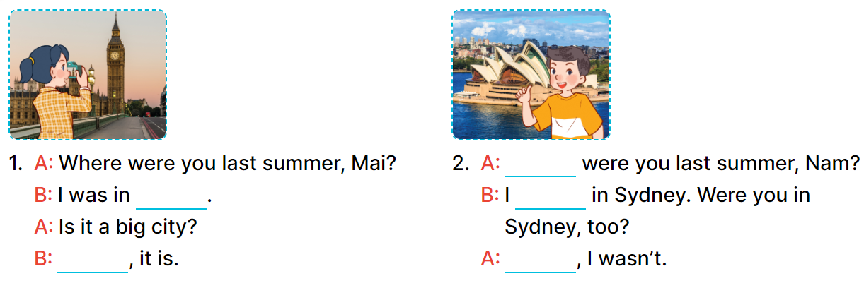  - Have Ss look at the first sentence and the pictures. Elicit and model with number 1: I was in London.  + Ask Ss read and complete the sentence.  -Have Ss work in pairs and complete the other gaps  - Ask a few Ss to stand up and read the sentences aloud.  -T gives feedbacks.  Key:  1. London, Yes 2. Where, was, No  Activity 3. Let’s play  *Aims: Ss will be able to review target words to make sentences about where someone was in the past by playing the game Making sentences.  *Procedure:  - Tell pupils that they are going to play the game Making sentences in groups of four or five.  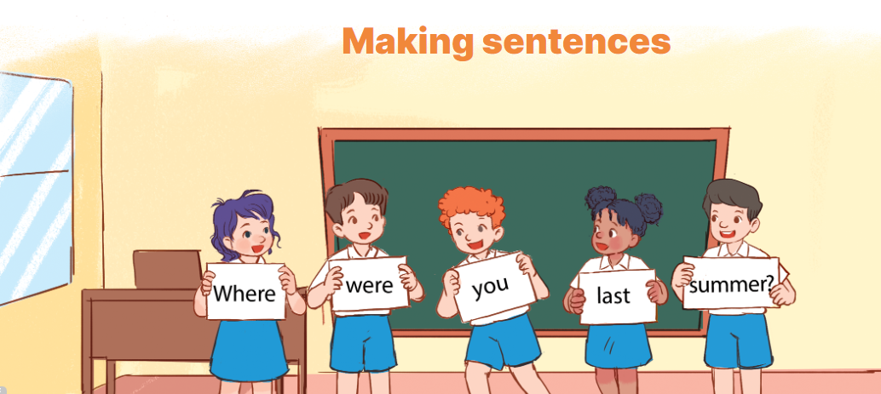  - Nominate one pupil in each group as a leader.  + The leader says a sentence and the other group members have to stand in a line, holding the word cards to make a sentence. Example: Where were you last summer?  - Have pupil work in groups to play the game.  - Invite two groups to the front of the class to play the game.  - Have the class give comments and announce the winner.  - The group that makes most correct sentences will win.  *Consolidation  *Aims: Ss will be able consolidate and wrap up the content of the lesson.  *Procedure:  - T asks ss to answer the following questions:  + What have you learnt from the lesson today?  +What are the core values of the lesson? (if the teacher can take from the lesson).  - T praises some Ss who are hardworking / active/ good…. as well as encourage others to try more.  - Practice part 5 again.  - Prepare the new lesson: Unit 10, Lesson 3 (1,2,3). | - Ss listen  - Ss play game  -Ss play game  - Ss open their books  -Look at the pictures and say:  1. Mai 2. Bill 3. Mary 4. Nam  + Picture a. Tokyo Tower  + Picture b. Big Ben  + Picture c. Temple of the Golden Buddha  + Picture d. Opera House  -Ss guess the answers  - Ss listen to the tape and match  - Ss listen again, match and swap books with their partners.  -Ss listen again and check together  - Ss check their answers and guessing  -Ss listen and repeat.  -Ss look at the picture and say  -Ss look and answer  -Ss read and complete  -Ss work in pairs and do the task  -Ss read aloud  -Ss listen and pay attention  -Ss listen  - Ss listen  -Ss play the game  - Ss play the game  -Ss answer the questions  -Ss listen and clap their hands  -Ss listen and take note
D. ADJUSTMENTS (if necessary):
………………………………………………………………………………………….…..……………………………………………………………………………...………………………………………….…..……………………………………………………………………………….……………………………………………………………………...

