Week 12 Preparing date: November 25th, 2024
Period 48 Teaching date: November 27th, 2024

Unit 7: Our timetables
Lesson 2 (4, 5, 6)
A. OBJECTIVES:
By the end of the lesson, Ss will be able to:
1. Knowledge:
- Identify the specific information by listening 2 conversations about school timetable to tick the correct pictures.
- Using clue pictures to complete the gaps;
- Perform the song “What subjects do you have today?” in interesting ways, using appropriate and meaningful gestures.
- Vocabulary: Review
- Skills: speaking, listening, reading and writing.
2. Competences:
- Co-operation: ready to help friends in pair work/ group work.
- Self-control and independent learning: perform listening tasks.
3. Attitude/ Qualities:
- Show their responsibility to follow the timetable and prepare their subjects before school.
B. TEACHING AIDS:
- Teacher: Teacher’s guide Pages 106,107; audio Tracks 72; website hoclieu.vn, posters, laptop, pictures, textbook, lesson plan, TV or projector.
- Students: Pupil’s book Page 53, notebooks, workbooks, school things.
C. PROCEDURES:
Stages/Time | Teacher’s activities | Students’ activities
1.Warm- up:  (5’)  2.Practice: (27’)  3. Homework. (3’) | Game: Slap the board  *Aims: to create a friendly and active atmosphere in the class to beginning the lesson.  *Procedure:  - Divide class into 2 groups  - How to play:  + Each group chooses five Ss to play.  + Class will read aloud.  + Look at the picture, listen and slap the picture you heard.  + Who faster will get 1 mark.  + Which group with higher mark is the winner.  - T gives feedback.  - Say “Open your book page 53” and look at “Unit 7, Lesson 2 (4,5,6)”.  Activity 1. Listen and tick:  *Aims: Ss will be able to listen to and understand two communicative contexts in which pupils ask and answer questions about timetables and tick the correct pictures  *Procedure:  - Ask pupils to look at Pictures 1a and 1b and identify a part of the timetables and the subject.  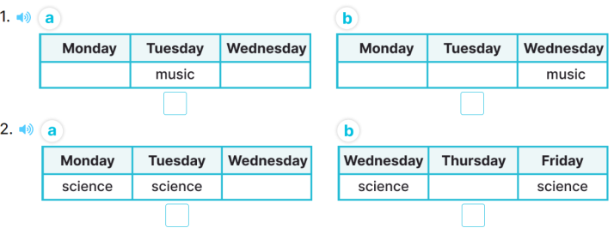  - T ask Ss to guess the answers.  + T writes Ss’guessing on the board.  - Listen to the tape:  + Play the recording  + Play the recording again and get Ss to swap books with their partners.  + Play the recording again to check answers together as a class.  + Write the answers on the board for Ss to correct their answers. Then checks Ss’ guessing.  - Play the recording, sentence by sentence, for the class to listen and repeat in chorus.  Key: 1. a 2. B  Activity 2. Look, complete and read  *Aims: Ss will be able to complete two gapped exchanges with the help of picture cues.  *Procedure:  - Have pupils read the sentences and guess the missing words  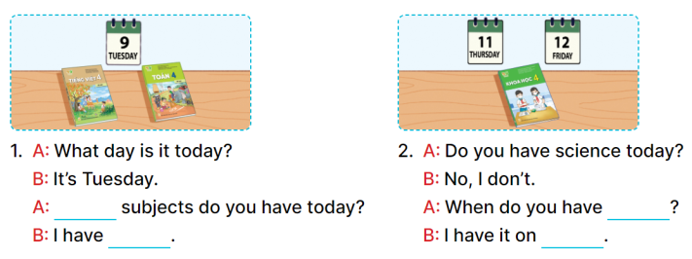  - Model the first gapped exchange.  - Elicit the names of the subjects that can be used to fill in the gaps (What, Vietnamese and maths).  - Give pupils look at the picture and fill in the gaps independently.  - Get pupils to swap books with a partner and check their answers before checking as a class.  - Invite one pupil to write the answers on the board.  - Invite four pairs of pupils to act out the complete exchanges in front of the class.  Key:  1. What, Vietnamese and maths  2. science, Thursday and Friday  Activity 3. Let’s sing  *Aims: Ss will be able to sing the song When subjects do you have today? with the correct pronunciation, rhythm, and melody.  *Procedure:  - Introduce the title and lyrics of the song: “ What subjects do you have today?”  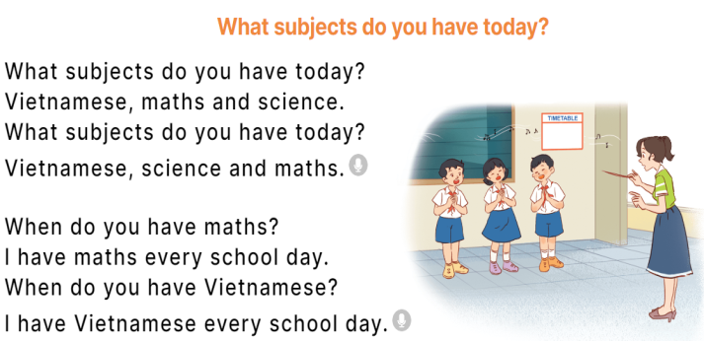  - Play the recording for Ss to listen to the whole song.  + Have them repeat the title and lyrics line by line.  + Tell Ss to point at the pictures while singing.  - Play the recording all the way through for Ss to listen to pronunciation and melody of the song.  - Play the recording line by line for Ss to listen, repeat and point to the pictures  - Play the recording for Ss to sing and do actions.  - Ask Ss to practice singing and doing actions in pairs or groups.  - Invite groups to the front of the classroom to perform the song  -T gives feedback.  *Consolidation  *Aims: Ss will be able consolidate and wrap up the content of the lesson.  *Procedure:  - T asks ss to answer the following questions:  + What have you learnt from the lesson today?  +What are the core values of the lesson? (if the teacher can take from the lesson).  - T praises some Ss who are hardworking / active/ good…. as well as encourage others to try more.  - Prepare the new lesson: Unit 7, Lesson 3 (1,2,3). | - Ss read the words  - Ss play game  -Ss play game  - Ss open their books  -Look at the pictures and say:  + Picture 1a. A part of the timetable in which music is taught on Tuesdays  + Picture 1b. A part of the timetable in which music is taught on Wednesdays  + Picture 2a. A part of the timetable in which science is taught on Wednesdays and Thursdays  + Picture 2b. A part of the timetable in which science is taught on Wednesdays and Fridays  -Ss guess the answers  - Ss listen to the tape and tick  - Ss listen again, tick and swap books with their partners.  -SS listen again and check  - Ss check their answers and guessing  -Ss listen and repeat.  -Ss look at the picture and say  -Ss look and pay attention  -Ss answer  -Ss say and fill in the gaps  -Ss work in pairs and swap books and check  -Ss write on the board  -SS ask and asnwer  - Ss listen  -Ss listen to the song  - Ss listen and repeat line by line without the action.  -Ss point to the pictures while singing  -Ss listen to melody of the song  - Ss listen and sing line by line.  - Ss sing and do actions.  + Ss work in groups (two groups) to sing.  -Ss perform in front of the class.  -Ss listen  -Ss answer the questions  -Ss listen and clap their hands  -Ss listen and take note
D. ADJUSTMENTS (if necessary):
…………………………………………………………………………………………………………………………………………………………………………………….……

