Week 12 Preparing date: November 23rd, 2024
Period 47 Teaching date: November 26th, 2024

Unit 7: Our timetables
Lesson 2 (1, 2, 3)
A. OBJECTIVES:
By the end of the lesson, Ss will be able to:
1. Knowledge:
- Identify the situation between Nam and Lucy (setting, participants, topic).
- Use the word “art, music, science” in relation to topic “school subjects” to talk about school timetable.
- Use sentence pattern “When do you have….? I have it on……..” to ask and answer about school timetable.
- Vocabulary: art, music, history and geography.
- Skills: speaking and listening
2. Competences:
- Critical Thinking: self-introduce
- Co-operation: ready to help friends in pair work/ group work.
- Sociability: Talk to each other, say good words to others.
3. Attitude/ Qualities:
- Kindness: Help partners to complete learning tasks.
- Honesty: tell the truth about feelings and emotions
B. TEACHING AIDS:
- Teacher: Teacher’s guide Pages 104,105, audio Tracks 71, 72, website hoclieu.vn, posters, laptop, pictures, textbook, lesson plan, TV or projector.
- Students: Pupil’s book Page 52, notebooks, workbooks, school things.
C. PROCEDURES:
Stages/Time | Teacher’s activities | Students’ activities
1.Warm- up:  (3’)  2. Presentation  (16’)  3.Practice: (7’)  4.Production: (7’)  5. Homework. (2’) | Matching game  *Aims: to create a friendly and active atmosphere in the class to beginning the lesson.  *Procedure:  - Using pictures and flashcards, get 3 pupils hold the pictures and 3 more hold the sentences.  - Ask them to find and match. Praise the ones who finish the matching.  - Then ask the class to look and say aloud.  - Say “Open your book page 52” and look at “Unit 7, Lesson 2 (1,2,3)”.  Activity 1. Vocabulary.  *Aims: Ss will be able to know the vocabulary in the new lesson.  *Procedure:  -T elicits the new words  + art : môn Mĩ thuật (realia)  + music : môn Âm nhạc (realia)  + history and geography :môn lịch sử và địa lý (realia)  - T models (3 times).  - T writes the words on the board.  - Checking: Rub out and remember  Activity 2. Look, listen and repeat:  *Aims: Ss will be able to understand and correctly repeat the sentences in two communicative contexts in which characters ask and answer questions about a school timetable.  *Procedure:  - Ask pupils to look at Pictures a and b and identify the characters.  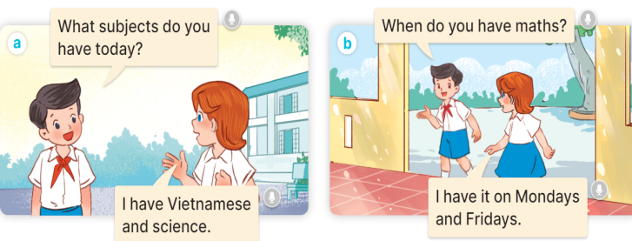  - Play the audio twice (sentence by sentence). Correct their pronunciation where necessary.  - Have Ss to practice the dialogue  - T invites a few pairs to the front of the class to practice.  - T checks pronunciation for ss.  Activity 3 Listen, point and say.  *Aims: Ss will be able to correctly say the words and use When do you have ………? – I have it on …….. to ask and answer questions about a timetable.  *Procedure:  * Model sentences:  - T asks Ss look at picture b and helps Ss know the structure from the dialogue.  - T introduces new structure for Ss.  - T explains, models and gives meaning.  - Have Ss repeat the model sentences.  A: When do you have Art?  B:I have it on Monday.  *Drill pictures  - Have Ss look at the pictures and identify the subjects and days of week  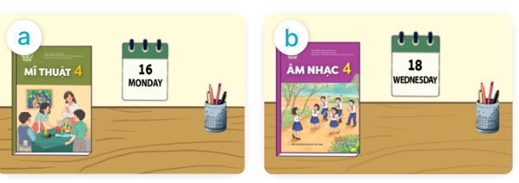  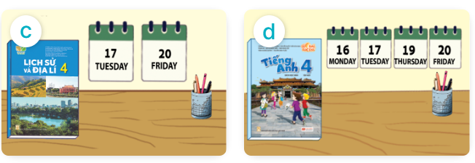  - Run through all the pictures.  - Run through model sentences.  - Have Ss to practise:  + T asks, Ss answer picture a  + Ss ask, T answers picture b  + Group A ask, group B answer picture c  + Group B ask, group A answer picture d  - Ask Ss to work in pairs.  - T controls and corrects.  - Invite a few pairs to come to the front of the classroom and point at the pictures and say the questions and answers in front of the class.  - T gives feedbacks.  Activity 4. Let’s talk.  *Aims: Ss will be able to enhance the correct use of When do you have ……? – I have it on ………. to ask and answer questions about a timetable in a freer context  *Procedure:  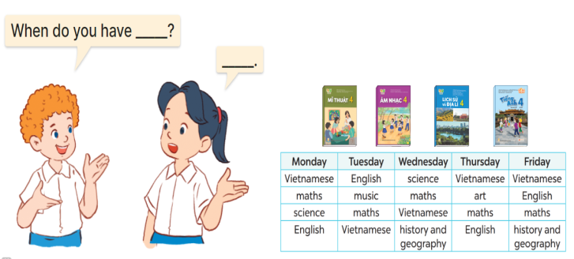  - Have Ss look at the picture and elicit the question and the answer in context.  + Who are they?  + What are they talking about?  - Elicit the missing words and write them on the board. Get pupils to say the completed sentences.  - Put Ss work in pairs to give and respond to instructions.  - Invite some pairs of Ss to the front of the class to ask and answer.  *Consolidation  *Aims: Ss will be able consolidate and wrap up the content of the lesson.  *Procedure:  - T asks ss to answer the following questions:  + What have you learnt from the lesson today?  +What are the core values of the lesson? (if the teacher can take from the lesson).  - T review the vocabulary and model sentences.  - T praises some Ss who are hardworking / active/ good…. as well as encourage others to try more.  - Learn the vocabulary and model sentences by heart  - Prepare the new lesson: Unit 7, Lesson 2 (4,5,6). | - Ss listen and matching  -Ss play game  - Ss open their books  -Ss listen and answer  - - Ss listen and repeat  + Choral repetition (3 times).  + Individual repetition (3 ss)  - Ss take note  - Ss look, remember and write  -Look at the pictures and say  + In picture a:  Nam: What subjects do you have today? Lucy: I have Vietnamese and science  + In picture b:  Nam: When do you have maths?  Lucy: I have it on Mondays and Fridays  -Ss listen and repeat in chorus (twice)  -Ss work in pairs to practice  -Ss practice the dialogue  -Ss listen  -Ss look at the picture and answer.  -Ss listen  -Ss listen and repeat  -Ss repeat  - Ss look, listen and answer  + Picture a: An art textbook and a calendar displaying Monday  + Picture b: A music textbook and a calendar displaying Wednesday.  + Picture c: A science textbook and two calendars displaying Tuesday and Friday.  + Picture d: An English textbook and three calendars displaying Monday, Tuesday and Thursday  -Ss listen and repeat  -Ss practice in chorus  -Ss practice in chorus  -Ss work in pairs to practice  -Ss point and say  -Ss listen.  -Ss look at the picture and answer  + a boy and a girl talking about a timetable  -Ss listen and answer  -Ss work in pairs  -Ss ask and answer  -Ss answer the questions  - Ss listen  -Ss listen and clap their hands  -Ss listen and take note
D. ADJUSTMENTS (if necessary):
………………………………………………………………………………………….…..……………………………………………………………………………...………………………………………….…..……………………………………………………………………………….……………………………………………………………………...

