Week 20 Preparing date: January 19th, 2025
Period 76 Teaching date: January 21st, 2025

Unit 11: My home
Lesson 3 (4, 5, 6)
A. OBJECTIVES:
By the end of the lesson, Ss will be able to:
1. Knowledge:
- Identify the specific information by scanning the text and circle the correct answers.
- Write about a student’s home.
- Present picture to the class at the Project time.
- Vocabulary: Review
- Skills: speaking, listening, reading and writing.
2. Competences:
- Co-operation: ready to help friends in pair work/ group work.
- Self-control and independent learning: perform reading tasks.
3. Attitude/ Qualities:
-Show their pride about their places/ address.
B. TEACHING AIDS:
- Teacher: Teacher’s guide Pages 168, 169, website hoclieu.vn, posters, laptop, pictures, textbook, lesson plan, TV or projector.
- Students: Pupil’s book Page 11, notebooks, workbooks, school things.
C. PROCEDURES:
Stages/Time | Teacher’s activities | Students’ activities
1.Warm- up: (5’)  2.Practice: (8’)  3.Production: (19’)  4. Homework. (3’) | Game: Spin the wheel  *Aims: to review the vocabulary and structure about greet and respond to greetings.  *Procedure:  - Have Ss spin the wheel and say the words with the target sound  - Say “Open your book page 11” and look at “Unit 11, Lesson 3 (4, 5, 6)”.  Activity 1. Read and circle:  *Aims: Ss will be able to read and show the understanding of the text by circling the correct options to fill in the blanks.  *Procedure:  - Explain and check comprehension.  - Model sentence 1.  +First, have Ss read Sentence 1 and decide what information they need to find in the text.  + Then, have them read the text carefully and find the information about the flat where the writer lives to decide if option a or b is correct.  + Circle the correct option.  - Ask Ss to do the task independently.  - Get Ss to swap their books with a partner and check their answers before checking as a class.  - Invite one or two pupils to read the text in front of the class.  Key: 1. b 2.a 3.b 4.a  Activity 2. Let’s write  *Aims: Ss will be able to use the target language to complete a gapped text about the place where pupils live.  *Procedure:  - Explain to the class the goal of this activity.  - Ask Ss to read each gapped sentence, guess the missing information and complete the sentence with their own personal information.  - Give Ss time to write their answers  - Ask Ss to swap and correct their answers in pairs.  - Check the answers as a class.  Key: Pupils’ answer.  Example: I live in a small house with my parents. It is in Nghia Lam Village. It is big. There are not manyvbuilding there, but there are a lot of trees, flowers and it has fresh air. I love my house.  Activity 3. Project.  *Aims: Ss will be able to draw a picture of the place where they live and present it to the class, using the target language.  *Procedure:  - Explain the goal of this activity to Ss.  - Point at the picture and explain what they should do to complete the project.  - Tell Ss to work in groups.  - Give the class time to introduce about your beautiful home.  +Example: I live in a small house with my parents. It is in Nghia Lam Village. It is big. There are not manyvbuilding there, but there are a lot of trees, flowers and it has fresh air. I love my house.  - Invite some Ss to show their pictures to the class and tell the class.  *Consolidation  *Aims: Ss will be able consolidate and wrap up the content of the lesson.  *Procedure:  - T asks ss to answer the following questions:  + What have you learnt from the lesson today?  +What are the core values of the lesson?  - T praises some Ss who are hardworking / active/ good…. as well as encourage others to try more.  - Prepare the new lesson: Unit 12: Lesson 1 (1,2,3). | - Ss listen and play the game  - Ss open their books  -Ss listen  - Ss read and answer  -Ss read and find the information  -Ss circle  -Ss do the task  -Ss swap books and check the correct answers  -Ss read the text in fornt of the class  -Ss listen  -Ss read and answer  -Ss write  -Ss swap books and check their answers  -Ss check  -Ss listen  -Ss listen  -Ss work in groups  -Ss show the picture and say.  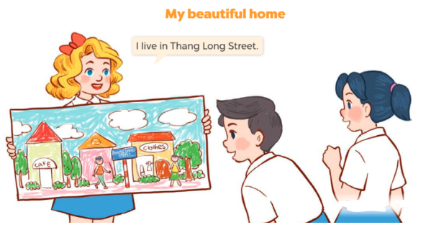  -Ss perform in front of the class.  -Ss answer the questions  -Ss listen and clap their hands  -Ss listen and take note
D. ADJUSTMENTS (if necessary):
………………………………………………………………………………………….…..……………………………………………………………………………...…………

