Week 19 Preparing date: January 12th, 2025
Period 73 Teaching date: January 13th, 2025

Unit 11: My home
Lesson 1 (1, 2, 3)
A. OBJECTIVES:
By the end of the lesson, Ss will be able to:
1. Knowledge:
- use the words at, in, live, road, street, in relation to the topic “My home”.
- use Where do you live? – I live ……..to ask and answer questions about where someone lives.
- Vocabulary: live, road, street.
- Model sentences:
A: Where do you live?
B: I live in Tran Hung Dao Street.
- Skills: speaking and listening
2. Competences:
- Co-operation: ready to help friends in pair work/ group work.
- Sociability: Talk to each other, say good words to others.
3. Attitude/ Qualities:
- Kindness: Help partners to complete learning tasks.
- Honesty: tell the truth about feelings and emotions
B. TEACHING AIDS:
- Teacher: Teacher’s guide Pages 158, 159, audio Tracks 1,2 , website hoclieu.vn, posters, laptop, pictures, textbook, lesson plan, TV or projector.
- Students: Pupil’s book Page 6, notebooks, workbooks, school things.
C. PROCEDURES:
Stages/Time | Teacher’s activities | Students’ activities
1.Warm- up:  (5’)  2. Presentation  (16’)  3.Practice: (7’)  4.Production: (5’)  5. Homework. (2’) | Game: jigsaw puzzle  *Aims: to create a friendly and active atmosphere in the class to beginning the lesson.  *Procedure:  - Divide class into 4 groups: Doreamon, Nobita, Xuka and Xeko.  - Ask Ss look at the pieces of picture.  - Ask Ss go to the board and jigsaw puzzle into the correct picture  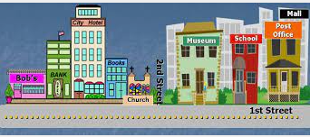  - T checks who’s the winner?  - Ask Ss look at the pieces of picture  - Say “Open your book page 6” and look at “Unit 11, Lesson 1 (1,2,3)”.  Activity 1. Vocabulary.  *Aims: Ss will be able to know the vocabulary in the new lesson.  *Procedure:  -T elicits the new words  + live : sống (situation)  + road : con đường (translation)  + street : đường phố (picture)  - T models (3 times).  - T writes the words on the board.  - Checking: Rub out and remember  Activity 2. Look, listen and repeat:  *Aims: Ss will be able to understand and correctly repeat the sentences in two communicative contexts (pictures) in which characters ask and answer the question about where Mary lives.  *Procedure:  - Have Ss look at Pictures a and b and identify the characters in the pictures and say what they can see in the pictures  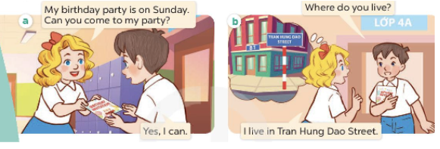  - Play the audio twice (sentence by sentence). Correct their pronunciation where necessary.  - Have Ss to practice the dialogue  - T invites a few pairs to the front of the class to practice.  - T checks pronunciation for ss.  Activity 3 Listen, point and say.  *Aims: Ss will be able to correctly say the phrases and use Where do you live? – I live ……….. to ask and answer questions about where someone lives  *Procedure:  * Model sentences:  - T asks Ss look at picture a, b and helps Ss know the structure from the dialogue.  - T introduces new structure for Ss.  - T explains, models and gives meaning.  -Have Ss repeat the model sentences.  A: Where do you live?  B: I live in Tran Hung Dao Street.  *Drill pictures  - Elicit and check comprehension and tell what the words and numbers on the plaques are about  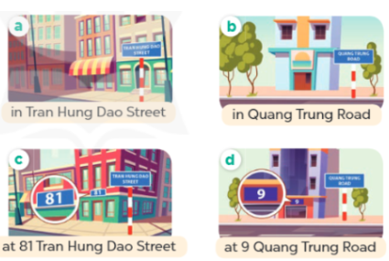  - Run through all the pictures.  - Run through model sentences.  + Run through the questions.  + Run through the answers  - Have Ss to practise:  + T says asks and Ss answer (change role).  + Ss – Ss (change role).  - Ask Ss to work in pairs.  - T controls and corrects.  - Invite a few pairs to come to the front of the classroom, point at the relevant character in each picture, and act out his/her role.  - Encourage Ss to practise speaking English.  - T gives feedbacks.  Activity 4. Let’s talk.  *Aims: Ss will be able to enhance the correct use of Where do you live? – I live …. to ask and answer questions about where someone lives in a freer context.  *Procedure:  - Ask questions to help them identify the names of the streets and roads, the house numbers and the houses without specific numbers.  + What can you see in the picture?  +Where are they?  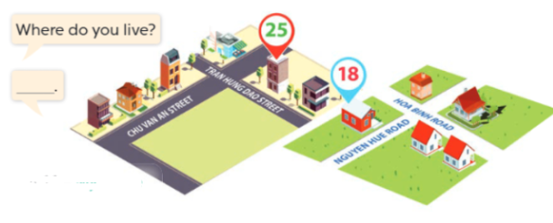  - T fills the gaps and writes the sentences on the board.  - T models  - T asks Ss to work in pairs to ask and answer  - Invite some pupils to the front of the class to present their exchanges.  - Give feedbacks  *Consolidation  *Aims: Ss will be able consolidate and wrap up the content of the lesson.  *Procedure:  - T asks ss to answer the following questions:  + What have you learnt from the lesson today?  - T review the vocabulary and model sentences.  - T praises some Ss who are hardworking / active/ good…. as well as encourage others to try more.  - Learn the vocabulary by heart  - Prepare the new lesson: Unit 11, Lesson 1 (4,5,6). | - Ss listen  - Ss play the game  - Ss open their books  -Ss listen and answer  - - Ss listen and repeat  + Choral repetition (3 times).  + Individual repetition (3 ss)  - Ss take note  - Ss look, remember and write  -Look at the pictures and get to know the characters in the pictures.  + Picture a.  Mary: My birthday party is on Sunday. Can you come to my party?  Minh: Yes, I can  + Picture b.  Minh: Where do you live?  Mary: I live in Tran Hung Dao Street  -Ss listen and repeat in chorus (twice)  -Ss work in pairs to practice  -Ss practice the dialogue  -Ss listen  -Ss look at the picture and answer.  -Ss listen  -Ss listen and repeat  -Ss repeat  - Ss look, listen and repeat  + Picture a: A house (without a house number) in Tran Hung Dao Street  + Picture b: A house (without a house number) in Quang Trung Road  + Picture c: A house at 81 Tran Hung Dao Street  + Picture d: A house at 9 Quang Trung Road  -Ss practice in chorus  -Ss practice in chorus  -Ss practice in chorus and individual  -Ss work in pairs to practice  -Ss listen  -Ss point and say  -Ss listen.  -Ss listen  -Ss look at the picture and answer  + some houses on two maps  -Ss note  - Ss say the completed sentences.  -Ss work in pairs  -Ss perform in front of the class.  -Ss answer the questions  - Ss listen  -Ss listen and clap their hands  -Ss listen and take note

D. ADJUSTMENTS (if necessary):
………………………………………………………………………………………….…..……………………………………………………………………………...………………………………………….…..…………………………………………………………

