Week 13 Preparing date: December 1st , 2024
Period 52 Teaching date: December 3rd, 2024

Unit 8: My school things
Lesson 2 (1, 2, 3)
A. OBJECTIVES:
By the end of the lesson, Ss will be able to:
1. Knowledge:
- understand and correctly repeat the sentences in two communicative contexts (pictures) focusing on the questions and answers about having a school thing.
- correctly say the words and use Do you have ……..? − Yes, I do. / No, I don’t. to ask and answer questions about having a school thing.
- enhance the correct use of Do you have …………..? − Yes, I do. / No, I don’t. to ask and answer questions about having a school thing.
- Vocabulary: pencil, pencil case, notebook, eraser
- Skills: speaking and listening
2. Competences:
- Critical Thinking: self-introduce
- Co-operation: ready to help friends in pair work/ group work.
- Sociability: Talk to each other, say good words to others.
3. Attitude/ Qualities:
- Kindness: Help partners to complete learning tasks.
- Honesty: tell the truth about feelings and emotions
B. TEACHING AIDS:
- Teacher: Teacher’s guide Pages 103, 104, 105, audio Tracks 81, 82, website sachmem.vn, posters, laptop, pictures, textbook, lesson plan, TV or projector.
- Students: Pupil’s book Page 58, notebooks, workbooks, school things.
C. PROCEDURES:
Stages/Time | Teacher’s activities | Students’ activities
1.Warm- up:  (3’)  2. Presentation  (16’)  3.Practice: (7’)  4.Production: (7’)  5. Homework. (2’) | Pass the school things.  *Aims: to create a friendly and active atmosphere in the class to beginning the lesson.  *Procedure:  - Review the previous lesson by having the class pass the school things with the music.  - When the music stops, those who have school things have to say the sentence: I have a …  - Say “Open your book page 52” and look at “Unit 8, Lesson 2 (1, 2, 3)”.  Activity 1. Vocabulary.  *Aims: Ss will be able to know the vocabulary in front of starting the new lesson.  *Procedure:  -T elicits the new words  + pencil : bút chì (realia)  + pencil case: hộp bút (realia)  + notebook :quyển vở (realia)  + eraser : cục tẩy (realia)  - T models (3 times).  - T writes the words on the board.  - Checking: Rub out and remember  Activity 2. Look, listen and repeat:  *Aims: Ss will be able to understand and correctly repeat the sentences in two communicative contexts (pictures) focusing on the questions and answers about having a school thing.  *Procedure:  - Have Ss look at Pictures a and b and identify names of the speakers in the pictures.  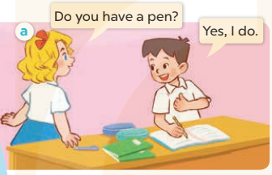  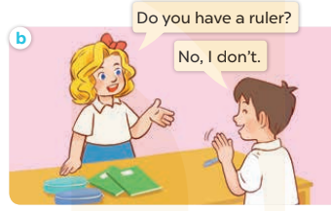  - Play the audio twice (sentence by sentence). Correct their pronunciation where necessary.  - Have Ss to practice the dialogue  - T invites a few pairs to the front of the class to practice.  - T checks pronunciation for ss.  Activity 3 2. Listen, point and say.  *Aims: Ss will be able to correctly say the words and use Do you have ……….? − Yes, I do. / No, I don’t. to ask and answer questions about having a school thing.  *Procedure:  * Model sentences:  - T asks Ss look at picture a, b and helps Ss know the structure from the dialogue.  - T introduces new structure for Ss.  - T explains, models and gives meaning.  -Have Ss repeat the model sentences.  A: Do you have a pen?  B: Yes, I do. / No, I don’t  *Drill pictures  - Have Ss look at the pictures and identify the school things.  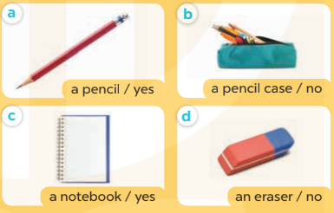  - Run through all the pictures.  - Run through model sentences.  +Run through question sentence  +Run through answer sentence  - Have Ss to practise:  + T asks, Ss answer picture a  + Ss asks, T answers picture b  + Group A ask, group B answer picture c  + Group B ask, group A answer picture d  - Ask Ss to work in pairs.  - T controls and corrects.  - Invite a few pairs to come to the front of the classroom and point at the pictures and say the questions and answers in front of the class.  - T gives feedbacks.  Activity 4. Let’s talk.  *Aims: Ss will be able to enhance the correct use of Do you have …….? − Yes, I do. / No, I don’t. to ask and answer questions about having a school thing.  *Procedure:  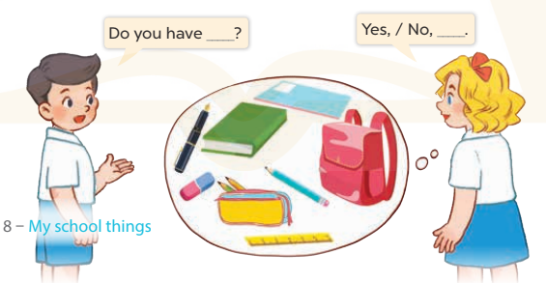  - Have Ss look at the picture and elicit the question and the answer in context.  + Who are they?  + What are they talking about?  - Put Ss work in pairs to ask and answer with with yes/ no  - Invite some pairs to the front of the classroom to take turns to hold up a school thing in their classroom.  *Consolidation  *Aims: Ss will be able consolidate and wrap up the content of the lesson.  *Procedure:  - T asks ss to answer the following questions:  + What have you learnt from the lesson today?  +What are the core values of the lesson? (if the teacher can take from the lesson).  - T review the vocabulary and model sentences.  - T praises some Ss who are hardworking / active/ good…. as well as encourage others to try more.  - Learn the vocabulary and model sentences by heart  - Prepare the new lesson: Unit 8, Lesson 2 (4,5,6). | - Ss listen  - Ss play game  -Ss open their books  -Ss listen and answer  - - Ss listen and repeat  + Choral repetition (3 times).  + Individual repetition (3 ss)  - Ss take note  - Ss look, remember and write  -Look at the pictures and say  + In picture a: Mary asks Minh if he has a pen: Do you have a pen? and he answers: Yes, I do.  + In picture b: Mary asks Minh if he has a ruler: Do you have a ruler? and he answers: No, I don’t.  -Ss listen and repeat in chorus (twice)  -Ss work in pairs to practice  -Ss practice the dialogue  -Ss listen  -Ss look at the picture and answer.  -Ss listen  -Ss listen and repeat  -Ss repeat  - Ss look, listen and answer  + Picture a: a pencil + Picture b: a pencil case  + Picture c: a notebook  + Picture d: an eraser  -Ss listen and repeat  -Ss practice in chorus  -Ss work in pairs to practice  -Ss point and say  -Ss listen.  -Ss look at the picture and answer  + Two pupils ask and answer the question about having a school thing (a book, a notebook, a school bag, an eraser, a pen, a pencil, a pencil case and a ruler.  -Ss work in pairs  -Ss ask and answer.  -Ss answer the questions  - Ss listen  -Ss listen and clap their hands  -Ss listen and take note
D. ADJUSTMENTS (if necessary):
………………………………………………………………………………………….…..……………………………………………………………………………...………………………………………….…..……………………………………………………………………………….……………………………………………………………………...

