Week 7 Preparing date: October 19th, 2024
Period 28 Teaching date: October 22nd, 2024
UNIT 4. OUR FREE-TIME ACTIVITIES
Lesson 3 (4, 5, 6)
A. OBJECTIVES:
By the end of the lesson, Ss will be able to:
1. Knowledge:
- read and show understanding of a text by answering four questions about Laura’s free-time activities at the weekend
- complete a letter to a penfriend about someone’s free-time activities at the weekend by writing the target words in the gaps using picture cues
- present their free-time activities to the class.
- Vocabulary: Review
- Skills: speaking, listening, reading and writing.
2. Competences:
- Communication and collaboration: work in pairs and groups to complete the learning tasks.
- Self-control and independent learning: perform reading and writing tasks.
3. Attitude/ Qualities:
- Show their love and interest in leisure activities and entertainment
B. TEACHING AIDS:
- Teacher: Teacher’s guide Pages 72, 73, 74; website hoclieu.vn, posters, laptop, pictures, textbook, lesson plan, TV or projector.
- Students: Pupil’s book Page 33, notebooks, workbooks, school things.
C. PROCEDURES:
Stages/  Time | Teacher’s activities | Students’ activities
1.Warm- up and review: (5’)  2.Practice: (8’)  3.Production: (18’)  4. Fun corner and wrap- up (4’) | Game: Spin the wheel  *Aims: to revise the new words and structures from previous lessons.  *Procedure:  - Tell Ss they are going to look at the pictures and answer the questions.  - Divide the class into 3 teams.  - Ss take turns to choose a number and answer the question.  - Check the Ss’ answers as a whole class.  - If they give the correct answers, they can spin the wheel to get points.  - The team with the most points will be the winner.  - Say “Open your book page 33” and look at “Unit 4, Lesson 3 (4,5,6)”.  Activity 1. Read and answer:  *Aims: Ss will be able to read and show understanding of a text by answering four questions about Laura’s free-time activities at the weekend  *Procedure:  - Have Ss read the questions carefully and tell ss to read Question 1 and identify the keywords (She always plays the violin).  - Explain the type of information they need for each answer.  - Set a time limit for Ss to do the task independently.  - Get Ss to swap books with a partner and check the answers before checking as a class.  - Invite some pairs to take turns asking and answering the questions.  - Ask Ss some more questions to check their comprehension of the text.  Ex: Who likes listening to music?  Does she like playing sports and games?  What does she help her mother do?  Key:  1. She always plays the violin (at the weekend).  2. She usually plays volleyball (on Saturdays).  3. She often goes for a walk on Sundays.  4. She helps her mother with the cooking on Sundays.  Activity 2. Let’s write  *Aims: Ss will be able to complete a letter to a penfriend about someone’s free-time activities at the weekend by writing the target words in the gaps using picture cues.  *Procedure:  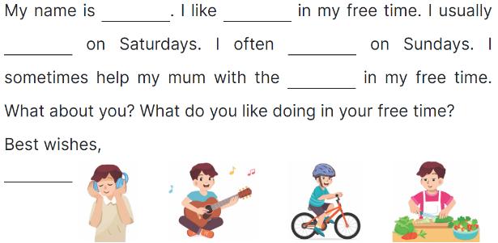  - Ask Ss to read the gapped letter and explain that they need to fill in the gaps with information about the boy in the pictures’ free-time activities.  - Have Ss complete the first, second and third gaps with names and an activity of their choice from the pictures.  - Give Ss time to complete the rest of the letter independently.  - Get Ss to swap their books with a partner and check each other’s spelling before checking as a class.  Key: Pupil’s answer  Ex:  Hi Kitty,  My name is Hoang. I like listening to music in my free time. I usually play the guitar on Saturdays. I often ride my bike on Sundays. I sometimes help my mum with the cooking in my free time. What about you? What do you like doing in your free time?  Love,  Hoang  Activity 3. Project.  *Aims: Ss will be able to present their free-time activities to the class.  *Procedure:  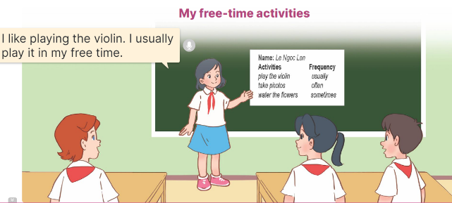  - Tell Ss about the goal of the activity.  - Have Ss work in groups. Each student looks at their lists and tells the group about their free-time activities.  - Invite a few ss to look at their lists and tell the class about them, ex: I like playing the guitar. I usually play it in my free time.  -T gives feedback  Game: Slap the board  - Divide the class into two or three teams.  - Teacher puts up a set of pictures or words on a board.  - A student from each team comes up to the board with fly swatters.  - They listen as the teacher calls out a word or a sentence and they race to slap the correct picture.  - Whoever is the fastest with the correct slap gets a point for their team.  - Team with the most points is the winner. | - Ss listen  - Ss listen to the rules  -Ss play game  - Ss open their books  - Ss read Question 1 and pay attention to keywords  - Ss read and answer question 2,3,4  - Ss read the text again and write the correct answers.  - Ss swap books and check answers  - Ss ask and answer the questions.  - Ss answer the questions.  - Ss listen to the teacher  - Ss complete the first, second and third gaps with names and an activity  - Ss complete the rest of the letter independently.  - Ss swap their and check  - Ss listen to the teacher  - Ss work in groups of five.  - Ss show their work and talk about their free-time activities in front of the class.  - Ss listen  -Ss listen to the teacher  -Ss play the game  -Ss congratulate the winner
D. ADJUSTMENTS (if necessary):
………………………………………………………………………………………….…..……………………………………………………………………………...……

