Week 7 Preparing date: October 19th, 2024
Period 27 Teaching date: October 22nd, 2024

UNIT 4. OUR FREE-TIME ACTIVITIES
Lesson 3 (1, 2, 3)
A. OBJECTIVES:
By the end of the lesson, Ss will be able to:
1. Knowledge:
- correctly pronounce the two-syllable words ꞌalways and ꞌsometimes with the stress on the first syllable, in isolation and in the sentences I ꞌalways listen to music. and She ꞌsometimes plays the violin.
- identify the stress on some two-syllable words and circle the word with a different stress pattern from the other two words
- say the chant with the correct pronunciation, word stress and rhythm.
- Vocabulary: Review
- Skills: speaking, listening, reading and writing.
2. Competences:
- Communication and collaboration: work in pairs and groups to complete the learning tasks.
- Self-control and independent learning: perform pronunciation and listening tasks.
3. Attitude/ Qualities:
- Explore new interests and develop healthier and balanced lifestyle, then improve general well-being.
B. TEACHING AIDS:
- Teacher: Teacher’s guide Pages 71, 72, 73; audio Tracks 42, 43, 44; website hoclieu.vn, posters, laptop, pictures, textbook, lesson plan, TV or projector.
- Students: Students’ book Page 32, notebooks, workbooks, school things.
C. PROCEDURES:
Stages/  Time | Teacher’s activities | Students’ activities
1.Warm- up and review: (5’)  2. Presentation (9’)  3.Practice: (17’)  3. Fun corner and wrap- up (4’) | Chatting  *Aims: to revise the words about someone’s appearance and personality  *Procedure:  - Place different pictures of free time activities on the board.  - Have Ss say the words related to the pictures.  - Tell Ss they are going to ask and answer the question about someone’s free-time activities in a freer context.  - Invite pairs of volunteers to the board. One asks the question, another one answers the question and points to the suitable picture.  - Continue until practicing all the vocabulary set. Praise Ss if they perform well.  - Say “Open your book page 32” and look at “Unit 4, Lesson 3 (1,2,3)”.  Activity 1. Listen and repeat:  *Aims: Ss will be able correctly pronounce the two-syllable words ꞌalways and ꞌsometimes with the stress on the first syllable, in isolation and in the sentences I ꞌalways listen to music. and She ꞌsometimes plays the violin.  *Procedure:  - Have Ss point at the words ꞌalways and ꞌsometimes with the stress on the first syllable, in isolation and in the sentences I ꞌalways listen to music. and She ꞌsometimes plays the violin.  - Play the recording for Ss to listen and repeat in chorus and individually until they feel confident.  - Let Ss work in pairs or groups, saying the words and reading the sentences.  - T invites some Ss to practice.  Activity 2. Circle, listen and check.  *Aims: Ss will be able to identify the stress on some two-syllable words and circle the word with a different stress pattern from the other two words.  *Procedure:  - Tell Ss circle the word having a different stress from each line. Then listen to the recording to check their answers.  - Set a time for Ss to do the task.  - Play the recording, once or twice, for Ss to listen and check their answers.  - Get Ss to swap books with a partner and check their answers before checking as a class.  - Play the recording again for Ss to double-check their answers.  - Invite a few Ss to read aloud all the words in the words.  Key: 1. c 2. b 3. b  Activity 3. Let’s chant  *Aims: Ss will be able to say the chant with the correct pronunciation, word stress and rhythm.  *Procedure:  - Introduce the title and lyrics of the chant.  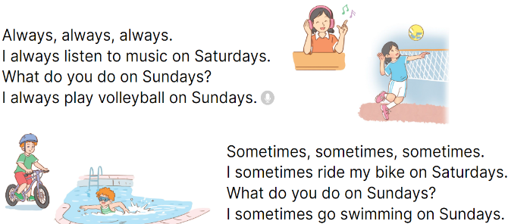  - Play the recording for Ss to listen to the whole chant.  + Have them repeat the title and lyrics line by line.  + Ask Ss to attend to two-syllable words with the stress on the first syllable in the chant, always and sometimes.  - Play the recording all the way through for Ss to listen to pronunciation and melody.  - Play the recording line by line for Ss to listen and repeat  - Play the recording for Ss to chant and clap along.  - Ask Ss to practice chant and clap along in pairs or groups.  - Invite groups to the front of the classroom to perform the chant  Game: Jump  - Flash cards (football, table tennis, Japan, England, dolphin, giraffe)  - Tell Ss they are going to play the game Jump. If the word is the same as the flash card, Ss jump. If it isn’t, they keep still. Ask them to say the word on the flash card.  - Ask Ss to stand at their desks.  - Hold up a flash card from the vocabulary set and say a word.  - Raise all the flash cards for Ss to say the words. | - Follow the T’s instructions.  -Ss pay attention and say  Ex:  A: What do you like doing in your free time?  B: I like playing badinton.  - Ss open their books  - - Ss point and pay attention  - Ss listen to the recording again and repeat.  -Ss work in pairs and practice  -Ss say the words and sentences  - Ss pay and listen to the teacher’s explanation.  - Ss do the task  - Ss listen to the recording to check their answers (individual)  - Ss swap books with a partner and check the answers  - Ss listen to the recording again and check their answers again.  - Ss stand up and read aloud the words.  - Ss look and listen.  - Ss listen to the chant  - Ss listen and repeat line by line without clap their hands  - Ss note the rhythm and pronunciation.  -Ss listen to melody of the chant  - Ss listen and chant line by line.  - Ss chant and clap along.  - Ss work in groups (two groups) to chant  -Ss perform in front of the class.  -Ss listen  -Ss play the game  -Ss read the words

