Week 7 Preparing date: October 19th, 2024
Period 26 Teaching date: October 21st, 2024

UNIT 4. OUR FREE-TIME ACTIVITIES
Lesson 2 (4, 5, 6)
A. OBJECTIVES:
By the end of the lesson, Ss will be able to:
1. Knowledge:
- listen to and understand two communicative contexts about what someone does at the weekend and tick the correct pictures
- complete two gapped exchanges with the help of picture cues
- listen to and complete the song What do you like doing in your free time? and to sing it with the correct pronunciation, rhythm and melody.
- Vocabulary: Review
- Skills: speaking, listening, reading and writing.
2. Competences:
- Communication and collaboration: work in pairs and groups to complete the learning tasks.
3. Attitude/ Qualities:
- Explore new interests and develop healthier and balanced lifestyle, then improve general well-being.
B. TEACHING AIDS:
- Teacher: Teacher’s guide Pages 69, 70; audio Tracks 40, 41; website hoclieu.vn, posters, laptop, pictures, textbook, lesson plan, TV or projector.
- Students: Student’s book Page 31, notebooks, workbooks, school things.
C. PROCEDURES:
Stages/ Time | Teacher’s activities | Students’ activities
1.Warm- up and review: (5’)  2.Practice: (25’)  3. Fun corner and wrap- up (5’) | Game: Lucky number  *Aims: to revise the learned words *Procedure:  - Divide the class into three teams.  - Have Ss take turns to choose a number.  - Ask Ss to look at the picture and say the activity.  - If the answer is correct, Teacher clicks the picture to open the hidden points.  - The team that gets more points wins. Praise the winner.  - Say “Open your book page 31” and look at “Unit 4, Lesson 2 (4,5,6)”.  Activity 1. Listen and tick:  *Aims: Ss will be able to listen to and understand two communicative contexts about what someone does at the weekend and tick the correct pictures.  *Procedure:  - Ask questions to help Ss identify the characters and their free-time activities.  + What’s he/she doing?  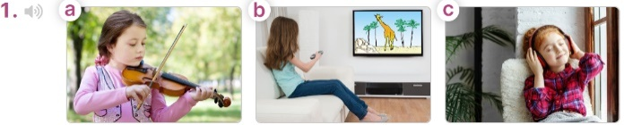  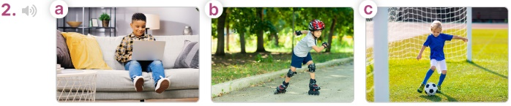  - T ask Ss to guess the answers.  + T writes Ss’guessing on the board.  - Listen to the tape:  + Play the recording  + Play the recording again for pupils to do the task.  + Play the recording a third time for pupils to check their answers.  - Get Ss to swap books with their partner, then check answers as a class.  + Write the answers on the board for Ss to correct their answers. Then checks Ss’ guessing.  - Play the recording, sentence by sentence, for Ss to listen and repeat individually and in chorus  Key: 1. b 2. a  Activity 2. Read and complete  *Aims: Ss will be able to complete two gapped exchanges with the help of picture cues.  *Procedure:  - Have Ss look at the pictures and identify the activities of the characters in the pictures.  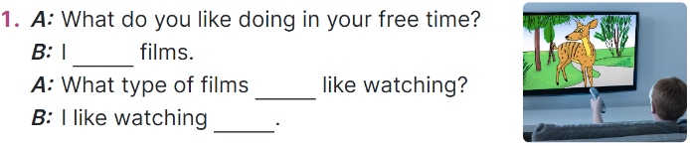  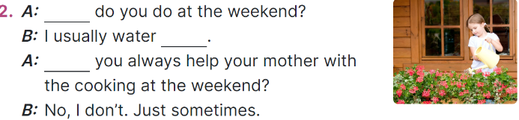  -Model sentences: have Ss read the question and ask what words are missing (like watching)  - Give Ss a time limit to read the gapped dialogues, look at the pictures and do the task independently.  - Get Ss to swap books with a partner and check their answers before checking as a class.  + Invite one student to write the answers on the board.  - Invite two pairs of Ss to act out the completed dialogues.  Key: 1. like watching; do you; cartoons  2. What; the flowers; Do  Activity 3. Listen, complete and sing  *Aims: Ss will be able to listen to and complete the song What do you like doing in your free time? and to sing it with the correct pronunciation, rhythm and melody.  *Procedure:  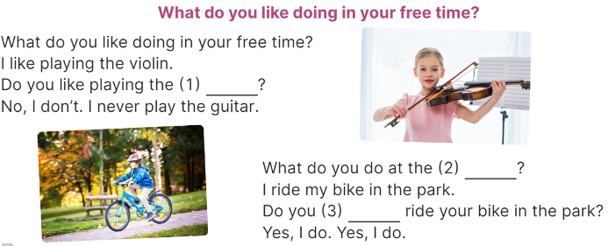  - Draw Ss’ attention to the gapped sentences.  - Play the recording the whole song.  + Then play the recording again to fill in the gaps with missing words.  - Check answers as a class.  + Play the recording line by line for Ss to listen and repeat.  - Play the recording all the way through for Ss to sing along and clap along with the recording.  Game: The football game  - Divide the class into 3 teams.  - Tell Ss that they are going to play football.  - Ss take turns to choose a number, read the question and say the answer.  - If the answer is correct, they will get points for their teams.  - If not, move to another team.  - The group with more points wins the game. | -Ss listen to the teacher  -Ss play the game  - Ss open their books  -Look at the pictures and say:  + Picture 1a: a girl playing the violin + Picture 1b: a girl watching a cartoon on TV  + Picture 1c: a girl listening to music + Picture 2a: a boy surfing the net  + Picture 2b: a boy roller skating in the park  + Picture 2c: a boy playing football  -Ss guess the answers  - Ss listen to the tape  - Ss listen again and do the task.  - Ss listen and check their answers  - Ss swap books, check answers as a class and guessing  -Ss write the answer on the board  -Ss listen and repeat  -Ss look at the picture and say  -Ss follow the teacher  - Ss do the task independently.  - Ss swap books with a partner and check their answers.  - Ss write the answers on the board  - Pairs of Ss read the completed dialogues aloud  - Ss guess the missing words  - Ss listen all song.  - Ss listen again and fill in the gaps  - Ss listen and repeat.  - Ss listen and sing along  -Ss listen to the teacher  - Ss play the game.  - Ss praise the winner.

