Week 7 Preparing date: October 19th, 2024
Period 25 Teaching date: October 21st, 2024

UNIT 4. OUR FREE-TIME ACTIVITIES
Lesson 2 (1, 2, 3)
A. OBJECTIVES:
By the end of the lesson, Ss will be able to:
1. Knowledge:
- understand and correctly repeat the sentences in two communicative contexts in which characters ask and answer questions about what someone does at the weekend;
- correctly say the words and use What do you do at the weekend? – I ____. to ask and answer questions about what someone does at the weekend
- use What do you do at the weekend? – I ______. in a freer context
- Vocabulary: always, usually, often, sometimes, rarely, never
- Structures:
A: What do you do at the weekend?
B: I usually listen to music.
- Skills: speaking and listening
2. Competences:
- Critical thinking and creativity: learn how to ask and answer questions about personal information correctly and fluently.
- Self-control and independent learning: perform speaking tasks.
3. Attitude/ Qualities:
- Explore new interests and develop a healthier and balanced lifestyle, then improve general well-being.
B. TEACHING AIDS:
- Teacher: Teacher’s guide Pages 66, 67, 68, audio Tracks 38, 39; website hoclieu.vn, posters, laptop, pictures, textbook, lesson plan, TV or projector.
- Students: Students’ book Page 30, notebooks, workbooks, school things.
C. PROCEDURES:
Stages/  Time | Teacher’s activities | Students’ activities
1.Warm- up and review: (3’)  2. Presentation (15’)  3.Practice: (7’)  4. Production: (6’)  5. Fun corner and wrap- up (4’) | Game: Slap the board  *Aims: to revise the vocabulary about different activities.  *Procedure:  - Prepare some flashcards about different activities and stick on the board  (play football, listen to music, read books, watch TV, clean the floor…)  - Divide class into 2 groups: Tom and Jerry.  - How to play:  + Each group chooses five Ss to play.  + Class will read aloud.  + Look at the picture, listen and slap the picture you heard.  + Who faster will get 1 mark.  + Which group with higher mark is the winner.  - Say “Open your book page 30” and look at “Unit 4, Lesson 2 (1,2,3)”.  Activity 1. Vocabulary.  *Aims: Ss will be able to know the vocabulary in the new lesson.  *Procedure:  -T elicits the new words  + always : luôn luôn (explain)  + usually: thường thường (explain)  + often : hay, thường (explain)  + sometimes : thỉnh thoảng (explain)  - T models (3 times).  - T writes the words on the board.  - Checking: Matching  Activity 2. Look, listen and repeat:  *Aims: Ss will be able to understand and correctly repeat the sentences in two communicative contexts in which characters ask and answer questions about what someone does at the weekend.  *Procedure:  - Have Ss look at Pictures a and b and identify the characters and their activities. + Who is he/ she?  + Where is he/ she?  + What is he/ she doing in the picture?  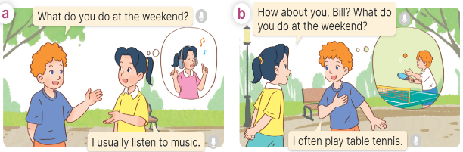  - Play the audio twice (sentence by sentence). Correct their pronunciation where necessary.  - Have Ss to practice the dialogue  - T invites a few pairs to the front of the class to practice.  - T checks pronunciation for ss.  Activity 3 Listen, point and say.  *Aims: Ss will be able to correctly say the words and use What do you do at the weekend? – I ____. to ask and answer questions about what they do at the weekend.  *Procedure:  * Structures:  - T asks Ss look at picture a and b in activity 1 and helps Ss know the structure from the dialogue.  - T introduces new structures for Ss.  - T explains, models and gives meaning.  - Have Ss repeat the structures  *Drill pictures  - Have Ss look at the pictures and identify the characters and their activities. 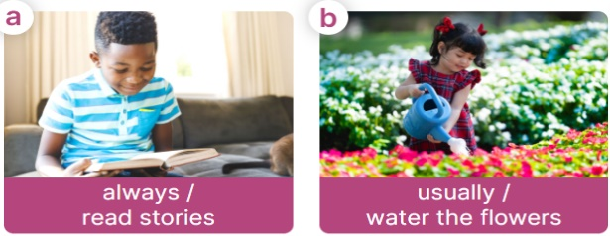  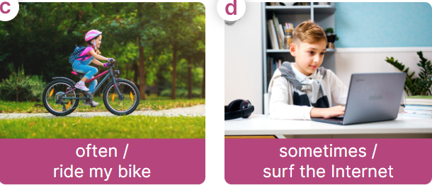  - Have Ss point at pictures, listen and run through all the pictures.  - Have Ss point at the bubbles, listen and run through model sentences.  - Have Ss to practise:  + T asks the first picture, Ss answer  + Ss asks the second picture, T answers  + Group A asks the third picture, group B  answers  + Group B asks the last picture, group A  - Ask Ss to work in pairs to practise asking and answering the What do you do at the weekend? - I _____.  - T controls and corrects.  - Invite a few pairs to point at the pictures and say the questions and answers in front of the class.  Activity 4. Let’s talk.  *Aims: Ss will be able to correctly use What do you do at the weekend? –_____. to ask and answer questions about what they do at the weekend in a freer context.  *Procedure:  - Ask Ss to look at the pictures and elicit the context  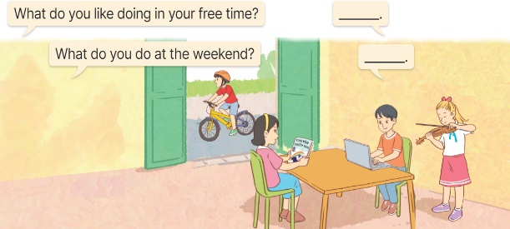  - Point at the ﬁrst building and elicit the question in the ﬁrst speech bubbl What do you like doing in your free time? and What do you do at the weekend? and the answer in the second speech bubble I like……… and I………. as an example.  - Give Ss time to work in pairs and take turns pointing at each picture to ask and answer using What do you like doing in your free time? - ………..  - Invite a few pairs to come to the front of the classroom and act out the exchanges.  Game: Lucky number  - Explain that Ss will play this game in three teams.  + There are six numbers, they have to choose the number and answer the free-time activity behind the number.  + If the answer is correct, their team can get the point. The number of candies behind the picture will be the points they get.  - Ask Ss to read all the words again. | -Ss listen and pay attention  - Ss listen to the teacher  -Ss play the game  .  -Ss continute playing the game  - Ss listen and open their books  -Ss listen and answer  - - Ss listen and repeat  + Choral repetition (3 times).  + Individual repetition (3 ss)  - Ss take note  - Ss look and match  -Look at the pictures and say.  + In picture a:  Bill: What do you do at the weekend?  Mai: I usually listen to music  + In picture b:  Mai: How about you, Bill? What do you do at the weekend?  Bill: I often play table tennis.  -Ss listen and repeat in chorus (twice)  -Ss work in pairs to practice  -Ss come to the front of the classroom to practice.  -Ss listen  - Ss look at the picture and answer.  -Ss listen  -Ss listen and repeat  -Ss repeat to the structures  - Ss look, listen and repeat  +Picture a: a boy reading a story and the words always / read stories underneath  + Picture b: a girl watering the flowers and the words usually / water the flowers underneath  + Picture c: a girl riding her bike in the park and the words often / ride my bike underneath  + Picture d: a boy surfing the Internet and the words sometimes / surf the Internet underneath  -Ss point at pictures, listen and repeat  -Ss point at the bubbles, listen and repeat  -Ss practice in chorus  -Ss practice in chorus  -Ss work in pairs to practise asking and answering the question  - Pairs of Ss point at the pictures and say in front of the class  -Ss look at the picture and say  - Ss look at the first building and elicit the missing words in speech bubbles and say the completed sentences.  - Ss role-play to practise asking and answering questions  - Ss practise asking and answering questions in front of the class.  -Ss listen to the teacher  -Ss play the game  -Ss read all the words again.

