Week 6 Preparing date: October14th , 2024
Period 24 Teaching date: October 16th , 2024
UNIT 4. OUR FREE-TIME ACTIVITIES
Lesson 1 (4, 5, 6)
A. OBJECTIVES:
By the end of the lesson, Ss will be able to:
1. Knowledge:
- listen to and understand four communicative contexts about what someone likes doing in their free time and number the pictures.
- complete four gapped exchanges with the help of picture cues.
- revise target words about free-time activities by playing Who has more correct answers?
- Vocabulary: Review
- Skills: speaking, listening, reading and writing.
2. Competences:
- Communication and collaboration: work in pairs and groups to complete the learning tasks.
- Self-control and independent learning: perform listening and reading tasks.
3. Attitude/ Qualities:
- Show their pride in their personal information and what they like doing in their free time.
B. TEACHING AIDS:
- Teacher: Teacher’s guide Pages 64, 65, 66; audio Tracks 37; website hoclieu.vn, posters, laptop, pictures, textbook, lesson plan, TV or projector.
- Students: Student’s book Page 29, notebooks, workbooks, school things.
C. PROCEDURES:
Stages/ Time | Teacher’s activities | Students’ activities
1.Warm- up and review: (5’)  2.Practice: (25’)  3. Fun corner and wrap- up (5’) | Game: “Pass the ball”  *Aims: to revise the learned different nationalities.  *Procedure:  - Ss pass the ball while the teacher plays the music.  - When the music stops, a student holding the ball says the sentence: “I like _________ in my free time”.  - Say “Open your book page 29” and look at “Unit 4, Lesson 1 (4,5,6)”.  Activity 1. Listen and number:  *Aims: Ss will be able to listen to and understand four communicative contexts about what someone likes doing in their free time and number the pictures.  *Procedure:  - Draw Ss’ attention to the pictures and ask questions  + What’s he/she doing?  + What does he/she like doing in their free time?  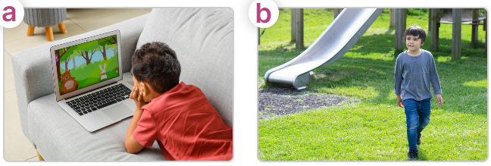  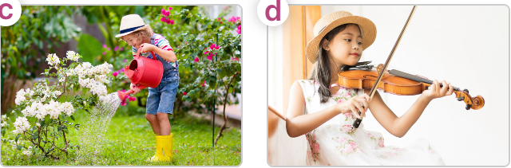  - T ask Ss to guess the answers.  + T writes Ss’guessing on the board.  - Listen to the tape:  + Play the recording  + Play the recording again for pupils to do the task.  + Play the recording a third time for pupils to check their answers.  - Get Ss to swap books with their partner, then check answers as a class.  + Write the answers on the board for Ss to correct their answers. Then checks Ss’ guessing.  - Play the recording, sentence by sentence, for Ss to listen and repeat individually and in chorus Key: 1. d 2. c 3. b 4. A  Activity 2. Read and complete  *Aims: Ss will be able to complete four gapped exchanges with the help of picture cues.  *Procedure:  - Have Ss look at the pictures and identify the activities of the characters in the pictures.  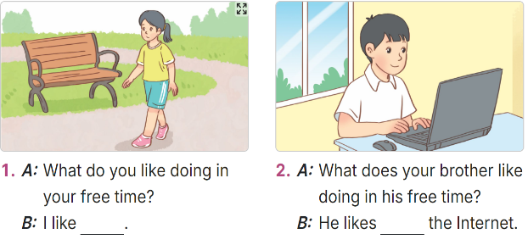  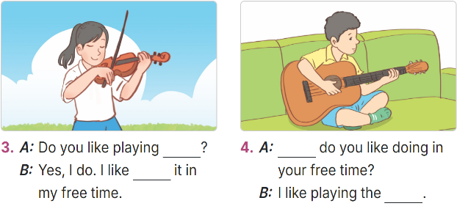  -Model sentences: have Ss read the question and ask what words are missing (go for a walk)  - Give Ss a time limit to read the gapped dialogues, look at the pictures and do the task independently.  - Get Ss to swap books with a partner and check their answers before checking as a class.  + Invite one student to write the answers on the board.  - Invite two pairs of Ss to act out the completed dialogues.  Key: 1. going for a walk  2. surfing  3. the violin; playing  4. What; guitar  Activity 3. Let’s play  *Aims: Ss will be able to revise target words about free-time activities by playing Who has more correct answers?  *Procedure:  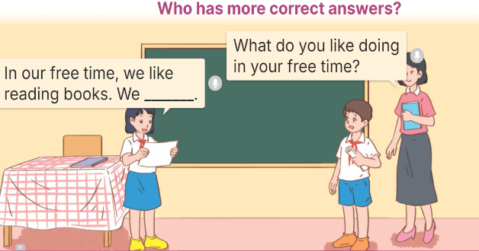  - Tell Ss that they are going to play Who has more correct answers? in groups.  - The groups will write as many sentences as possible about their free-time activities within five minutes on their paper, Ex: In our free time, we like reading books. We like watching TV.  + The group that gets more correct sentences is the winner.  - Have Ss work in groups of five or six.  - Invite representatives of two groups to the front of the class to read their sentences aloud.  - Check answers together as a class and decide which group is the winner.  Game: Spinner the wheel  - Divide the class into 2 teams.  - In teams, they take turns to look at the picture and answer the questions. If they have the correct ones, they will get the points.  - The team with more points wins the game. | -Ss listen to the teacher  -Ss play the game  - Ss open their books  -Look at the pictures and say:  + Picture a: a boy watching a cartoon.  + Picture b: a boy going for a walk in the park.  + Picture c: a girl watering the flowers.  + Picture d: a girl playing the violin.  -Ss guess the answers  - Ss listen to the tape  - Ss listen again and do the task.  - Ss listen and check their answers  - Ss swap books with their partner, then check answers as a class and guessing  -Ss write the answer on the board  -Ss listen and repeat  -Ss look at the picture and say  -Ss follow the teacher  - Ss do the task independently.  - Ss swap books with a partner and check their answers.  - Ss write the answers on the board  - Pairs of Ss read the completed dialogues aloud  - Ss follow the teacher’s instructions.  - Ss discuss and make as many sentences as possible to answer the questions: “What do you like doing in your free time?”  -Ss work in groups  - The representative of each group read aloud their sentences in their group.  -Ss congratulate the winner  -Ss listen to the teacher  - Ss play the game.  - Ss praise the winner.

