Week 6 Preparing date: October14th , 2024
Period 23 Teaching date: October 16th , 2024

UNIT 4. OUR FREE-TIME ACTIVITIES
Lesson 1 (1, 2, 3)
A. OBJECTIVES:
By the end of the lesson, Ss will be able to:
1. Knowledge:
- understand and correctly repeat the sentences in two communicative contexts focusing on asking and answering questions about personal information
- correctly say the words and use What do you like doing in your free time? – I like _____. to ask and answer questions about hobbies
- enhance the correct use of What do you like doing in your free time? – I like _____ . to ask and answer questions about hobbies in freer contexts
- Vocabulary: play the violin, surf the Internet, go for a walk, water the flower.
- Structures:
A: What do you like doing in your free time?
B: I like playing the violin.
- Skills: speaking and listening
2. Competences:
- Critical thinking and creativity: learn how to ask and answer questions about personal information correctly and fluently.
- Self-control and independent learning: perform speaking tasks.
3. Attitude/ Qualities:
- Show their pride in their personal information and what they like doing in their free time.
B. TEACHING AIDS:
- Teacher: Teacher’s guide Pages 61, 62, 63, 64, audio Tracks 35, 36, website hoclieu.vn, posters, laptop, pictures, textbook, lesson plan, TV or projector.
- Students: Students’ book Page 28, notebooks, workbooks, school things.
C. PROCEDURES:
Stages/  Time | Teacher’s activities | Students’ activities
1.Warm- up and review: (3’)  2. Presentation (15’)  3.Practice: (7’)  4. Production: (6’)  5. Fun corner and wrap- up (4’) | Game: Slap the board  *Aims: to revise the vocabulary about different activities.  *Procedure:  - Prepare some flashcards about different activities and stick on the board  (play football, listen to music, read books, watch TV, clean the floor…)  - Divide class into 2 groups: Tom and Jerry.  - How to play:  + Each group chooses five Ss to play.  + Class will read aloud.  + Look at the picture, listen and slap the picture you heard.  + Who faster will get 1 mark.  + Which group with higher mark is the winner.  - Say “Open your book page 28” and look at “Unit 4, Lesson 1 (1,2,3)”.  Activity 1. Vocabulary.  *Aims: Ss will be able to know the vocabulary in the new lesson.  *Procedure:  -T elicits the new words  + play the violin : chơi đàn violin  (picture)  + surf the Internet : lướt mạng in-tơ-net (picture)  + go for a walk : đi dạo bộ (picture)  + water the flowers : tưới nước hoa  (picture )  + free time: thời gian rãnh (situation)  - T models (3 times).  - T writes the words on the board.  - Checking: Matching  Activity 2. Look, listen and repeat:  *Aims: Ss will be able to understand and correctly repeat the sentences in two communicative contexts in which characters ask and answer questions about what someone likes doing in their free time.  *Procedure:  - Have Ss look at Pictures a and b and identify the characters and their activities. + Who is he/ she?  + Where is he/ she?  + What is he/ she doing in the picture?  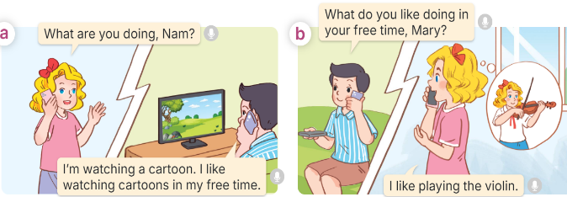  - Play the audio twice (sentence by sentence). Correct their pronunciation where necessary.  - Have Ss to practice the dialogue  - T invites a few pairs to the front of the class to practice.  - T checks pronunciation for ss.  Activity 3 Listen, point and say.  *Aims: Ss will be able to correctly say the words and use What do you like doing in your free time? – I like _____. to ask and answer questions about what someone likes doing in their free time.  *Procedure:  * Structures:  - T asks Ss look at picture b in activity 1 and helps Ss know the structure from the dialogue.  - T introduces new structures for Ss.  - T explains, models and gives meaning.  - Have Ss repeat the structures  *Drill pictures  - Have Ss look at the pictures and identify the characters and their activities. 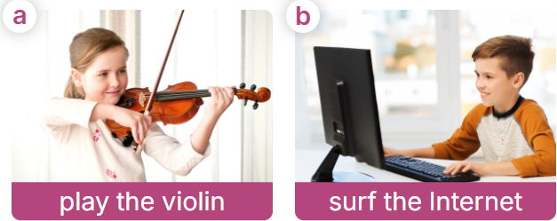  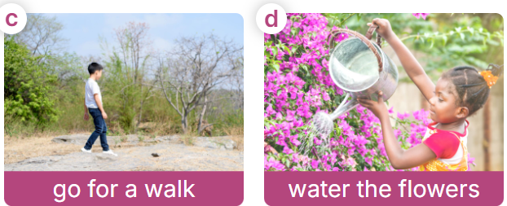  - Have Ss point at pictures, listen and run through all the pictures.  - Have Ss point at the bubbles, listen and run through model sentences.  - Have Ss to practise:  + T asks the first picture, Ss answer  + Ss asks the second picture, T answers  + Group A asks the third picture, group B  answers  + Group B asks the last picture, group A  - Ask Ss to work in pairs to practise asking and answering the What do you like doing in your free time? - I like _____.  - T controls and corrects.  - Invite a few pairs to point at the pictures and say the questions and answers in front of the class.  Activity 4. Let’s talk.  *Aims: Ss will be able to correctly use What do you like doing in your free time? - ____. to ask and answer questions about what someone likes doing in their free time in a freer context.  *Procedure:  - Ask Ss to look at the pictures and elicit the context  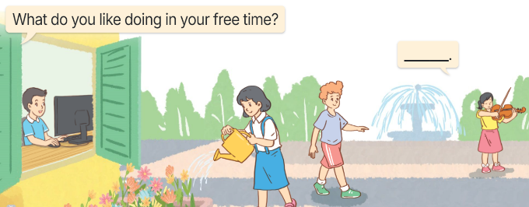  - Point at the ﬁrst building and elicit the question in the ﬁrst speech bubble What do you like doing in your free time? and the answer in the second speech bubble I like……… as an example.  - Give Ss time to work in pairs and take turns pointing at each picture to ask and answer using What do you like doing in your free time? - ………..  - Invite a few pairs to come to the front of the classroom and act out the exchanges.  Game: Racing car  - The teacher divides the class into two teams.  - Each team takes turns choosing the number and answering the question.  -The team that drives the car to the finish line first is the winner. | -Ss listen and pay attention  - Ss listen to the teacher  -Ss play the game  .  -Ss continute playing the game  - Ss listen and open their books  -Ss listen and answer  - - Ss listen and repeat  + Choral repetition  (3 times).  + Individual repetition  (3 ss)  - Ss take note  - Ss look and match  -Look at the pictures and say.  + In picture a:  Mary: What are you doing, Nam? Nam: I’m watching a cartoon. I like watching cartoons in my free time.  + In picture b:  Nam: What do you like doing in your free time, Mary?  Mary: I like playing the violin.  -Ss listen and repeat in chorus (twice)  -Ss work in pairs to practice  -Ss come to the front of the classroom to practice.  -Ss listen  - Ss look at the picture and answer.  -Ss listen  -Ss listen and repeat  -Ss repeat to the structures  - Ss look, listen and repeat  +Picture a: a girl playing the violin  + Picture b: a boy surfing the Internet  + Picture c: a boy going for a walk + Picture d: a girl watering the flowers  -Ss point at pictures, listen and repeat  -Ss point at the bubbles, listen and repeat  -Ss practice in chorus  -Ss practice in chorus  -Ss work in pairs to practise asking and answering the question  - Pairs of Ss point at the pictures and say in front of the class  -Ss look at the picture and say  - Ss look at the first building and elicit the missing words in speech bubbles and say the completed sentences.  - Ss role-play to practise asking and answering questions  - Ss practise asking and answering questions in front of the class.  -Ss listen to the teacher  -Ss play the game  -Ss congratulate the winner

