Week 6 Preparing date: October12th, 2024
Period 22 Teaching date: October 14th, 2024

UNIT 3. MY FOREIGN FRIENDS
Lesson 3 (4, 5, 6)
A. OBJECTIVES:
By the end of the lesson, Ss will be able to:
1. Knowledge:
- read and show the understanding of the text by completing the table.
- fill in the form with some information about a foreign friend.
- work in groups, search and find the names of five countries and their nationality adjectives, use the information to make a poster and give a presentation.
- Vocabulary: Review
- Skills: speaking, listening, reading and writing.
2. Competences:
- Communication and collaboration: work in pairs and groups to complete the learning tasks.
- Self-control and independent learning: perform reading and writing tasks.
3. Attitude/ Qualities:
- Show their pride in where they come from and great respect for where someone comes from by asking and answering about nationality
B. TEACHING AIDS:
- Teacher: Teacher’s guide Pages 54, 55, 56; website hoclieu.vn, posters, laptop, pictures, textbook, lesson plan, TV or projector.
- Students: Pupil’s book Page 27, notebooks, workbooks, school things.
C. PROCEDURES:
Stages/  Time | Teacher’s activities | Students’ activities
1.Warm- up and review: (5’)  2.Practice: (8’)  3.Production: (18’)  4. Fun corner and wrap- up (4’) | Game: “A happy circle”  *Aims: to revise the new words and structures from previous lessons.  *Procedure:  - Write the question and answer on the board.  - Explain that they are going to make a circle, then ask and answer the questions about their friends’ personality.  - Put Ss in groups of six.  - Model the game. Have two Ss of each group make a question and answer about their friends’ personality.  - Have the class play the game.  - Invite one or two groups to perform in the front of the class. Praise Ss to encourage their performance.  - Say “Open your book page 27” and look at “Unit 3, Lesson 3 (4,5,6)”.  Activity 1. Read and complete:  *Aims: Ss will be able to read and show the understanding of the text by completing the table.  *Procedure:  - Ask Ss to study the table. Make sure that they understand the information in each column.  - Model number 1  + Have Ss read the information in the table and decide what information they need (nationality).  + Have Ss find the information about Emma’s nationality in the text. Write the word to fill in blank 1 is American.  - Set a time limit for Ss to do the task in groups  - Get Ss to swap their books with other groups and check their answers before checking as a class.  - Ask Ss to choose five keywords about Emma (American, hair, classmates, dishes, and friendly). Have Ss work in pairs and talk about Emma.  Key: 1. American, 2. long,  3. helpful, 4. friends  Activity 2. Let’s write  *Aims: Ss will be able to fill in the form with some information about a foreign friend  *Procedure:  - Tell the class the goal of the activity and explain that they should read fill in the form with the information about a foreign friend.  - Model question 1.  - Give Ss time to do the writing task independently.  - Get Ss to swap books with a partner and check their answers before checking as a class.  - Invite one or two Ss to stand up and read aloud their answers.  Key: Pupil’s answer  Ex:  My foreign friend’s name Kitty  His / Her age 10  His / Her nationality British  His / Her appearance long hair, short  His / Her personality friendly and active  Activity 3. Project.  *Aims: Ss will be able to work in groups, search and find the names of five countries and their nationality adjectives, use the information to make a poster and give a presentation.  *Procedure:  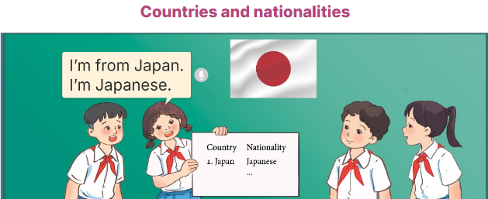  - Explain that they have searched for the names of five countries and their nationality adjectives and prepared a poster to present in class.  - Have groups put the posters on the desk and practice the presentation.  - Get two groups to work together and take turns to give their presentations.  - Invite a few groups to show their poster and give their presentations in front of the class. Praise good performances.  Game: Who’s faster?  - Tell Ss that they are going to look at pictures or word cards and answer the teacher's questions.  - Prepare sets of pictures (Australian, Malaysian, American, Japanese) and word cards (friendly, helpful, clever, active).  - Ask Ss to work in two groups.  - Show a picture or a word card on the board and ask a question related to the picture or the word card.  - Ask Ss to raise their hands as fast as they can to answer the question.  - The student with the correct answer will get points for their group.  - Remark Ss’ pronunciation. Praise the winner. | - Ss listen  - Ss listen to the rules  -Ss play game  Ex: A: What’s Hoang (he) like?  B: He’s active.  - Ss open their books  - Ss study the table.  - Ss follow the teacher demonstrating the example.  -Ss find the information about Emma’s nationality in the text.  - Ss do the task  - Ss swap their books and check their answers before checking as a class.  - Ss work in pairs and talk about Emma.  - Ss listen to the teacher’s explanation.  - Ss fill in the first blank  - Ss complete the form independently.  - Ss swap their books and check their answers  - Ss read their completed form in front of the class.  - Ss listen to the teacher  - Ss work in groups and practice the presentation.  - Two groups work and take turns to give their presentations.  - Ss show their poster and give their presentations  -Ss listen to the teacher  -Ss play the game  -Ss congratulate the winner

