Week 6 Preparing date: October12th, 2024
Period 21 Teaching date: October 14th, 2024

UNIT 3. MY FOREIGN FRIENDS
Lesson 3 (1, 2, 3)
A. OBJECTIVES:
By the end of the lesson, Ss will be able to:
1. Knowledge:
- correctly repeat with correct stress in the two syllable words, as in the words ‘active and ‘friendly, and in the sentences He’s an active boy. and She’s a friendly girl.
- identify the word stress on the two syllable words and circle the word with a different stress pattern from the other two words.
- say the chant with the correct pronunciation, word stress and rhythm.
- Vocabulary: Review
- Skills: speaking, listening, reading and writing.
2. Competences:
- Communication and collaboration: work in pairs and groups to complete the learning tasks.
- Self-control and independent learning: perform pronunciation and listening tasks.
3. Attitude/ Qualities:
- Raise their awareness of good personality
B. TEACHING AIDS:
- Teacher: Teacher’s guide Pages 53, 54; audio Tracks 32,33, 34; website hoclieu.vn, posters, laptop, pictures, textbook, lesson plan, TV or projector.
- Students: Students’ book Page 26, notebooks, workbooks, school things.
C. PROCEDURES:
Stages/  Time | Teacher’s activities | Students’ activities
1.Warm- up and review: (5’)  2. Presentation (9’)  3.Practice: (17’)  4. Fun corner and wrap- up (4’) | Game: Crossword puzzle  *Aims: to revise the words about someone’s appearance and personality  *Procedure:  - Tell Ss that they are going to complete the crossword puzzle.  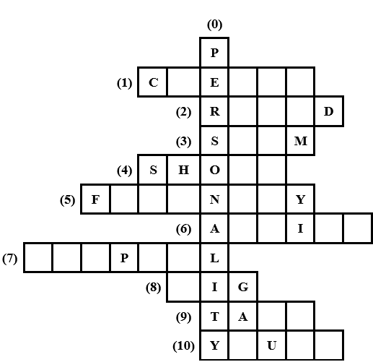  - Have Ss work in two groups. Give each group a crossword puzzle.  - Model with the first word  ex: personality.  - Ask two groups to look at the crossword puzzle carefully, then complete the words in it.  - Give Ss two minutes to do the task. Go around and give further support to the group who find it difficult to do the task.  - Check the answers as the class.  - The group with more correct words wins the game.  - Ask Ss to read all the words aloud.  - Say “Open your book page 26” and look at “Unit 3, Lesson 3 (1,2,3)”.  Activity 1. Listen and repeat:  *Aims: Ss will be able to correctly repeat with correct stress in the two syllable words, as in the words ‘active and ‘friendly, and in the sentences He’s an active boy. and She’s a friendly girl.  *Procedure:  - Have Ss point at the words ‘active and ‘friendly, and in the sentences He’s an active boy. and She’s a friendly girl.  - Play the recording for Ss to listen and repeat in chorus and individually until they feel confident.  - Let Ss work in pairs or groups, saying the words and reading the sentences.  - T invites some Ss to practice.  Activity 2. Circle, listen and check.  *Aims: Ss will be able toidentify the word stress on the two syllable words and circle the word with a different stress pattern from the other two words.  *Procedure:  - Tell Ss circle the word having a different stress from each line. Then listen to the recording to check their answers.  - Set a time for Ss to do the task.  - Play the recording, once or twice, for Ss to listen and check their answers.  - Get Ss to swap books with a partner and check their answers before checking as a class.  - Play the recording again for Ss to double-check their answers.  - Invite a few Ss to read aloud all the words in the words.  Key: 1.c 2.c 3.a  Activity 3. Let’s chant  *Aims: Ss will be able to say the chant with the correct pronunciation, word stress and rhythm.  *Procedure:  - Introduce the title and lyrics of the chant.  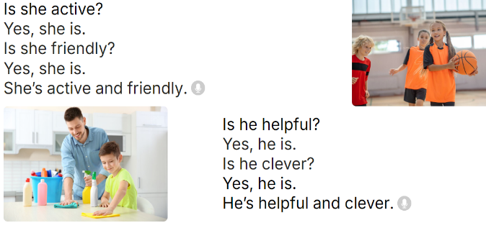  - Play the recording for Ss to listen to the whole chant.  + Have them repeat the title and lyrics line by line.  + Ask Ss to attend to two-syllable words with the stress on the first syllable in the chant, active, friendly, helpful and clever  - Play the recording all the way through for Ss to listen to pronunciation and melody.  - Play the recording line by line for Ss to listen and repeat  - Play the recording for Ss to chant and clap along.  - Ask Ss to practice chant and clap along in pairs or groups.  - Invite groups to the front of the classroom to perform the chant  Game: Circle jump  - Divide the class into groups. Have two groups make two lines to play the game.  - Draw four large circles on the floor.  - Place some word cards (active, friendly, clever, helpful) in each circle.  - Call out a word, and a student from each group has to run and stand inside the corresponding circle as quickly as possible.  - Ask Ss to say the word when standing in the circle.  - The first student saying the correct word gets a point for their group. The group with more points wins the game. | - Follow the T’s instructions.  - Look at the crossword puzzle carefully, then complete the words in it.  - Do the task in two minutes.  - Check the answers in the class.  *Key:  0. personality 1. clever  2. round 3. slim 4. Short  5. friendly 6. active  7. helpful 8. big  9. tall 10. young  - Praise the winner.  - Read all the words aloud  - Ss open their books  - - Ss point and pay attention  - Ss listen to the recording again and repeat.  -Ss work in pairs and practice  -Ss say the language in front of the class  - Ss pay and listen to the teacher’s explanation.  - Ss do the task  - Ss listen to the recording to check their answers (individual)  - Ss swap books with a partner and check the answers  - Ss listen to the recording again and check their answers again.  - Ss stand up and read aloud the words.  - Ss look and listen.  - Ss listen to the chant  - Ss listen and repeat line by line without clap their hands  - Ss note the rhythm and pronunciation.  -Ss listen to melody of the chant  - Ss listen and chant line by line.  - Ss chant and clap along.  - Ss work in groups (two groups) to chant  -Ss perform in front of the class.  -Ss listen  -Ss listen  -Ss play the game  -Ss praise the winner

