Week 1 Preparing date: September 8th,
Period 4 Teaching date: September 11th,

STARTER
C. Outdoor activites
A. OBJECTIVES:
By the end of the lesson, Ss will be able to revise some competences learnt in Grade 3:
1. Knowledge:
- greeting, introducing themselves and introducing each other.
- talking about activities in the classroom.
- talking about outdoor activities.
- Vocabulary: Review
- Skills: listening, speaking and reading.
2. Competences:
- Oral communication: let’s play and say.
- Sociability: talk to each other, say good words to others.
3. Attitude/ Qualities:
- Honesty: tell the truth about feelings and emotions.
- Responsibility: appreciate kindness
B. TEACHING AIDS:
- Teacher: Teacher’s guide Page 14, 15, website hoclieu.vn, posters, laptop, pictures, textbook, lesson plan, TV or projector.
- Students: Pupil’s book Page 9, notebooks, workbooks, school things.
C. PROCEDURES:
Stages/Time | Teacher’s activities | Students’ activities
1.Warm- up: (3’)  2. Practice (30’)  3. Homework. (2’) | Sing a song: What are you doing?  *Aims: to create a friendly and active atmosphere in the class to beginning the lesson.  *Procedure:  - Show the song on the screen.  https://www.youtube.com/watch?v=HrHqq8xJiU4  - Ask pupils to listen, sing and dance the song.  - Say “Open your book page 9” and look at “Starter, Outdoor activites”.  Activity 1. Let’s play  *Aims: Ss will be able to practise the names of outdoor activites by playing “Miming game”  *Procedure:  - Elicit the language that pupils need to talk about break time activites.  + Ex: What are they doing?  They’re…………..(swimming, running, singing, skating, skipping).  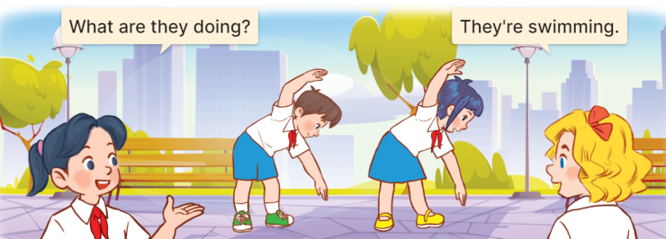  - Explain how the game is played:  + Two pupils mime the action of an activity.  + One pupil ask What are they doing?  + And the other pupils guess the action and answer.  - Divide class into groups of five to play the game.  - The team that guesses the correct answer first gets one point or star.  - The team with the most points or stars is the winner.  Activity 2 Follow the lines and say  *Aims: Ss will be able to match the pupils with the pictures ans talk about their hobbies.  *Procedure:  - Tell pupils the goal of the activity and explain that they should follow the lines to match the pupils with the pictures, point to the pupils and say what their hobbies are.  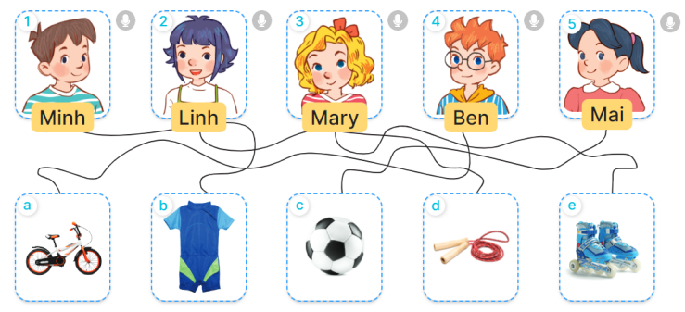  - Do the first picture as an example:  + First, have pupils look at Minh and the the line to Picture b (a swimsuit).  + Then have them say: “Look at Minh. His hobby is swimming”.  - Set a time limit for pupils to do the activity independently. Go around the classroom and offer help if necessary.  - Get pupils to swap books with a partner and check their answer.  - Check the answer together.  - Invite some pupils to look at the task they have done and talk about pupils’ hobbies in front of the class.  Activity 3: Read and act out:  *Aims: Ss will be able to read the chant aloud and act out with the help of the lyrics and picture cues.  *Procedure:  - Have pupils look at the first picture to identify the meaning of the first two lines.    - Get pupils to read aloud the first line and jump up. Then have them read the second line aloud and jump up high.  - Give pupils a time limit to read the first verse and act out in pairs or groups.  - Go around the classroom and give further support to pupils who find it difficult to do the task.  - Repeat with the second and third verses of the chant.  - When pupils are familiar with the verses and actions, ask them to read the whole chant aloud and act out.  - Invite a few groups to the front of the class to say the chant and act out.  *Consolidation  *Aims: Ss will be able consolidate and wrap up the content of the lesson.  *Procedure:  - T asks ss to answer the following questions:  + What have you learnt from the lesson today?  - T review the outdoor activities.  - Learn the outdoor activities by heart  - Prepare the new lesson: Unit 1: My friends- Lesson 1. | - Ss listen  - Sing and dance the song in chorus.  - Ss listen and open their books.  - Ss listen and answer  -Ss listen and pay attention  -Ss play the game  -Ss play the game  -Ss listen  -Ss look and pay attention  -Ss look at the picture and the line  -Ss look and say  -Ss do the tak  -Ss swap books together  - Ss check the answer  -Ss say about the pictures  -Ss look t the picture and answer.  - Ss read and act out  -Ss read and act out in pairs  - Ss work in pairs  -Ss listen and repeat  -Ss read and act out the whole chant  -Ss say the chant and act out in font of the class.  -Ss answer the questions  - Ss listen  -Ss listen

D. ADJUSTMENTS (if necessary):
………………………………………………………………………………………….…..……………………………………………………………………………...………………………………………….…..……………………………………………………………………………….…………………………………………………

