Week 1 Preparing date: September 4th,
Period 2 Teaching date: September 6th,

STARTER
A. Hello again!
A. OBJECTIVES:
By the end of the lesson, Ss will be able to revise some competences learnt in Grade 3:
1. Knowledge:
- greeting, introducing themselves and introducing each other.
- talking about activities in the classroom.
- talking about outdoor activities.
- Vocabulary: Review
- Skills: speaking and listening
2. Competences:
- Oral communication: introduce themselves
- Co-operation: ready to help friends in pair work/ group work.
- Sociability: Talk to each other, say good words to others.
3. Attitude/ Qualities:
- Kindness: Help partners to complete learning tasks.
- Honesty: tell the truth about feelings and emotions.
B. TEACHING AIDS:
- Teacher: Teacher’s guide Pages 10-11, audio Tracks 1,2, website hoclieu.vn, posters, laptop, pictures, textbook, lesson plan, TV or projector.
- Students: Pupil’s book Page 7, notebooks, workbooks, school things.
C. PROCEDURES:
Stages/Time | Teacher’s activities | Students’ activities
1.Warm- up:  (3’)  2. Practice (30’)  3. Homework. (2’) | Sing a song: Hello song  *Aims: to create a friendly and active atmosphere in the class to beginning the lesson.  *Procedure:  - Show the song on the screen.  https://www.youtube.com/watch?v=tVlcKp3bWH8  - Ask pupils to listen, sing and dance the song.  - Say “Open your book page 7” and look at “Starter, Hello again!”.  Activity 1. Let’s sing  *Aims: Ss will be able to sing the song “Hello. How are you?” with the correct pronunciation, rhythm and melody.  *Procedure:  - Draw pupils’ attention to the lyric of the song.  - Have pupils read the verses of the lyrics.  - Have pupils listen to the verses, check comprehension, drawing their attention to the pronunciation, rhythm and melody.  + Minh meets and greets Lucy on the first day of school.  + Nam introduces Mary and Mai.  - Listen to and practise singing the song, line by line, while clapping their hands.  - Ask pupils to listen to and sing the whole song while clapping their hands.  - Invite a few groups to the front of the class to sing the song.  Activity 2. Listen and tick:  *Aims: Ss will be able to listen and understand a short text in which Ms Hoa greets the characters in the classroom and tick the correct pictures.  *Procedure:  - Draw pupils’ attention to the characters and check comprehension.  + Who is he/she?  + Where is he/she?  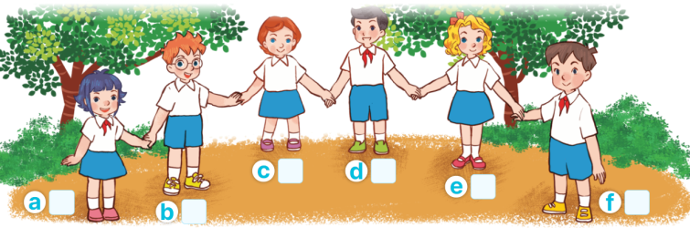  - Play the recording all the way through.  - Play the recording and tick the pictures.  - Tell pupils to swap their books with their partners, then check answers together as a class.  - Have Ss to listen and repeat in chorus, sentence by sentence. Correct their pronunciation where necessary.  Key: f (Minh); b (Ben); a (Linh); c (Lucy)  Activity 3. Let’s play  *Aims: Ss will be able to spell some words learnt in Grade 3 by playing the game “Spelling bee”.  *Procedure:  - Before playing the game, have pupils look at the English alphabet and sing The Alphabet song or spell the letters of the song.  - Tell pupils that they are going to spell some words they have learnt.  - Explain how to play the game. Check comprehension and give feedback.  - Write the words on a piece of paper or on the board.  - Call a group of four pupils to the front of the class.  - Give the piece of paper to one of group members and ask him/her to say on word (ex: friend). The other members spell the word (ex: F-R-I-E-N-D). The pupil who correctly spells the word first gets one point or star.  - The pupil who has the most points or stars at the end of the game wins.  *Consolidation  *Aims: Ss will be able consolidate and wrap up the content of the lesson.  *Procedure:  - T asks ss to answer the following questions:  + What have you learnt from the lesson today?  - T review the song.  - Learn the song.  - Prepare the new lesson: B.Classroom activities. | - Sing and dance the song in chorus.  - Ss listen and open their books.  -Look at the board and listen.  -Ss listen and read.  -Ss listen and and answer  -Ss listen again and repeat.  -Ss listen and sing whole song.  -Ss sing in front of the class.  -Look at the screen and listen.  - Ss look, listen and answer.  -Ss listen to the tape and tick  -Ss listen again and check themselves  - Ss swap their books with their partners and check answers.  - Ss listen and repeat in chorus  -Ss look and sing a song.  -Ss listen and note.  -Ss listen and remember  -Ss listen  -Ss go the board and play the game.  - Ss play the game  -Ss get the point or star.  - Ss listen and answer.  -Ss listen and pay attention.
D. ADJUSTMENTS (if necessary):
………………………………………………………………………………………….…..……………………………………………………………………………...………………………………………….…..……………………………………………………………………………….……………………………………………………………………...

