LESSON PLAN
UNIT 8: MY SCHOOL THINGS (cont.)
Period 54 Lesson 3 (1, 2&3)
Class 3A Date of teaching: December 6th, 2023
A. OBJECTIVES:
By the end of the lesson, students will be able to:
1. Knowledge:
- Correctly repeat the sounds of the letter cluster oo and letter a in isolation, in the words book and eraser, and in the sentences I have a book. and Do you have an eraser? with correct pronunciation and intonation.
- Identify the target words book and eraser while listening.
- Say the chant with the correct rhythm and pronunciation.
- Vocabulary: Review
- Skills: Speaking, listening, reading and writing.
2. Competences:
- Listening: Listen and repeat, listen and circle.
- Critical thinking: Listen and circle.
- Oral communication: Let’s chant.
- Co-operation: Ready to help friends in pair work/ group work.
- Sociability: Talk to each other, say good words to others.
3. Attitude/ Qualities:
- Diligence: Complete learning tasks
- Self-confidence: Develop the ability to work as a team member.
- Kindness: Help partners to complete learning tasks.
- Honesty: Tell the truth about feelings and emotions.
B. TEACHING AIDS:
- Teacher: Teacher’s guide Pages 107, 108; audio Tracks 84, 85, 86; website sachmem.vn, posters, laptop, pictures, textbook, lesson plan and TV or projector.
- Students: Pupil’s book Page 60, notebooks, workbooks and school things.
C. PROCEDURES:
Stages/Time | Teacher’s activities | Students’ activities
1. Warm- up  (5mins)  2. Presentation  (12mins)  3. Practice:  (13mins)  4.Consolidation  (4mins)  4. Homework  (1min) | - Greet the class and introduce some teachers.  - Ask students the question: “How are you?”  - Guide students to play the game.  “ Hot seat”  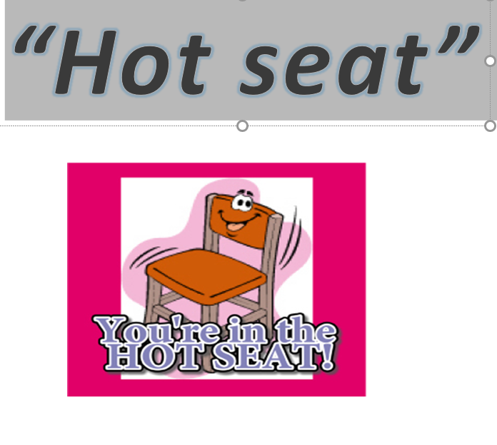  * Aims: Ss will be able to create a friendly and active atmosphere in the class to beginning the lesson.  * Procedures:  Tell pupils how to play the game:  - First, split the class into two teams.  - Then vote about 5 players for each team.  - One person from each team to sit in the "Hot Seat", facing the classroom, back facing the board.  - As the teacher gives the pictures or vocabulary items .  - Whole class look at the pictures and do actions. ( Don’t say anything, and the players don’t look at the board.)  - The players in the hot seat look at actions and try to guess the word.  - The first hot seat player to say the word wins a point for their team.  - Then change the player over, with a new member of each team taking their place in their team's hot seat.  * School things:  1. pen 2. eraser 3. school 4. book  5. notebook  - Remark and give the present for winning team.  - Lead to the new lesson: “ We have just reviewed some school things and today we will learn to pronounce these words more clearly.”  - Ask students to open their books on  page 60 and notebooks to write the new lesson.  UNIT 8: MY SCHOOL THINGS (cont.)  Period 54 Lesson 3 - Part (1, 2, 3)  Activity 1. Listen and repeat.  *Aims: Ss will be able to correctly repeat the sounds of the letter cluster oo and letter a in isolation, in the words book and eraser, and in the sentences I have a book. and Do you have an eraser? with correct pronunciation and intonation.  *Procedures:  - Give out the picture ( book ) and  lead Ss to learn the sound of the letter cluster “oo” and tell Ss how to  say this sound.  - Have Ss say this sound in chorus then individual.  - Introduce more pictures (cook, goodbye) by asking some questions. (What’s this?/ Who’s she?/, ….?)  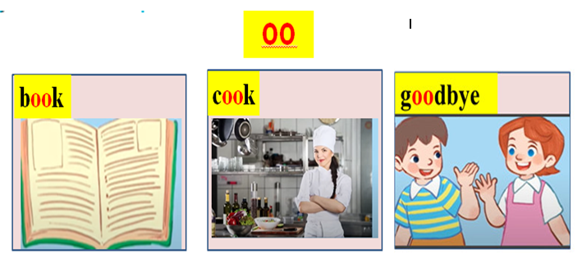  - Have Ss say the sound oo in the words book, cook and goodbye.  - Have Ss watch video the sound “oo”  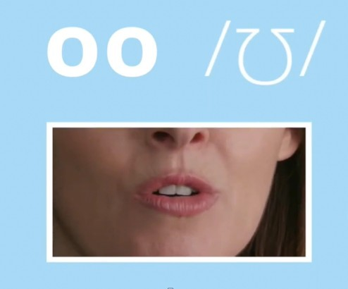  - Give the instruction the sound of the letter “a”  - Ask Ss to practise the sound of the letter “a” in the the words: eraser, cake, and table in group then individual.  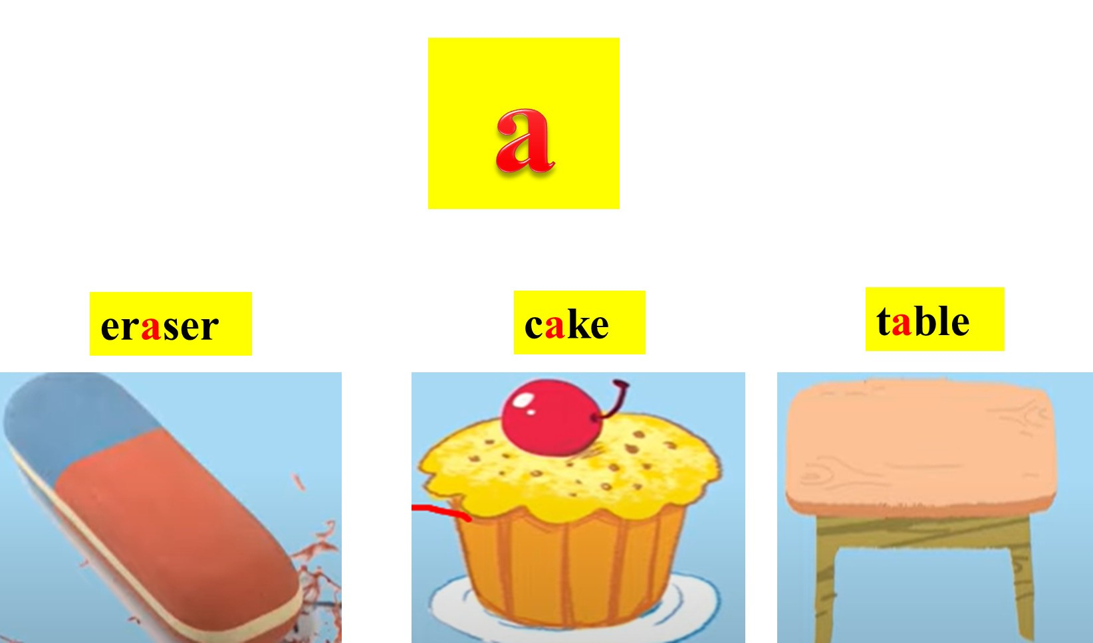  - Have Ss watch video and follow.  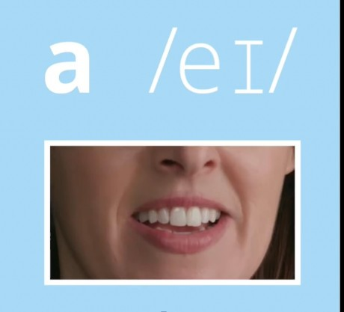  - Have Ss to practise two sounds “oo” and “a” in chorus.  - Ask Ss to look at the model to listen and repeat.  1.Listen and repeat.  oo book I have a book.  a eraser Do you have an eraser?  - Draw pupils’ attention to the letter cluster oo, the word book and the sentence I have a book.  - Play the recording for pupils to listen and repeat.  - Encourage them to point at the letters / word/ sentence while listening.  - Play the recording again.  - Ask Ss to read model in chorus and individual.  Ask Ss to work in pair to practise finding the same sounds but the different words.  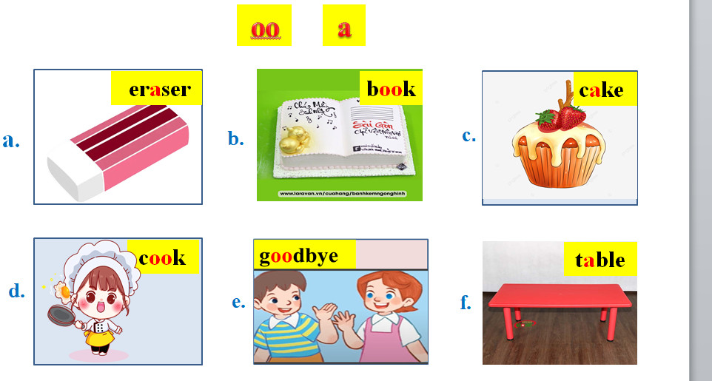  - Invite some pairs to the front of the class and say the sounds and the words.  - Introduce the game.  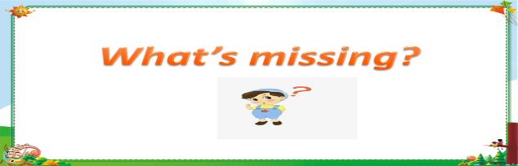  *Aims: Ss will be able to create and active atmosphere in the class while learning the lesson.  - Give out some pictures and ask Ss to say them in chorus and in individual.  - Put the pictures on the board and ask Ss to remember.  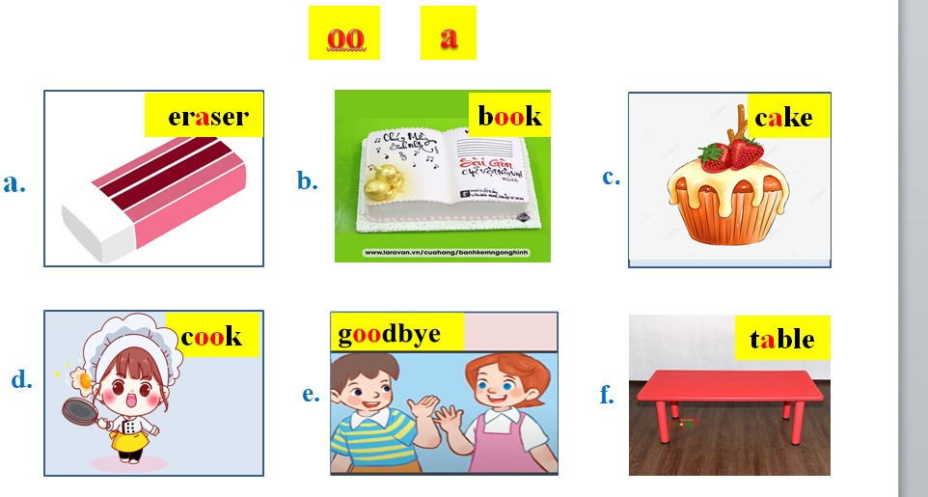  *Procedures:  - Say: “ You are a rabbit, follow me: eating, drinking and sleeping, and then Ms Van will pick up one picture away, when you wake up, which one is missing, can you say it aloud?”.  - Have Ss to play the game.  - Remark and give the feedback.  - Lead to the part 2 by saying “ to practise the sounds and the words about school things more clearly, let’s learn part 2.”  Activity 2. Listen and circle.  1. I have________.  a. a book b. an eraser c. a pencil case  2. Do you have_______?  a. a pencil case b. an eraser c. a book  - Draw students’ attention to the sentences and the gap-fill options. Tell them about the activity.  - Play the recording for Sentence 1 for students to listen.  - Play the recording again for them to listen and circle the correct option.  - Play the recording a third time for students to check their answers.  - Repeat the procedures for Sentence 2.  - Write the correct answers on the board.  - Play the recording for students to check their answers again.  - Invite one or two students to stand up, listen and repeat the completed sentences.  * Key: 1.b 2.c  - Give Ss handouts and guide what Ss  have to do. ( When teacher says the words (in the pictures) having the sounds oo or the sound a, students show the correct sounds.)  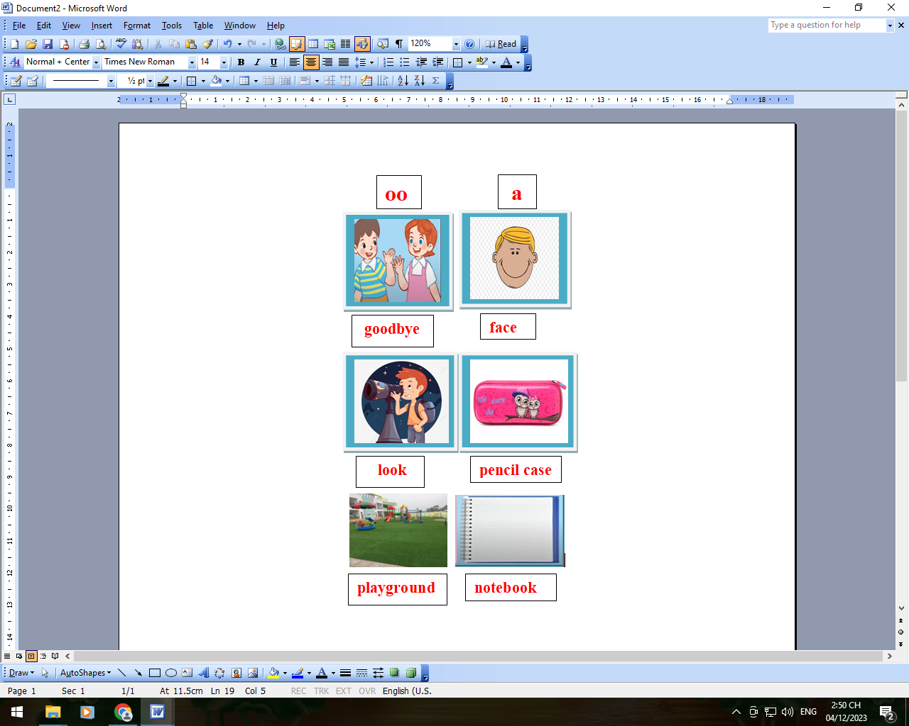  - Remark and give the feedback.  - Lead to part 3 by saying “Would you like to chant?”  Activity 3. Let’s chant.  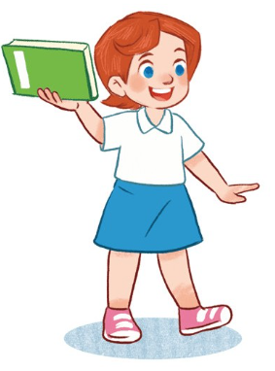  Book, book, book.  I have a book.  Do you have a book?  Yes, I do. Yes, I do.  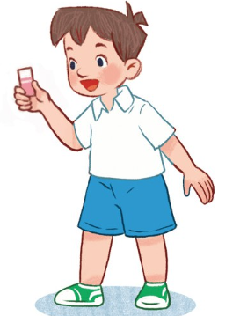  Eraser, eraser,eraser.  I have an eraser.  Do you have an eraser?  No, I don't. No, I don't.  *Aims: Ss will be able to say the chant with the correct rhythm and pronunciation.  *Procedures:  - Draw students’ attention to the lyrics of the chant. Check comprehension of the lyrics and give feedback.  - Play the recording all the way through so that pupils can listen to the whole chant.  - Ask Ss to listen and chant, then clap the hands in chorus and groups.  - Encourage them to listen carefully to the rhythm and pronunciation.  - Draw their attention to the sounds of the letter cluster oo and letter a in the words book and eraser in the chant.  - Chant line by line for Ss to listen and repeat.  - Correct their pronunciation where necessary.  - Ask Ss to sing karaoke .  - Call some Ss to the front of the class and sing karaoke.  - Give the feedback.  - Ask Ss to make another chants in groups by changing the name of school things and practise chanting.  *Let’s chant.  .  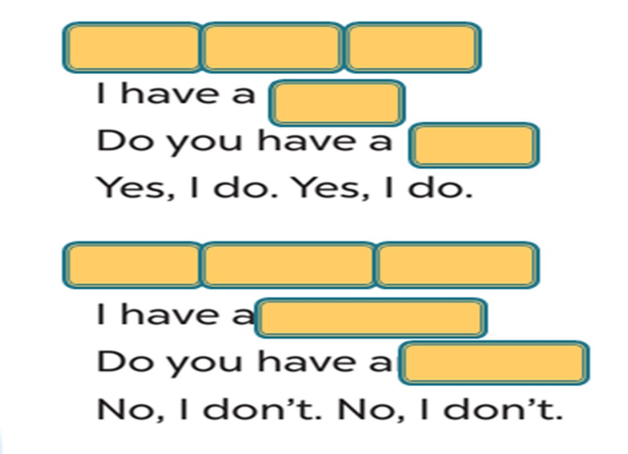  .  .  ?  .  ?  - Divide the class into six groups and give handouts.  - Help Ss correct the mistakes. ( If necessary.)  - Ask Ss to perform the chant to the front of the class.  - Praise and educate by saying “School things are really important. You have to bring to school and keep them carefully.”  - Repractise the sounds: (oo, a)  - Prepare the next lesson: Unit 8- Lesson 3: Part 4, 5, 6 | - Greet the teachers.  - Answer the question.  - Listen to teacher’s instruction about the game.  - Play the game.  - Open the books and notebooks to write the new lesson.  - Write the title on their notebooks.  - Listen and repeat the sound “oo” in chorus .  - Say the sound in chorus  then individual.  - Look at the pictures and answer the questions:  + It’s a book.  + She’s a cook.  + They say “goodbye”.  - Say the sound and the words in chorus then individual.  - Watch and follow the video.  - Practise the sound “a” and the words.  - Say the sound and the words in group then individual.  - Watch and follow the video.  - Practise the sounds “oo, a”  - Listen and repeat in chorus.  - Work in pairs.(2-3 pairs.)  - Read the model and clap the hands in chorus then individual.  - Look at and practise in pairs.  - Say the sounds and words in front of the class in pairs.  - Listen to teacher’s instruction.  - Say in chorus then individual.  - Look at and remember.  - Listen to the instructions of the game.  - Play the game.  - Listen and circle.  - Circle the correct answers.  - Read the completed sentences.  - Listen the teacher’s request.  - Listen and show the sounds “oo” or “a ”.  - Listen to the chant.  - Listen and chant in chorus and groups.  - Chant and clap the hands.  - Chant line by line after teacher.  - Sing karaoke ( whole class)  - Sing karaoke in the front of the class.  -Work in groups.  -Write the names of school things and practise the chant.  - Perform in front of the class in group.  - Listen to the teacher’s education.  - Write homework on their notebooks.

