Week 3 Preparing date: September ………,
Period 12 Teaching date: September ………..,

Unit 2: Our names
Lesson 1 (4,5,6)
A. OBJECTIVES:
By the end of the lesson, Ss will be able to:
1. Knowledge:
- use What’s your name? – My name’s…... to ask and answer questions about names
- listen to and demonstrate understanding of simple communicative contexts in relation to the topic "Our names"
- read and write about people’s names
- Vocabulary: Review
- Skills: speaking, listening, reading and writing.
2. Competences:
- Critical Thinking: self-introduce
- Co-operation: ready to help friends in pair work/ group work.
- Self-control and independent learning: perform listening tasks.
3. Attitude/ Qualities:
- Kindness: Help partners to complete learning tasks.
- Honesty: tell the truth about feelings and emotions.
- Diligence: complete learning tasks.
B. TEACHING AIDS:
- Teacher: Teacher’s guide Pages 28,29; audio Tracks 17; website sachmem.vn, posters, laptop, pictures, textbook, lesson plan, TV or projector.
- Students: Pupil’s book Page 17, notebooks, workbooks, school things.
C. PROCEDURES:
Stages/Time | Teacher’s activities | Students’ activities
1.Warm- up:  (5’)  2.Practice: (27’)  3. Homework. (3’) | Game: Interview your friend(s).  *Aims: to create a friendly and active atmosphere in the class to beginning the lesson.  *Procedure:  - Each Ss gets 1 sheet of paper from the teacher.  - Ask Ss fill in the information about themselves. Then they can move around the class to ask and answer the questions to know more about their friends’ family member.  -Have Ss perform in front of the class  - T gives feedback.  - Say “Open your book page 17” and look at “Unit 2, Lesson 1 (4,5,6)”.  Activity 1. Listen and tick:  *Aims: Ss will be able to listen to and understand two dialogues in which pupils ask and answer questions about names.  *Procedure:  - Elicit the names of the characters in the pictures.  - Point at the pictures respectively to explain the context.  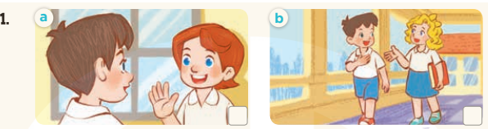  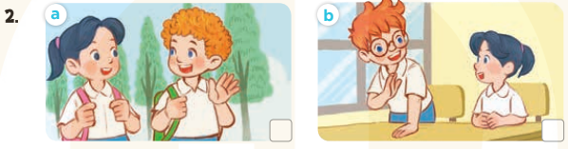  - T ask Ss to guess the answers.  + T writes Ss’guessing on the board.  - Listen to the tape:  + Play the recording  + Play the recording again and get Ss to swap books with their partners.  + Play the recording again to check answers together as a class.  + Write the answers on the board for Ss to correct their answers. Then checks Ss’ guessing.  - Play the recording, sentence by sentence, for the class to listen and repeat in chorus.  Key: 1.b 2.a  Activity 2. Look, complete and read.  *Aims: Ss will be able to complete three target sentence patterns with the help of picture cues.  *Procedure:  - Get Ss to look at the pictures and identify the characters  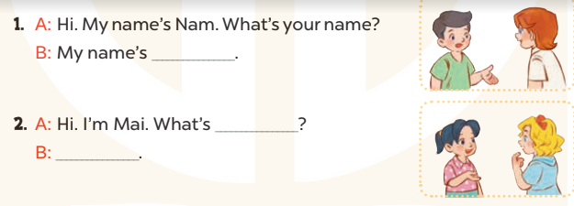  - Have Ss look at the three incomplete sentences and elicits the missing words in the sentences.  - T models with sentence 1  + Ask Ss what is missing in the sentence.  + Have Ss look at the picture and complete the gap, then read the completed sentence in chorus.  -Have Ss work in groups and complete the sentence 2.  - Ask a few Ss to stand up and read the completed sentences aloud.  -T gives feedbacks.  Key:  - Lucy 2. your name; Mary  Activity 3. Let’s play.  *Aims: Ss will be able to review the characters’ names by playing the game Slap the board.  *Procedure:  - Divide class into 2 groups  - How to play:  + Put the flash cards or write the words of the six pupils on the board.  + Each group chooses six Ss to play.  + Invite one Ss to the front of the class and ask What's your name? The class answers the question aloud with one of the names on the board (ex: My name's Bill).  + Look at the picture, listen and slap the picture you heard.  + Who faster will get 1 mark.  + Which group with higher mark is the winner.  - T gives feedback.  *Consolidation  *Aims: Ss will be able consolidate and wrap up the content of the lesson.  *Procedure:  - T asks ss to answer the following questions:  + What have you learnt from the lesson today?  +What are the core values of the lesson? (if the teacher can take from the lesson).  - T praises some Ss who are hardworking / active/ good…. as well as encourage others to try more.  - Ask and answer about the pictures on page 17.  - Prepare the new lesson: Unit 2, Lesson 2 (1,2,3). | - Ss listen  -Ss interview their friends and fill in their paper  -Ss perform  - Ss open their books  -Look at the pictures and say:  + Picture 1a: Minh greets Lucy and asks her name.  + Picture 1b: Minh greets Mary and asks her name.  + Picture 2a: Mai greets Bill and asks his name.  + Picture 2b: Mai greets Ben and asks his name.  -Ss guess the answers  - Ss listen to the tape and tick  - Ss listen again, tick and swap books with their partners.  - Ss check their answers and guessing  -Ss listen and repeat.  -Ss look at the picture and say:  + They’re Nam, Lucy in picture a  + They’re Mary and Mai in picture b  -Ss listen and answer  -Ss answer: My name’s Lucy  -Ss look, complete and read the completed sentence in chorus.  -Ss complete the sentence  -Ss read aloud  - Ss look and listen.  -Ss play game  -Ss listen to the teacher.  -Ss answer the questions  -Ss listen and clap their hands  -Ss listen and take note
D. ADJUSTMENTS (if necessary):
………………………………………………………………………………………….…..……………………………………………………………………………...………………………………………….…..……………………………………………………………………………….……………………………………………………………………...

