Week 3 Preparing date: September …….
Period 11 Teaching date: September ……,

Unit 2: Our names
Lesson 1 (1, 2, 3)
A. OBJECTIVES:
By the end of the lesson, Ss will be able to:
1. Knowledge:
- use the words what, your, name, my in relation to the topic “Our names”
- use What’s your name? – My name’s ………. to ask and answer questions about name
- listen to and demonstrate understanding of simple communicative contexts in relation to the topic "Our names"
- Vocabulary: what, your, name, my
- Skills: speaking and listening
2. Competences:
- Oral Communication: speak about names, ask and answer the questions
- Co-operation: ready to help friends in pair work/ group work.
- Sociability: Talk to each other, say good words to others.
3. Attitude/ Qualities:
- Kindness: Help partners to complete learning tasks.
- Honesty: tell the truth about feelings and emotions
- Diligence: complete learning tasks
B. TEACHING AIDS:
- Teacher: Teacher’s guide Pages 26, 27, audio Tracks 15,16, website sachmem.vn, posters, laptop, pictures, textbook, lesson plan, TV or projector.
- Students: Pupil’s book Page 16, notebooks, workbooks, school things.
C. PROCEDURES:
Stages/Time | Teacher’s activities | Students’ activities
1.Warm- up:  (3’)  2. Presentation  (16’)  3.Practice: (7’)  4.Production: (7’)  5. Homework. (2’) | Game: Who is faster?  *Aims: to create a friendly and active atmosphere in the class to beginning the lesson.  *Procedure:  - Divide the class into groups.  - Arrange the flashcards on the board.  - Invite a student from each group to go to the board.  - T says a word and the students run to tap the right card.  - The group has more cards that will be the winner.  - Say “Open your book page 16” and look at “Unit 2, Lesson 1 (1,2,3)”.  Activity 1. Vocabulary.  *Aims: Ss will be able to know the vocabulary in front of starting the new lesson.  *Procedure:  -T elicits the new words  + what : gì, cái gì (translation)  + name : tên (situation)  + my : của tôi (translation)  + your : của bạn (translation)  - T models (3 times).  - T writes the words on the board.  - Checking: Rub out and remember  Activity 2. Listen, point and repeat:  *Aims: Ss will be able to understand and correctly repeat the sentences in two communicative contexts (pictures) focusing on asking and answering questions about names.  *Procedure:  - Have pupils look at Pictures a and b and identify the characters in the pictures.  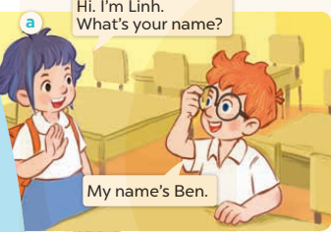  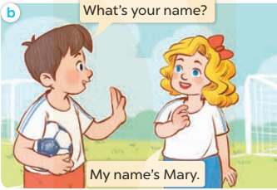  - Play the audio twice (sentence by sentence). Correct their pronunciation where necessary.  - Have Ss to practice the dialogue  - T invites a few pairs to the front of the class to practice.  - T checks pronunciation for ss.  Activity 3 Listen, point and say.  *Aims: Ss will be able to correctly say the character names and use What's your name? - My name's ….. to ask and answer questions about names.  *Procedure:  * Model sentences:  - T asks Ss look at picture a and helps Ss know the structure from the dialogue.  - T introduces new structure for Ss.  - T explains, models and gives meaning.  -Have Ss repeat the model sentences.  * Note: What’s = what is  My name’s = my name is  *Drill pictures  - Elicit and check comprehension the name of each character.  - Run through all the pictures.  - Run through model sentences.  + Run through the questions.  + Run through the answers.  - Have Ss to practise:  + T asks the first – Ss answer (change role).  + Ss – Ss (change role).  - Ask Ss to work in pairs to ask and answer the question What’s your name? My name’s……  - T controls and corrects.  - Invite a few pairs to come to the front of the classroom, point at the relevant character in each picture, and act out his/her role.  - Encourage Ss to practise speaking English.  - T gives feedbacks.  Activity 4. Let’s talk.  *Aims: Ss will be able to enhance the correct use of What’s your name? and My name’s…. . to ask and answer questions about names.  *Procedure:  - T asks ss look at the second bubble and ask  +What’s your name?  - Get Ss to repeat the question and the answer several times in pairs.  - T models: Go around the classroom, pointing to Ss and asking What’s your name?  - Ask Ss ask and answer about their own names in pairs.  - Invite some groups to perform in front of the class.  - Give feedbacks  *Consolidation  *Aims: Ss will be able consolidate and wrap up the content of the lesson.  *Procedure:  - T asks ss to answer the following questions:  + What have you learnt from the lesson today?  +What are the core values of the lesson? (if the teacher can take from the lesson).  - T review the vocabulary and model sentences.  - T praises some Ss who are hardworking / active/ good…. as well as encourage others to try more.  - Learn the vocabulary and model sentences by heart  - Prepare the new lesson: Unit 2, Lesson 1 (4,5,6). | - Ss listen.  -Ss look at the board  - Ss play the game  - Ss listen and clap their hands  - Ss open their books  -Ss listen and answer  - - Ss listen and repeat  + Choral repetition (3 times).  + Individual repetition (3 ss)  - Ss take note  - Ss look, remember and write  -Look at the pictures and get to know the characters in the pictures.  + In picture a: Linh says: Hi. I’m Linh. What’s your name? And Ben answers: My name’s Ben.  + In pucture b: Minh asks: What’s your name? And Mary answers: My name’s Mary.  -Ss listen and repeat in chorus (twice)  -Ss work in pairs to practice  -Ss practice the dialogue  -Ss listen  -Ss look at the picture and answer.  -Ss listen  -Ss listen and repeat  -Ss repeat to the introduce and respond to greetings.  - Ss look, listen and repeat  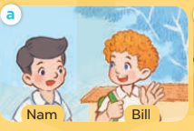  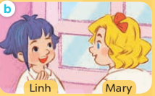  -Ss practice in chorus  -Ss work in pairs to practice  -Ss point and ask and answer  -Ss listen.  -Ss listen  -Ss look at the picture and answer  + My name’s Mai  -Ss ask and answer  - Ss answer  -Ss work in pairs  -Ss perform in front of the class.  -Ss answer the questions  - Ss listen  -Ss listen and clap their hands  -Ss listen and take note

D. ADJUSTMENTS (if necessary):
………………………………………………………………………………………….…..……………………………………………………………………………...………………………………………….…..……………………………………………………………………………….……………………………………………………………………...

