Week 3 Preparing date: September …..,
Period 10 Teaching date: September …………,

Unit 1: Hello
Lesson 3 (4,5,6)
A. OBJECTIVES:
By the end of the lesson, Ss will be able to:
1. Knowledge:
- read four sentences and choose the correct responses about the topic “Greetings and goodbye”.
- read, understand and complete three exchanges with their personal information about the topic “Greetings and goodbye”.
- Vocabulary: Review
- Skills: speaking, listening, reading and writing.
2. Competences:
- Critical Thinking: self-introduce
- Co-operation: ready to help friends in pair work/ group work.
- Self-control and independent learning: perform listening tasks.
3. Attitude/ Qualities:
- Kindness: Help partners to complete learning tasks.
- Honesty: tell the truth about feelings and emotions.
- Diligence: complete learning tasks.
B. TEACHING AIDS:
- Teacher: Teacher’s guide Pages 26, 27; website sachmem.vn, posters, laptop, pictures, textbook, lesson plan, TV or projector.
- Students: Pupil’s book Page 15, notebooks, workbooks, school things.
C. PROCEDURES:
Stages/Time | Teacher’s activities | Students’ activities
1.Warm- up:  (5’)  2.Practice: (8’)  3.Production: (19’)  4. Homework. (3’) | Game: “Nought and crosses”  *Aims: to review the vocabulary and structure about greet and respond to greetings.  *Procedure:  - T helps ss to review the vocabulary and structure about greet and respond to greetings, using “How are you? and fine, thank you.  - T introduces how to play game.  - T reviews structure before play game.  - T guides Ss play game:  + Divide class into 2 groups.  + T gives Ss to watch the picture.  + T will ask “How are you?” and Ss will answer  + Ss have correct answers, they will get a nought or cross and choose the way so that they win.  + The group has more correct answers that will be the winner and get a flower.  - T gives feedback.  - Say “Open your book page 15” and look at “Unit 1, Lesson 3 (4,5,6)”.  Activity 1. Read and circle:  *Aims: Ss will be able to read four sentences and choose the correct responses.  *Procedure:  - Elicit the context and give feedback.  - T models with sentence 1.  + Get Ss to read Sentence 1  + Elicit the answer and give feedback. Circle the letter b.  -Have Ss work in pairs and circle the sentences 2, 3 and 4.  - Tell Ss to swap books with a partner, then check answers together as a class.  - Write the correct answers on the board for pupils to correct their answers.  - Invite pairs of Ss to stand up and role play  -T gives feedbacks.  Key: 1. b 2. a 3. a 4.b  Activity 2. Let’s write  *Aims: Ss will be able to read, understand and complete three exchanges with their personal information.  *Procedure:  - Get Ss to look at the pictures and identify the characters  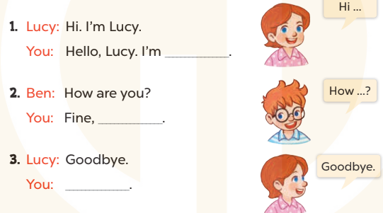  - Elicit the context and the missing words  - T models with sentence 1  + Ask Ss what is missing in the sentence.  + Have Ss complete the gap, then role -play the exchange.  -Have Ss work in groups and complete the sentences 2 and 3.  - Get Ss to swap books with a partner, then check the answers together as a class.  - Ask a few Ss to stand up and role play the completed sentences aloud.  -T gives feedbacks.  Key:  1. Pupil’s answer  2. thank you/ thanks  3. Goodbye/ bye  Activity 3. Project.  *Aims: Ss will be able to make a pupil card for pupils to use, and use their work to practise talking to their classmates.  *Procedure:  - Stick the pupil card sample on the board and model with the name, class, school.  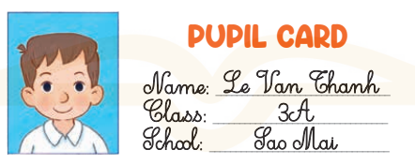  - T asks Ss to make their name cards and present them to their class.  - T asks ss to work in group and do the project in class.  - T calls some Ss to the front of the class to present their cards, using their name card and saying Hello.I’m + (name).  - Have Ss to stick their cards on the wall of the classroom  - Create a class display of pupil cards and vote for the best decorated one.  - T gives feedback.  *Consolidation  *Aims: Ss will be able consolidate and wrap up the content of the lesson.  *Procedure:  - T asks ss to answer the following questions:  + What have you learnt from the lesson today?  +What are the core values of the lesson? (if the teacher can take from the lesson).  - T praises some Ss who are hardworking / active/ good…. as well as encourage others to try more.  - Learn the number by heart  - Prepare the new lesson: Unit 1, Lesson 2 (1,2,3). | - Ss listen and answer  - Ss listen to the rules  -Ss play game  - Ss listen  - Ss open their books  - Ss look at the sentences and say  -Ss read and circle  -Ss work in pairs and circle  -Ss swap books and check  -Ss check the correct their answers  -Ss role play  -Ss listen  -Ss look at the picture and say:  + They’re Ben and Lucy  -Ss look and answer  -Ss answer: I’m…….  -Ss complete and role play  -Ss complete the sentences  -Ss swap books and check their answers  -Ss role play  -Ss listen  - Ss look and listen  -Ss prepare necessary school things to carry out the project (paper, pens, pencils, coloured pencils, scissors , glue,…..)  -Ss make their name cards and present them to their class.  -Ss work in groups  -Ss present their cards  - Ss stick their cards on the wall of the classroom.  -Ss vote  -Ss listen  -Ss answer the questions  -Ss listen and clap their hands  -Ss listen and take note
D. ADJUSTMENTS (if necessary):
………………………………………………………………………………………….…..……………………………………………………………………………...…………

