Week 3 Preparing date: September …..,
Period 9 Teaching date: September ………….,

Unit 1: Hello
Lesson 3 (1, 2, 3)
A. OBJECTIVES:
By the end of the lesson, Ss will be able to:
1. Knowledge:
- correctly repeat the sounds of the letters h and b in isolation, in the words hello and bye, and in the sentences Hello, Ben. and Bye, Ben. with the correct pronunciation and intonation.
- identify the target words hello and bye while listening.
- Vocabulary: Review
- Skills: speaking, listening, reading and writing.
2. Competences:
- Co-operation: ready to help friends in pair work/ group work.
- Sociability: Talk to each other, say good words to others.
3. Attitude/ Qualities:
- Kindness: Help partners to complete learning tasks.
- Honesty: tell the truth about feelings and emotions
B. TEACHING AIDS:
- Teacher: Teacher’s guide Pages 25, 26; audio Tracks 12,13, 14; website sachmem.vn, posters, laptop, pictures, textbook, lesson plan, TV or projector.
- Students: Pupil’s book Page 14, notebooks, workbooks, school things.
C. PROCEDURES:
Stages/Time | Teacher’s activities | Students’ activities
1.Warm- up:  (5’)  2. Presentation  (9’)  3.Practice: (19’)  4. Homework. (2’) | Game: Find a partner  *Aims: to create a friendly and active atmosphere in the class to beginning the lesson.  *Procedure:  - Divide the class into 2 teams: boys and girls. Prepare the name tags.  - Set the rules: Make a circle, then ask 1 Ss to come stand in the circle and choose a name tag.  The one whose name is called will come to the circle and practise speaking by saying Hi, I’m ___.  - Encourage students to join the game.  - Say “Open your book page 14” and look at “Unit 1, Lesson 3 (1,2,3)”.  Activity 1. Listen and repeat:  *Aims: Ss will be able to correctly repeat the sounds of the letters h and b in isolation, the words hello and bye, and the sentences Hello, Ben. and Bye, Ben. with correct pronunciation and intonation.  *Procedure:  - T gives instruction to the letter h and b, the word hello and bye, the sentence Hello, Ben and Bye, Ben.  - Play the recording for the letter h, b  - Encourage Ss to point at the letter/ word/ sentence while listening.  - Play the recording again and encourage Ss to listen and repeat. - Do this several times until Ss feel confident.  - T calls some Ss to practice.  - T gives feedbacks.  Activity 2. Listen and circle.  *Aims: Ss will be able to identify the target words hello and bye while listening.  *Procedure:  - Elicit the sentences and the gap-fill options.  - T ask Ss to guess the answers.  + T writes Ss’guessing on the board.  - Listen to the tape:  + Play the recording  + Play the recording again and get Ss to swap books with their partners.  + Play the recording again to check answers together as a class.  + Write the answers on the board for Ss to correct their answers. Then checks Ss’ guessing.  - Play the recording, sentence by sentence, for the class to listen and repeat in chorus.  - Invite one or two Ss to stand up and read the completed sentences.  Key: 1.c 2.a  Activity 3. Let’s chant  *Aims: Ss will be able to say the chant with the correct rhythm and pronunciation.  *Procedure:  - Introduce the title and lyrics of the chant.  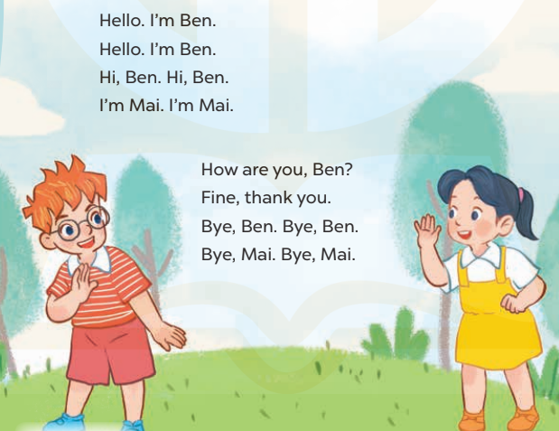  - Play the recording for Ss to listen to the whole chant.  + Have them repeat the title and lyrics line by line.  + Ask Ss to attend to the sounds of the letters h and b and the words Hello and Bye.  - Play the recording all the way through for Ss to listen to pronunciation and melody.  - Play the recording line by line for Ss to listen and repeat  - Play the recording for Ss to chant and clap along.  - Ask Ss to practice chant and clap along in pairs or groups.  - Invite groups to the front of the classroom to perform the chant  -T gives feedback.  *Consolidation  *Aims: Ss will be able consolidate and wrap up the content of the lesson.  *Procedure:  - T asks ss to answer the following questions:  + What have you learnt from the lesson today?  +What are the core values of the lesson? (if the teacher can take from the lesson).  - T review the vocabulary and model sentences.  - T praises some Ss who are hardworking / active/ good…. as well as encourage others to try more.  - Practice the chant more.  - Prepare the new lesson: Unit 1, Lesson 3 (4,5,6). | - Ss listen  -Ss listen the rules  - Ss play the game  - Ss open their books  - Ss recognize the differences about color of letter  - - Ss listen  - Ss listen and point  - Ss listen again and repeat  -Ss listen again and repeat  -Ss practice  -Ss listen  -Ss listen and say:  + Number 1: …..,Ben  + Number 2: …..,Ben.  -Ss guess the answers  - Ss listen to the tape and circle  - Ss listen again, circle and swap books with their partners.  - Ss check their answers and guessing  -Ss listen and repeat.  -Ss read the sentences  - Ss look and listen.  -Ss listen to the chant  - Ss listen and repeat line by line without clap their hands  -Ss note the sounds, words  -Ss listen to melody of the song  - Ss listen and chant line by line.  - Ss chant and clap along.  - Ss work in groups (two groups) to chant  -Ss perform in front of the class.  -Ss listen  -Ss listen.  -Ss listen  -Ss answer the questions  - Ss listen  -Ss listen and clap their hands  -Ss listen and take note

D. ADJUSTMENTS (if necessary):
………………………………………………………………………………………….…..……………………………………………………………………………...………………………………………….…..……………………………………………………………………………….……………………………………………………………………...

