Week 5 Preparing date: October …..,
Period 19 Teaching date: October …..,

Unit 3: Our friends
Lesson 2 (1, 2, 3)
A. OBJECTIVES:
By the end of the lesson, Ss will be able to:
1. Knowledge:
-use the words this, that, it, yes, no, friend, teacher, Mr (Mr Long), Ms (Ms Hoa) in relation to the topic “Our friends”;
-use Is this / that ? – Yes, it is. / No, it isn’t. It’s….. to ask and answer questions about someone;
-ask and answer questions about someone in contexts.
- Vocabulary: yes, no, teacher friend
- Skills: speaking and listening
2. Competences:
- Critical Thinking: self-introduce
- Co-operation: ready to help friends in pair work/ group work.
- Sociability: Talk to each other, say good words to others.
3. Attitude/ Qualities:
- Kindness: Help partners to complete learning tasks.
- Honesty: tell the truth about feelings and emotions
B. TEACHING AIDS:
- Teacher: Teacher’s guide Pages 43, 44; audio Tracks 29,30, website sachmem.vn, posters, laptop, pictures, textbook, lesson plan, TV or projector.
- Students: Pupil’s book Page 24, notebooks, workbooks, school things.
C. PROCEDURES:
Stages/Time | Teacher’s activities | Students’ activities
1.Warm- up:  (3’)  2. Presentation  (16’)  3.Practice: (7’)  4.Production: (7’)  5. Homework. (2’) | Game: Roll the dice  *Aims: to create a friendly and active atmosphere in the class to beginning the lesson.  *Procedure:  - Divide the class into 2 teams.  - Each team choose a character on the slide (Nam or Mary) for their team.  - The 2 teams take turns to choose letters to go to the questions. For each correct answer, pupils can roll the dice and click the coloured stones to move their characters.  - The team who finishes first will be the winner.  - Say “Open your book page 24” and look at “Unit 3, Lesson 2 (1,2,3)”.  Activity 1. Vocabulary.  *Aims: Ss will be able to know the vocabulary in front of starting the new lesson.  *Procedure:  -T elicits the new words  + friend : bạn bè  + teacher : giáo viên  + yes : vâng, có  + no : không  - T models (3 times).  - T writes the words on the board.  - Checking: What and where  Activity 2. Listen, point and repeat:  *Aims: Ss will be able to understand and correctly repeat the sentences in two communicative contexts (pictures) focusing on asking and answering questions about someone.  *Procedure:  - Have Ss look at Pictures a and b and identify the characters in the pictures.  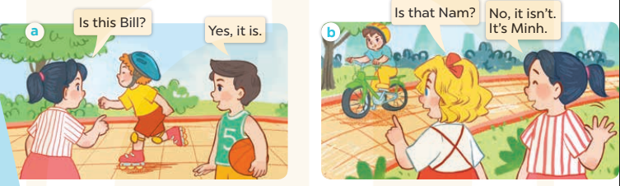  - Play the audio twice (sentence by sentence). Correct their pronunciation where necessary.  - Have Ss to practice the diaguage  - T invites a few pairs to the front of the class to practice.  - T checks pronunciation for ss.  Activity 3. Listen, point and say.  *Aims: Ss will be able to correctly say the words and use Is this / that ……? and Yes, it is. / No, it isn’t. It’s…….. to ask and answer questions about the characters.  *Procedure:  * Model sentences:  - T asks Ss look at picture a, b and helps Ss know the structure from the dialogue.  - T introduces new structure for Ss.  - T explains, models and gives meaning.  - Have Ss repeat the model sentences.  * It’s = it is  *Drill pictures  - Elicit and check comprehension the name of each character.  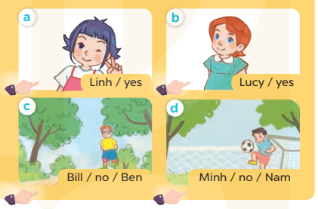  - Run through all the pictures.  - Run through model sentences.  + Run through the questions  + Run through the answers  - Have Ss to practise:  + T asks – Ss answer (change role).  + Ss – Ss (change role).  - Ask Ss to work in pairs.  - T controls and corrects.  - Invite a few pairs to come to the front of the classroom, point at the relevant character in each picture, and act out his/her role.  - Invite Ss to go to the board and role play. Encourage Ss to practise speaking English.  - T gives feedbacks.  Activity 4. Let’s talk.  *Aims: Ss will be able to enhance the correct use of Is this/ that…….? and Yes, it is. / No, it isn’t. It’s………. to ask and answer questions about someone  *Procedure:  - T asks ss to guess each character and what the children say.  + What can you see in the picture?  +Who are they?  +Where are they?  +What are they saying?  - T fills the gaps and writes the sentences on the board.  - T models  - T asks Ss use of Is this/ that…….? to ask , and answer (groups of four)  - Invite some groups to perform.  - Give feedbacks  *Consolidation  *Aims: Ss will be able consolidate and wrap up the content of the lesson.  *Procedure:  - T asks ss to answer the following questions:  + What have you learnt from the lesson today?  +What are the core values of the lesson? (if the teacher can take from the lesson).  - T review the vocabulary and model sentences.  - T praises some Ss who are hardworking / active/ good…. as well as encourage others to try more.  - Learn the vocabulary and model sentences by heart  - Prepare the new lesson: Unit 3, Lesson 2 (4,5,6). | - Ss listen  - Ss play the game  - Ss open their books  -Ss listen and answer  - - Ss listen and repeat  + Choral repetition (3 times).  + Individual repetition (3 ss)  - Ss take note  - Ss look, remember and slap  -Look at the pictures and get to know the characters in the pictures.  + In picture a: Mai asks: Is this Bill? And Nam answers Yes, it is.  – In picture b: Mary asks Is that Nam? And Mai answers: No, it isn’t. It’s Minh  -Ss listen and repeat in chorus (twice)  -Ss work in pairs to practice  -Ss practice the diaguage  -Ss listen  -Ss look at the picture and answer.  -Ss listen  -Ss listen and repeat  -Ss repeat to the introduce someone  -Ss listen and answer  - Ss look, listen and repeat  - Ss practice in chorus  -Ss work in pairs to practice  -Ss listen  -Ss point and say  -Ss go to the board and rold play.  -Ss listen  -Ss look at the picture and answer  + A picture of Bill and Mai in the park. Bill asks Mai about Linh and Nam.  -Ss note  - Ss say the completed sentences.  -Ss work in groups  -Ss perform in front of the class.  -Ss answer the questions  - Ss listen  -Ss listen and clap their hands  -Ss listen and take note

D. ADJUSTMENTS (if necessary):
………………………………………………………………………………………….…..……………………………………………………………………………...………………………………………….…..……………………………………………………………………………….……………………………………………………………………...

