Week 4 Preparing date: September …….
Period 13 Teaching date: September ……,

Unit 2: Our names
Lesson 2 (1, 2, 3)
A. OBJECTIVES:
By the end of the lesson, Ss will be able to:
1. Knowledge:
- use the words what, your, name, my, how old, years old in relation to the topic “Our names”;
- use How old are you? - I'm……. to ask and answer questions about someone’s age;
- Vocabulary: how old, year
- Skills: speaking and listening
2. Competences:
- Oral Communication: speak about names, ask and answer the questions
- Co-operation: ready to help friends in pair work/ group work.
- Sociability: Talk to each other, say good words to others.
3. Attitude/ Qualities:
- Kindness: Help partners to complete learning tasks.
- Honesty: tell the truth about feelings and emotions
- Diligence: complete learning tasks
B. TEACHING AIDS:
- Teacher: Teacher’s guide Pages 29, 30, audio Tracks 18,19, website sachmem.vn, posters, laptop, pictures, textbook, lesson plan, TV or projector.
- Students: Pupil’s book Page 18, notebooks, workbooks, school things.
C. PROCEDURES:
Stages/Time | Teacher’s activities | Students’ activities
1.Warm- up:  (3’)  2. Presentation  (16’)  3.Practice: (7’)  4.Production: (7’)  5. Homework. (2’) | Game: Guess the pictures  *Aims: to create a friendly and active atmosphere in the class to beginning the lesson.  *Procedure:  - The first Ss has to take the last four or three letters of that word and form a new word.  - The second Ss does the same, and the chain continues until a Ss is unable to form a word.  - The Ss who fails to form a word or misspells it is out of the game.  -T give feedback  - Say “Open your book page 18” and look at “Unit 2, Lesson 2 (1,2,3)”.  Activity 1. Vocabulary.  *Aims: Ss will be able to know the vocabulary in front of starting the new lesson.  *Procedure:  -T elicits the new words  + how old : bao nhiêu tuổi  (situation)  + year : tuổi, năm (situation)  - T models (3 times).  - T writes the words on the board.  - Checking: Rub out and remember  Activity 2. Listen, point and repeat:  *Aims: Ss will be able to understand and correctly repeat the sentences in two communicative contexts (pictures) focusing on asking and answering questions about the character’s age.  *Procedure:  - Have pupils look at Pictures a and b and identify the characters in the pictures.  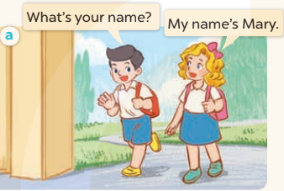  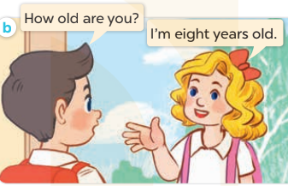  - Play the audio twice (sentence by sentence). Correct their pronunciation where necessary.  - Have Ss to practice the dialogue  - T invites a few pairs to the front of the class to practice.  - T checks pronunciation for ss.  Activity 3 Listen, point and say.  *Aims: Ss will be able to correctly say the words and use How old are you? – I’m………years old. to ask and answer questions about someone’s age.  *Procedure:  * Model sentences:  - T asks Ss look at picture a and helps Ss know the structure from the dialogue.  - T introduces new structure for Ss.  - T explains, models and gives meaning.  -Have Ss repeat the model sentences.  *Drill pictures  - Elicit and check comprehension the name of each character.  - Run through all the pictures.  - Run through model sentences.  + Run through the questions.  + Run through the answers.  - Have Ss to practise:  + T asks the first – Ss answer (change role).  + Ss – Ss (change role).  - Ask Ss to work in pairs to ask and answer the question How old are you? I’m……  - T controls and corrects.  - Invite a few pairs to come to the front of the classroom, point at the relevant character in each picture, and act out his/her role.  - Encourage Ss to practise speaking English.  - T gives feedbacks.  Activity 4. Let’s talk.  *Aims: Ss will be able to enhance the correct use of How old are you? and to correctly respond using their own ages.  *Procedure:  - Have Ss look at the picture and explain that the two children want to buy some birthday cakes. The shop assistant asks their ages and the children answer  - T asks Ss look at the first speech bubble and ask How old are you?  - Get Ss to repeat the question and the answer several times in pairs.  - T models: Go around the classroom, pointing to Ss and asking What’s your name?  - Ask Ss ask and answer about their own ages in pairs.  - Invite some groups to perform in front of the class.  - Give feedbacks  *Consolidation  *Aims: Ss will be able consolidate and wrap up the content of the lesson.  *Procedure:  - T asks ss to answer the following questions:  + What have you learnt from the lesson today?  +What are the core values of the lesson? (if the teacher can take from the lesson).  - T review the vocabulary and model sentences.  - T praises some Ss who are hardworking / active/ good…. as well as encourage others to try more.  - Learn the vocabulary and model sentences by heart  - Prepare the new lesson: Unit 2, Lesson 2 (4,5,6). | - Ss listen.  -Ss look at the board  - Ss play the game  - Ss listen and clap their hands  - Ss open their books  -Ss listen and answer  - - Ss listen and repeat  + Choral repetition (3 times).  + Individual repetition (3 ss)  - Ss take note  - Ss look, remember and write  -Look at the pictures and get to know the characters in the pictures.  + In picture a: Nam asks: What’s your name? And Mary answers: My name’s Mary.  + In pucture b: Nam asks: How old are you? And Mary answers: I’m eight years old..  -Ss listen and repeat in chorus (twice)  -Ss work in pairs to practice  -Ss practice the dialogue  -Ss listen  -Ss look at the picture and answer.  -Ss listen  -Ss listen and repeat  -Ss repeat to the introduce and respond to greetings.  -Ss look at the picture and answer  + In picture a: A girl is holding a birthday cake with number 7.  + In picture b: A girl is holding a birthday cake with number 8.  + In picture c: A boy is holding a birthday cake with number 9.  + In picture d: A boy is holding a birthday cake with number 10.  - Ss look, listen and repeat  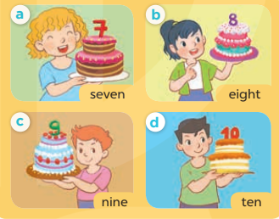  -Ss practice in chorus  -Ss work in pairs to practice  -Ss point and ask and answer  -Ss listen.  -Ss listen  -Ss look at the picture and listen  -Ss look and answer  + I’m four years old.  -Ss ask and answer  - Ss answer  -Ss work in pairs  -Ss perform in front of the class.  -Ss answer the questions  - Ss listen  -Ss listen and clap their hands  -Ss listen and take note

D. ADJUSTMENTS (if necessary):
………………………………………………………………………………………….…..……………………………………………………………………………...………………………………………….…..……………………………………………………………………………….……………………………………………………………………...

