Week 6 Preparing date: October …..,
Period 22 Teaching date: October ………….,

Unit 3: Our friends
Lesson 3 (4, 5, 6)
A. OBJECTIVES:
By the end of the lesson, Ss will be able to:
1. Knowledge:
- read and match four target sentence patterns with four pictures
- read, understand and complete three sentences by writing the target words in the gaps.
- draw three pictures of their friends and introduce them to the class.
- Vocabulary: Review
- Skills: speaking, listening, reading and writing.
2. Competences:
- Critical Thinking: self-introduce
- Co-operation: ready to help friends in pair work/ group work.
- Self-control and independent learning: perform listening tasks.
3. Attitude/ Qualities:
- Kindness: Help partners to complete learning tasks.
- Honesty: tell the truth about feelings and emotions.
- Diligence: complete learning tasks.
B. TEACHING AIDS:
- Teacher: Teacher’s guide Pages 49, 50, website sachmem.vn, posters, laptop, pictures, textbook, lesson plan, TV or projector.
- Students: Pupil’s book Page 27, notebooks, workbooks, school things.
C. PROCEDURES:
Stages/Time | Teacher’s activities | Students’ activities
1.Warm- up:  (5’)  2.Practice: (8’)  3.Production: (19’)  4. Homework. (3’) | Game: “Chant”  *Aims: to create a friendly and active atmosphere in the class to beginning the lesson.  *Procedure:  - Ask Ss chant and do the actions in Unit 3, Lesson 3 page 26 in groups.  - Give point for the groups and encourage them.  - Say “Open your book page 27” and look at “Unit 3, Lesson 3 (4,5,6)”.  Activity 1. Read and match:  *Aims: Ss will be able to read and match four target sentence patterns with four pictures.  *Procedure:  - Ask Ss some questions:  + Who are they?  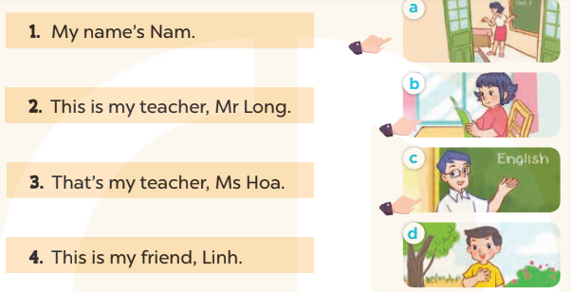  - T models with sentence 1.  + Get Ss to read Sentence 1  + Have Ss look at the pictures and match the sentences with the correct picture.  -Have Ss work in pairs and match the sentences 2, 3, 4.  - Tell Ss to swap books with a partner, then check answers together as a class.  - Write the correct answers on the board for pupils to correct their answers.  - Invite pairs of Ss to stand up and role play  -T gives feedbacks.  Key: 1. d 2. c 3. a 4. b  Activity 2. Let’s write  *Aims: Ss will be able to read, understand and complete three sentences by writing the target words in the gaps.  *Procedure:  - Write the first incomplete sentence on the board and encourage Ss to say the answer.  1.This …….. my friend, Mai.  - Give Ss time to write the answer in their notebooks.  - Ask Ss to write the answers to the sentences 2 and 3.  - Get Ss to swap books with a partner, then check the answers together as a class.  - Ask a few Ss to stand up and read the sentences in front of the class.  -T gives feedbacks.  Key: 1. Is  2. This is my  3. That’s my teacher  Activity 3. Project.  *Aims: Ss will be able to draw three pictures of their friends and use them to practise talking to their classmates.  *Procedure:  - Ask Ss to draw three pictures of their friends as homework at the beginning of Unit 3 -Lesson 3 (4,5,6)  - Show the pictures of his/ her friends and model with This is my friend, Hoa.  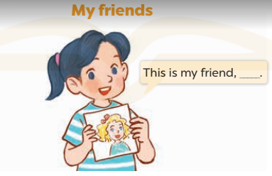  - T asks ss to work in groups and show the pictures of their friends to talk to the groups such as This is my friend, (name).  - T calls some Ss to the front of the class to present their friends, and saying Hello. My name’s….  I’m…….years old. This is my friends,……  - Have Ss to stick their pictures on the wall of the classroom  - Create a class display using the pictures and vote for the most creative.  - T gives feedback.  *Consolidation  *Aims: Ss will be able consolidate and wrap up the content of the lesson.  *Procedure:  - T asks ss to answer the following questions:  + What have you learnt from the lesson today?  +What are the core values of the lesson? (if the teacher can take from the lesson).  - T praises some Ss who are hardworking / active/ good…. as well as encourage others to try more.  - Prepare the new lesson: Unit 4, Lesson 1 (1,2,3). | - Ss listen and chant  - Ss open their books  - Ss look at the pictures and answer  My name's Nam  -Ss read and match  -Ss work in pairs and match  -Ss swap books and check  -Ss check the correct their answers  -Ss role play  -Ss listen  -Ss look at the sentence and say the answer:  +This is my friend, Mai.  -Ss write the answer  -Ss write  -Ss swap books and check their answers  -Ss read the sentences  -Ss listen  - Ss drew and coloured draw three pictures of their friends at home.  -Ss listen to the teacher  -Ss work in groups  -Ss present their pictures  - Ss stick their pictures on the wall of the classroom.  -Ss vote  -Ss listen  -Ss answer the questions  -Ss listen and clap their hands  -Ss listen and take note
D. ADJUSTMENTS (if necessary):
………………………………………………………………………………………….…..……………………………………………………………………………...…………

