Week 7 Preparing date: October …….
Period 28 Teaching date: October ……,

Unit 4: Our bodies
Lesson 3 (4, 5, 6)
A. OBJECTIVES:
By the end of the lesson, Ss will be able to:
1. Knowledge:
- read and write about parts of the body and instructions;
- make flashcards of the body parts and present them to the class.
- Vocabulary: Review
- Skills: speaking, listening, reading and writing.
2. Competences:
- Critical Thinking: self-introduce
- Co-operation: ready to help friends in pair work/ group work.
- Self-control and independent learning: perform listening tasks.
3. Attitude/ Qualities:
- Kindness: Help partners to complete learning tasks.
- Honesty: tell the truth about feelings and emotions.
- Diligence: complete learning tasks.
B. TEACHING AIDS:
- Teacher: Teacher’s guide Pages 60, 61; website sachmem.vn, posters, laptop, pictures, textbook, lesson plan, TV or projector.
- Students: Pupil’s book Page 33, notebooks, workbooks, school things.
C. PROCEDURES:
Stages/Time | Teacher’s activities | Students’ activities
1.Warm- up:  (5’)  2.Practice: (8’)  3.Production: (19’)  4. Homework. (3’) | Game: “Chant”  *Aims: to review the vocabulary and structure about greet and respond to greetings.  *Procedure:  - Ask Ss chant and do the actions in Unit 4, Lesson 3 page 32 in groups.  - Give point for the groups and encourage them.  - Say “Open your book page 33” and look at “Unit 4, Lesson 3 (4, 5, 6)”.  Activity 1. Read and match:  *Aims: Ss will be able to read the four sentences/ exchanges on the left and match them with the pictures on the right correctly.  *Procedure:  - T models with sentence 1.  + Get Ss to read Sentence 1  + Ask Ss to read the first exchange and draw a line to match.  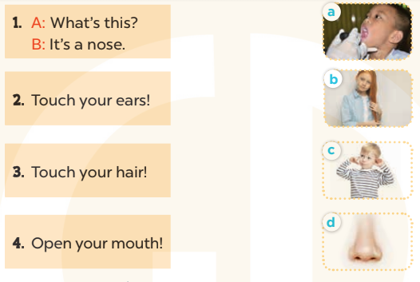  -Have Ss work in pairs and match the sentences 2, 3, 4.  - Tell Ss to swap books with a partner, then check answers together as a class.  - Write the correct answers on the board for pupils to correct their answers.  - Invite pairs of Ss to stand up and role play  -T gives feedbacks.  Key: 1. d 2. c 3. b 4. a  Activity 2. Let’s write  *Aims: Ss will be able to read, understand and complete four target sentences / exchanges with picture cues.  *Procedure:  - Have Ss read the sentences and ask some questions:  + What’s this?  + What’s that?  + What are they doing?  - Check their comprehension and remind Ss to write their personal information.  - Give Ss time to write the answers to the questions independently  - Get Ss to swap books with a partner, then check the answers together as a class.  - Ask a few Ss to stand up and role play the dialogue in front of the class.  -T gives feedbacks.  Key: 1. a hand 2. an eye  3. nose 4. Open  Activity 3. Project.  *Aims: Ss will be able to revise the target vocabulary items by making flashcards of the body parts pupils have learnt and presenting them to the class.  *Procedure:  - Ask Ss to look at the picture of an eye in the book. Demonstrate how to make a flashcard of an eye. Draw an eye on a card and write the word eye under the picture.  - Show Ss your flashcard of an eye. Tell them to pass it around so that they can see what they are going to make.  - Put Ss into groups and give each group a set of materials for making flashcards of the body parts.  - Give Ss enough time to make flashcards. Encourage them to decorate their flashcards.  - When Ss have finished making their flashcards, give them time to present the flashcards to their classmates. Go around the classroom to monitor and offer support.  Game: Who is the fastest writer?  - T asks 6 - 8 Ss to join this game.  - T says out loud a word (twice).  *Consolidation  *Aims: Ss will be able consolidate and wrap up the content of the lesson.  *Procedure:  - T asks ss to answer the following questions:  + What have you learnt from the lesson today?  +What are the core values of the lesson? (if the teacher can take from the lesson).  - T praises some Ss who are hardworking / active/ good…. as well as encourage others to try more.  - Prepare the new lesson: Unit 5, Lesson 1 (1, 2, 3). | - Ss listen and chant  - Ss open their books  - Ss look at the pictures and answer  -Ss read and match  -Ss work in pairs and match  -Ss swap books and check  -Ss check the correct their answers  -Ss role play  -Ss listen  -Ss look at the pictures and say:  + It’s a hand  + It’s an eye  + A girl touches her nose  + A boy opens his mouth.  -Ss listen to the teacher  -Ss write  -Ss swap books and check their answers  -Ss role play  -Ss listen  - Ss listen and note  -Ss listen to the teacher  -Ss make flashcards of the body parts  -Ss continute to make the flashcards  -Ss present the flashcards  -Ss listen  -Ss write as fast as they can.  -Ss answer the questions  -Ss listen and clap their hands  -Ss listen and take note
D. ADJUSTMENTS (if necessary):
………………………………………………………………………………………….…..……………………………………………………………………………...…………

