Week 7 Preparing date: October …….
Period 26 Teaching date: October ……,

Unit 4: Our bodies
Lesson 2 (4, 5, 6)
A. OBJECTIVES:
By the end of the lesson, Ss will be able to:
1. Knowledge:
- listen to and demonstrate understanding of simple communicative contexts in relation to the topic “Our bodies”
- read and match the sentence halves to make complete instructions and read them aloud.
- Vocabulary: Review
- Skills: speaking, listening, reading and writing.
2. Competences:
- Critical Thinking: self-introduce
- Co-operation: ready to help friends in pair work/ group work.
- Self-control and independent learning: perform listening tasks.
3. Attitude/ Qualities:
- Kindness: Help partners to complete learning tasks.
- Honesty: tell the truth about feelings and emotions.
- Diligence: complete learning tasks.
B. TEACHING AIDS:
- Teacher: Teacher’s guide Pages 56, 57, 58; audio Tracks 41; website sachmem.vn, posters, laptop, pictures, textbook, lesson plan, TV or projector.
- Students: Pupil’s book Page 31, notebooks, workbooks, school things.
C. PROCEDURES:
Stages/Time | Teacher’s activities | Students’ activities
1.Warm- up:  (5’)  2.Practice: (27’)  3. Homework. (3’) | Game: Simon says  *Aims: to create a friendly and active atmosphere in the class to beginning the lesson.  *Procedure:  - T is the “Simon” and calls out the actions. Every student must follow and do the action, but only when they hear “Simon says ...”.  - If teacher leaves out “Simon says” before giving instruction, anyone who does the action is out.  - Then, teacher can choose one or more students as the leader to continue a game.  - Say “Open your book page 31” and look at “Unit 4, Lesson 2 (4,5,6)”.  Activity 1. Listen and number:  *Aims: Ss will be able to listen to and understand four communicative contexts in which instructions are given.  *Procedure:  - Elicit the actions of the characters in the pictures.  - Point at the pictures respectively to explain the context.    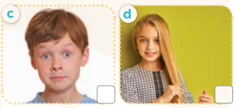  - T ask Ss to guess the answers.  + T writes Ss’guessing on the board.  - Listen to the tape:  + Play the recording  + Play the recording again and get Ss to swap books with their partners.  + Play the recording again to check answers together as a class.  + Write the answers on the board for Ss to correct their answers. Then checks Ss’ guessing.  - Play the recording, sentence by sentence, for the class to listen and repeat in chorus.  Key: 1. b 2. d 3. a 4. c  Activity 2. Look, match and read.  *Aims: Ss will be able to correctly match the sentence halves to make complete instructions and read them aloud.  *Procedure:  - Get Ss to look at the pictures and identify the actions of the characters.  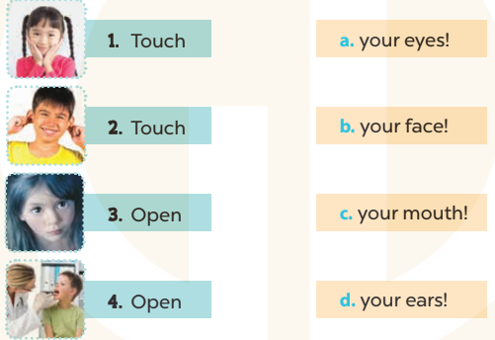  - Have Ss look at the first picture and incomplete sentence.  - T models with sentence 1  + Ask Ss to read and match. When Ss answer correctly (Touch your face!)  + Tell them to draw a line to match the two sentence halves  -Have Ss work in groups and match the sentence 2, 3 and 4.  - Ask a few Ss to stand up and read the matched instructions aloud.  -T gives feedbacks.  Key: 1. b 2. d 3. a 4. c  Activity 3. Let’s play.  *Aims: Ss will be able to practise using target sentence patterns by playing the game Touch your hair!  *Procedure:  - Elicit the language that Ss need to give instructions (Touch your ……! and Open your……..!). When Ss answer correctly, write the language on the board.  - Have Ss look at the picture. Get them to say how to play the game. Explain the rules of the game again:  + A boy / girl standing in the centre gives an instruction and other Ss have to follow it.  + If a pupil does not follow the instruction, he or she will be "out".  + Check Ss’ understanding by getting one Ss to repeat what they have to do.  - Have the whole class play the game. Ask one or two Ss to be the observer(s) of the game. Give out the instructions and monitor Ss while they play the game. Ss who cannot follow the rules of the game will be “out” and become the observers.  - Divide the class into four teams. Each team plays the game. Ss are eliminated if they do not perform the correct actions. Give stars/ points to the winner.  *Consolidation  *Aims: Ss will be able consolidate and wrap up the content of the lesson.  *Procedure:  - T asks ss to answer the following questions:  + What have you learnt from the lesson today?  +What are the core values of the lesson? (if the teacher can take from the lesson).  - T praises some Ss who are hardworking / active/ good…. as well as encourage others to try more.  - Practice about the pictures on page 31.  - Prepare the new lesson: Unit 4, Lesson 3 (1,2,3). | - Ss listen  -Ss play game  - Ss open their books  -Look at the pictures and say:  + Picture a: a boy touching his nose  + Picture b: a girl opening her mouth  + Picture c: a boy opening his eyes  + Picture d: a girl touching her hair  -Ss guess the answers  - Ss listen to the tape and write number  - Ss listen again, write and swap books with their partners.  - Ss check their answers and guessing  -Ss listen and repeat.  -Ss look at the pictures and say  -Ss listen and answer  -Ss read and match  -Ss complete the sentence  -Ss read aloud  -Ss listen  -Ss look at the picture and play the game  -Ss play the game  -Ss listen to the teacher.  -Ss answer the questions  -Ss listen and clap their hands  -Ss listen and take note
D. ADJUSTMENTS (if necessary):
………………………………………………………………………………………….…..……………………………………………………………………………...………………………………………….…..……………………………………………………………………………….……………………………………………………………………...

