Week 8 Preparing date: October …..,
Period 29 Teaching date: October …..,

Unit 5: My hobbies
Lesson 1 (1, 2, 3)
A. OBJECTIVES:
By the end of the lesson, Ss will be able to:
1. Knowledge:
- understand and correctly repeat the sentences in two communicative contexts (pictures) focusing on asking and answering about hobbies.
- correctly say the words and use: What’s your hobby? – It’s ……... to ask and answer about hobbies.
- Vocabulary: sing, dance, draw, swim, hobby.
- Skills: speaking and listening
2. Competences:
- Critical Thinking: self-introduce
- Co-operation: ready to help friends in pair work/ group work.
- Sociability: Talk to each other, say good words to others.
3. Attitude/ Qualities:
- Kindness: Help partners to complete learning tasks.
- Honesty: tell the truth about feelings and emotions
B. TEACHING AIDS:
- Teacher: Teacher’s guide Pages 62, 63, 64, audio Tracks 45, 46, website sachmem.vn, posters, laptop, pictures, textbook, lesson plan, TV or projector.
- Students: Pupil’s book Page 34, notebooks, workbooks, school things.
C. PROCEDURES:
Stages/Time | Teacher’s activities | Students’ activities
1.Warm- up:  (3’)  2. Presentation  (16’)  3.Practice: (7’)  4.Production: (7’)  5. Homework. (2’) | Sing: The hobby song  *Aims: to create a friendly and active atmosphere in the class to beginning the lesson.  *Procedure:  - Show the song on the screen.  https://www.youtube.com/watch?v=90LfcLAjLiI  - Ask Ss to listen, sing and dance the song.  - Say “Open your book page 34” and look at “Unit 5, Lesson 1 (1,2,3)”.  Activity 1. Vocabulary.  *Aims: Ss will be able to know the vocabulary in front of starting the new lesson.  *Procedure:  -T elicits the new words  + sing- singing : hát (mime)  + draw- drawing : vẽ (mime)  + dance- dancing :nhảy/ múa(mime)  + swim- swimming : bơi (mime)  + hobby : sở thích (translation)  - T models (3 times).  - T writes the words on the board.  - Checking: Matching  Activity 2. Look, listen and repeat:  *Aims: Ss will be able to understand and correctly repeat the sentences in two communicative contexts (pictures) focusing on asking and answering about hobbies.  *Procedure:  - Have Ss look at Pictures a and b and identify the characters in the pictures.  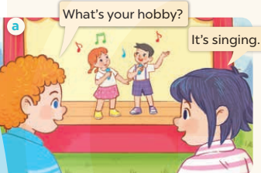  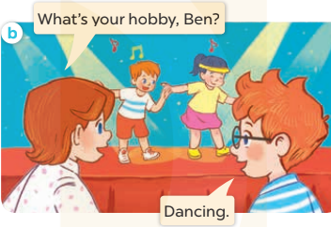  - Play the audio twice (sentence by sentence). Correct their pronunciation where necessary.  - Have Ss to practice the dialogue  - T invites a few pairs to the front of the class to practice.  - T checks pronunciation for ss.  Activity 3 2. Listen, point and say.  *Aims: Ss will be able to correctly say the words and use: What's your hobby? - It's…… to ask and answer about hobbies.  *Procedure:  * Model sentences:  - T asks Ss look at picture a and helps Ss know the structure from the dialogue.  - T introduces new structure for Ss.  - T explains, models and gives meaning.  -Have Ss repeat the model sentences.  *Drill pictures  - Elicit and check comprehension the name of each character.  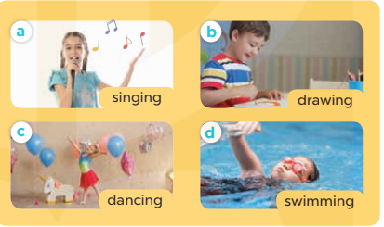  - Run through all the pictures.  - Run through model sentences.  - Have Ss to practise:  + T asks, Ss answer picture a  + Ss ask, T answers picture b  + Group A ask, group B answer picture c  + Group B ask, group A answer picture d  - Ask Ss to work in pairs.  - T controls and corrects.  - Invite a few pairs to come to the front of the classroom and point at the pictures and say the questions and answers in front of the class.  - T gives feedbacks.  Activity 4. Let’s talk.  *Aims: Ss will be able to enhance the correct use of What's your hobby? – It's …... to ask and answer questions about someone's hobby.  *Procedure:  - T asks ss to guess each character and what the children say.  + What can you see in the picture?  +Who are they?  +Where are they?  +What are they saying?  - T fills the gaps and writes the sentences on the board.  - T models  - T asks Ss to ask and answer questions using What's your hobby? –It's ………...  - Invite some pairs to perform.  - Give feedbacks  *Consolidation  *Aims: Ss will be able consolidate and wrap up the content of the lesson.  *Procedure:  - T asks ss to answer the following questions:  + What have you learnt from the lesson today?  +What are the core values of the lesson? (if the teacher can take from the lesson).  - T review the vocabulary and model sentences.  - T praises some Ss who are hardworking / active/ good…. as well as encourage others to try more.  - Learn the vocabulary and model sentences by heart  - Prepare the new lesson: Unit 5, Lesson 1 (4,5,6). | - Ss sing and dance the song  - Ss open their books  -Ss listen and answer  - - Ss listen and repeat  + Choral repetition (3 times).  + Individual repetition (3 ss)  - Ss take note  - Ss look, remember and match  -Look at the pictures and get to know the characters in the pictures.  + In picture a: Bill points to the activity on the stage and asks Linh: What’s your hobby? Linh says: It’s singing.  + In picture b: Lucy points to the activity on the stage and asks Ben: What’s your hobby, Ben? Ben says: Dancing.  -Ss listen and repeat in chorus (twice)  -Ss work in pairs to practice  -Ss practice the dialogue  -Ss listen  -Ss look at the picture and answer.  -Ss listen  -Ss listen and repeat  -Ss repeat to the hobbies.  - Ss look, listen and answer  + Picture a: a girl singing  + Picture b: a boy drawing  + Picture c: a girl dancing  + Picture d: a boy swimming  -Ss listen and repeat  -Ss practice in chorus  -Ss work in pairs to practice  -Ss point and say  -Ss listen.  -Ss look at the picture and answer  + They are on the beach/ by the sea  + A boy and a girl are drawing  + Three boys are swimming  -Ss note  - Ss say the completed sentences.  -Ss work in pairs  -Ss perform in front of the class.  -Ss answer the questions  - Ss listen  -Ss listen and clap their hands  -Ss listen and take note

D. ADJUSTMENTS (if necessary):
………………………………………………………………………………………….…..……………………………………………………………………………...………………………………………….…..……………………………………………………………………………….……………………………………………………………………...

