Period 39 Teaching date: November …..,

Unit 6: Our school
Lesson 1 (4, 5, 6)
A. OBJECTIVES:
By the end of the lesson, Ss will be able to:
1. Knowledge:
- listen to and understand four communicative contexts in which pupils ask and answer questions about their school
- read and complete three target sentence patterns with the help of picture cues.
- sing the song Our school with the correct pronunciation and melody.
- Vocabulary: Review
- Skills: speaking, listening, reading and writing.
2. Competences:
- Critical Thinking: self-introduce
- Co-operation: ready to help friends in pair work/ group work.
- Self-control and independent learning: perform listening tasks.
3. Attitude/ Qualities:
- Kindness: Help partners to complete learning tasks.
- Honesty: tell the truth about feelings and emotions.
- Diligence: complete learning tasks.
B. TEACHING AIDS:
- Teacher: Teacher’s guide Pages 81,82,83; audio Tracks 59,60; website sachmem.vn, posters, laptop, pictures, textbook, lesson plan, TV or projector.
- Students: Pupil’s book Page 45, notebooks, workbooks, school things.
C. PROCEDURES:
Stages/Time | Teacher’s activities | Students’ activities
1.Warm- up:  (5’)  2.Practice: (27’)  3. Homework. (3’) | Game: Matching game  *Aims: to create a friendly and active atmosphere in the class to beginning the lesson.  *Procedure:  - Write 4 new words on the board and asks Ss to read (whole class).  - Ask 4 Ss to come to the board and write their school in the pieces of paper and keep them in secret.  - Ask 1 Ss to come to the board and guess their school written in the paper (He has to write the answers in the small pieces of paper and stick to each 4 Ss.  - Ask the Ss on the board to ask the question to find out the answers and give him or her point if correct (repeat the activities depending the time).  - Say “Open your book page 45” and look at “Unit 6, Lesson 1 (4,5,6)”.  Activity 1. Listen and tick:  *Aims: Ss will be able to listen to and understand two communicative contexts to ask and answer questions about a school.  *Procedure:  - Elicit the word for the place in each picture  - Point at the pictures respectively to explain the context.  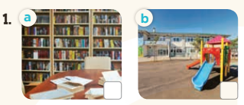  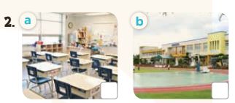  - T ask Ss to guess the answers.  + T writes Ss’guessing on the board.  - Listen to the tape:  + Play the recording  + Play the recording again and get Ss to swap books with their partners.  + Play the recording again to check answers together as a class.  + Write the answers on the board for Ss to correct their answers. Then checks Ss’ guessing.  - Play the recording, sentence by sentence, for the class to listen and repeat in chorus.  Key: 1. b 2. a  Activity 2. Look, complete and read  *Aims: Ss will be able to complete three target sentence patterns with the help of picture cues.  *Procedure:  - Get Ss to look at the pictures and identify the places in the pictures.  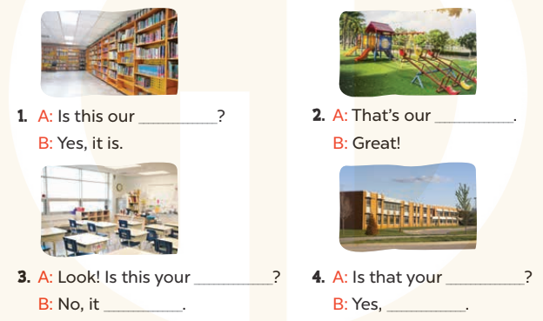  - Have Ss look at the four dialogue and the pictures. Elicit and model with picture 1  + Ask Ss to read the sentence 1 in chorus.  + Ask them what is missing in the question (library). Then have them complete the gap (Is this our library?).  -Have Ss work in pairs and complete the dialogue 2, 3, 4.  - Ask a few Ss to stand up and read the sentences aloud.  -T gives feedbacks.  Key:  1. library 2. playground  3. classroom; isn’t  4. school; it is  Activity 3. Let’s sing  *Aims: Ss will be able to sing the song Our school with the correct pronunciation and melody.  *Procedure:  - Introduce the title and lyrics of the song: “Our school”  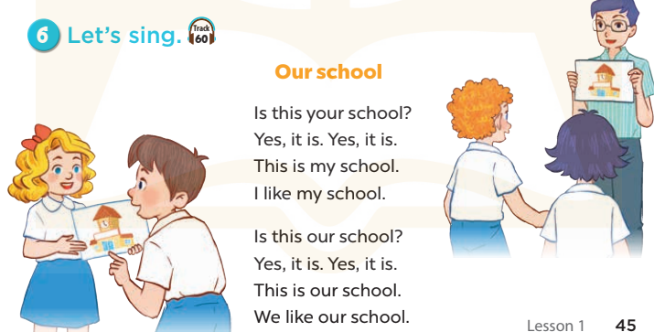  - Play the recording for Ss to listen to the whole song.  + Have them repeat the title and lyrics line by line.  + Tell Ss to point at the pictures while singing.  - Play the recording all the way through for Ss to listen to pronunciation and melody of the song.  - Play the recording line by line for Ss to listen, repeat and point to the pictures  - Play the recording for Ss to sing and do actions.  - Ask Ss to practice singing and doing actions in pairs or groups.  - Invite groups to the front of the classroom to perform the song  -T gives feedback.  *Consolidation  *Aims: Ss will be able consolidate and wrap up the content of the lesson.  *Procedure:  - T asks ss to answer the following questions:  + What have you learnt from the lesson today?  +What are the core values of the lesson? (if the teacher can take from the lesson).  - T praises some Ss who are hardworking / active/ good…. as well as encourage others to try more.  - Practice part 5 again.  - Prepare the new lesson: Unit 6, Lesson 2 (1,2,3). | - Ss read the words  - Ss play game  -Ss play game  - Ss open their books  -Look at the pictures and say:  + Picture 1a: a library + Picture 1b: a playground  + Picture 2a: a classroom  + Picture 2b: a school  -Ss guess the answers  - Ss listen to the tape and tick  - Ss listen again, tick and swap books with their partners.  - Ss check their answers and guessing  -Ss listen and repeat.  -Ss look at the picture and say  -Ss look and answer  -Ss read  -Ss say and complete  -Ss work in pairs and complete  -Ss read aloud  - Ss listen  -Ss listen to the song  - Ss listen and repeat line by line without the action.  -Ss point to the pictures while singing  -Ss listen to melody of the song  - Ss listen and sing line by line.  - Ss sing and do actions.  + Ss work in groups (two groups) to sing.  -Ss perform in front of the class.  -Ss listen  -Ss answer the questions  -Ss listen and clap their hands  -Ss listen and take note
D. ADJUSTMENTS (if necessary):
………………………………………………………………………………………….…..……………………………………………………………………………...………………………………………….…..……………………………………………………………………………….……………………………………………………………………...

