Week 10 Preparing date: November …..,
Period 38 Teaching date: November …..,

Unit 6: Our school
Lesson 1 (1, 2, 3)
A. OBJECTIVES:
By the end of the lesson, Ss will be able to:
1. Knowledge:
- use the words school, classroom, library, playground in the sentence pattern: Is this our ……………? – Yes, it is. / No, it isn’t.
- use Is this our………… ? – Yes, it is. / No, it isn’t. to ask and answer questions about their school.
- Vocabulary: school, classroom, library, playground
- Skills: speaking and listening
2. Competences:
- Co-operation: ready to help friends in pair work/ group work.
- Sociability: Talk to each other, say good words to others.
3. Attitude/ Qualities:
- Kindness: Help partners to complete learning tasks.
- Honesty: tell the truth about feelings and emotions
B. TEACHING AIDS:
- Teacher: Teacher’s guide Pages 79, 80, 81, audio Tracks 57, 58, website sachmem.vn, posters, laptop, pictures, textbook, lesson plan, TV or projector.
- Students: Pupil’s book Page 44, notebooks, workbooks, school things.
C. PROCEDURES:
Stages/Time | Teacher’s activities | Students’ activities
1.Warm- up:  (3’)  2. Presentation  (16’)  3.Practice: (7’)  4.Production: (7’)  5. Homework. (2’) | Sing: Jigsaw puzzle  *Aims: to create a friendly and active atmosphere in the class to beginning the lesson.  *Procedure:  - Divide class into 4 groups: Tom, Jerry, Miu and Chit.  - Ask Ss look at the pieces of picture.    - Ask Ss go to the board and jigsaw puzzle into the correct picture.  -T checks who’s the winner?  - Say “Open your book page 44” and look at “Unit 6, Lesson 1 (1,2,3)”.  Activity 1. Vocabulary.  *Aims: Ss will be able to know the vocabulary in front of starting the new lesson.  *Procedure:  -T elicits the new words  + school : trường học (picture)  + library : thư viện (picture)  + classroom :phòng học (picture)  + playground : sân chơi (picture)  - T models (3 times).  - T writes the words on the board.  - Checking: Matching  Activity 2. Look, listen and repeat:  *Aims: Ss will be able to understand and correctly repeat the sentences in two communicative contexts (pictures) to ask and answer questions about their school.  *Procedure:  - Have Ss look at Pictures a and b and identify names of the speakers in the pictures.  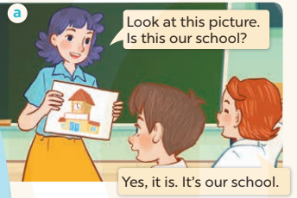  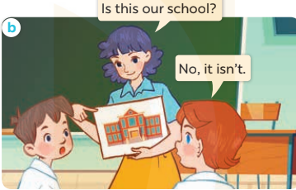  - Play the audio twice (sentence by sentence). Correct their pronunciation where necessary.  - Have Ss to practice the dialogue  - T invites a few pairs to the front of the class to practice.  - T checks pronunciation for ss.  Activity 3 Listen, point and say.  *Aims: Ss will be able to correctly say the words and use Is this our …….? – Yes, it is. / No, it isn't. to ask and answer questions about their school.  *Procedure:  * Model sentences:  - T asks Ss look at picture a and helps Ss know the structure from the dialogue.  - T introduces new structure for Ss.  - T explains, models and gives meaning.  -Have Ss repeat the model sentences.  *Drill pictures  - Elicit and check comprehension the places of school  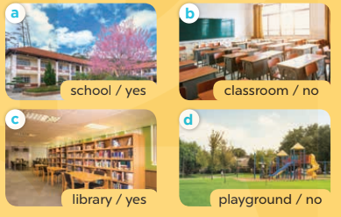  - Run through all the pictures.  - Run through model sentences.  +Run through the question sentences  +Run through the answer sentences  - Have Ss to practise:  + T asks, Ss answer picture a  + Ss ask, T answers picture b  + Group A ask, group B answer picture c  + Group B ask, group A answer picture d  - Ask Ss to work in pairs.  - T controls and corrects.  - Invite a few pairs to come to the front of the classroom and point at the pictures and say the questions and answers in front of the class.  - T gives feedbacks.  Activity 4. Let’s talk.  *Aims: Ss will be able to enhance the correct use of Is this our ……..? – Yes, it is. / No, it isn't. to ask and answer questions about their school.  *Procedure:  - Have Ss look at the picture and elicit the question and the answer in context.  + What can you see in the picture?  + How many pictures are there?  - Stick the flash cards for school, classroom, library and playground on the wall at various places around the classroom and point at a certain flash card to elicit the question and answer.  - Give Ss time to practise in pairs.  - Invite some pairs of Ss to the front of the class to perform their conversations.  *Consolidation  *Aims: Ss will be able consolidate and wrap up the content of the lesson.  *Procedure:  - T asks ss to answer the following questions:  + What have you learnt from the lesson today?  +What are the core values of the lesson? (if the teacher can take from the lesson).  - T review the vocabulary and model sentences.  - T praises some Ss who are hardworking / active/ good…. as well as encourage others to try more.  - Learn the vocabulary and model sentences by heart  - Prepare the new lesson: Unit 6, Lesson 1 (4,5,6). | - Ss listen  -Ss look at the pieces of the picture  -Ss put into the correct picture  -Ss check  - Ss open their books  -Ss listen and answer  - - Ss listen and repeat  + Choral repetition (3 times).  + Individual repetition (3 ss)  - Ss take note  - Ss look, remember and match  -Look at the pictures and say  + In picture a: Ms Hoa says: Look at this picture. Is this our school? Lucy answers: Yes, it is. It’s our school.  + In picture b: Ms Hoa asks: Is this our school? Lucy answers: No, it isn’t.  -Ss listen and repeat in chorus (twice)  -Ss work in pairs to practice  -Ss practice the dialogue  -Ss listen  -Ss look at the picture and answer.  -Ss listen  -Ss listen and repeat  -Ss repeat to the place  - Ss look, listen and answer  + Picture a: a school  + Picture b: a classroom  + Picture c: a library  + Picture d: a playground  -Ss listen and repeat  -Ss practice in chorus  -Ss work in pairs to practice  -Ss point and say  -Ss listen.  -Ss look at the picture and answer  + I can see 4 places…  + There are 4 pictures  -Ss look and answer  -Ss work in pairs  -Ss perform in front of the class.  -Ss answer the questions  - Ss listen  -Ss listen and clap their hands  -Ss listen and take note
D. ADJUSTMENTS (if necessary):
………………………………………………………………………………………….…..……………………………………………………………………………...………………………………………….…..……………………………………………………………………………….……………………………………………………………………...

