Week 10 Preparing date: November …….,
Period 37 Teaching date: November ………,

Fun time 1
A. OBJECTIVES:
By the end of the lesson, Ss will be able to:
1. Knowledge:
- take part in three fun activities relating to their language knowledge and competences.
- Vocabulary: Review
- Skills: speaking, writing and listening
2. Competences:
- Co-operation: ready to help friends in pair work/ group work.
- Sociability: Talk to each other, say good words to others.
3. Attitude/ Qualities:
- Kindness: Help partners to complete learning tasks.
- Honesty: tell the truth about feelings and emotions
B. TEACHING AIDS:
- Teacher: Teacher’s guide Pages 76, 77, 78; website sachmem.vn, posters, laptop, pictures, textbook, lesson plan, TV or projector.
- Students: Pupil’s book Page 42, 43, notebooks, workbooks, school things.
C. PROCEDURES:
Stages/Time | Teacher’s activities | Students’ activities
1.Warm- up:  (3’)  2. Practice  (30’)  3. Homework. (2’) | Sing: Head, shoulders, knees and toes  *Aims: to create a friendly and active atmosphere in the class to beginning the lesson.  *Procedure:  - Show the song on the screen.  https://www.youtube.com/watch?v=WX8HmogNyCY  - Ask Ss to listen, sing and dance the song.  - Say “Open your book page 42, 43” and look at “Fun time”.  Activity 1. Find, circle and match:  *Aims: Ss will be able to revise learnt vocabulary by doing the word search.  *Procedure:  - Have Ss look at the pictures and ask +What’s this?  + What do you see in the pictures?  - Write the words or stick the flash cards of the words, one by one, on the board.  - Point at each word on the board and have Ss say the word as a class.  - Point at the picture of an ear, and match the word “ear” that has been circled as an example.  - Tell Ss to find the rest of the words in the word search.  - Have Ss match the words in the word search with the pictures.  - Have Ss check and correct their answers in pairs  - Have Ss work in pairs, one points at the pictures and the other points at the circled words in the word search and say them aloud.  Key:  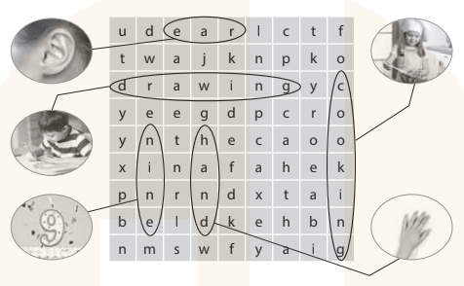  Activity 2. Quiz time  *Aims: Ss will be able to revise vocabulary and sentence patterns learnt in Units 1–5.  *Procedure:  - Put Ss into two teams, Team 1 and Team 2.  - Have one representative of each team stand next to their boxes, Box 1 and Box 2.  - Explain the rules: Two quiz masters will read different dialogues for each pair of Ss.  Example:  Quiz master 1 (showing a flash card): What’s this?  Quiz master 2: It’s a hand.  - After listening to the dialogue, each representative has to find the right flash card and put it in their team’s box.  - The quicker representative earns one point for his / her team. Then, other pairs take turns to compete. The quiz continues until the end of the time limit (5 – 10 dialogues are recommended).  - The team with most points wins.  Activity 3. Look and match  *Aims: Ss will be able to learn the five senses and how they relate to our bodies.  *Procedure:  - T elicits the names of the body parts: eye, ear, nose, hand, mouth.  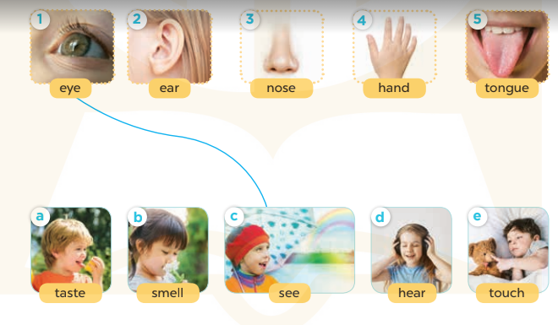  - Point to your eyes and ask Ss what they do with their eyes  - Write see on the board and model it  for Ss to repeat.  - Have Ss complete the activity by drawing lines to match the body parts to the senses.  - Check answers together as a class.  Key: 1-c 2-d 3-b 4-e 5-a  *Consolidation  *Aims: Ss will be able consolidate and wrap up the content of the lesson.  *Procedure:  - T asks ss to answer the following questions:  + What have you learnt from the lesson today?  +What are the core values of the lesson? (if the teacher can take from the lesson).  - T praises some Ss who are hardworking / active/ good…. as well as encourage others to try more.  - Prepare the new lesson: Unit 6, Lesson 1 (1,2,3). | - Ss listen  - Ss sing a song  -Ss look at the picture and answer  - - Ss note  - Ss say the word  - Ss look and match  -Ss find the words  -SS match the words with pictures  -Ss check their answer  -Ss say aloud  -Ss listen  -Ss listen and play game  -Ss play game  - Ss look, listen and answer  - Ss answer  -Ss listen and repeat  -Ss work in pairs to practice  -Ss check their answer.  -Ss answer the questions  -Ss listen and clap their hands  -Ss listen and take note

D. ADJUSTMENTS (if necessary):
………………………………………………………………………………………….…..……………………………………………………………………………...………………………………………….…..……………………………………………………………………………….……………………………………………………………………...

