Week 11 Preparing date: November …..,
Period 44 Teaching date: November …..,

Unit 7: Classroom instructions
Lesson 1 (1, 2, 3)
A. OBJECTIVES:
By the end of the lesson, Ss will be able to:
1. Knowledge:
-use the words open, close, stand up, sit down and please in relation to the topic “Classroom instructions”
-use …………. please! to give instructions;
- Vocabulary: open, close, stand up, sit down, please
- Skills: speaking and listening
2. Competences:
- Critical Thinking: self-introduce
- Co-operation: ready to help friends in pair work/ group work.
- Sociability: Talk to each other, say good words to others.
3. Attitude/ Qualities:
- Kindness: Help partners to complete learning tasks.
- Honesty: tell the truth about feelings and emotions
B. TEACHING AIDS:
- Teacher: Teacher’s guide Pages 90, audio Tracks 67, 68, website sachmem.vn, posters, laptop, pictures, textbook, lesson plan, TV or projector.
- Students: Pupil’s book Page 50, notebooks, workbooks, school things.
C. PROCEDURES:
Stages/Time | Teacher’s activities | Students’ activities
1.Warm- up:  (3’)  2. Presentation  (16’)  3.Practice: (7’)  4.Production: (7’)  5. Homework. (2’) | Sing: Baby shark  *Aims: to create a friendly and active atmosphere in the class to beginning the lesson.  *Procedure:  - Show the song on the screen.  https://www.youtube.com/watch?v=XqZsoesa55w  - Ask Ss to listen, sing and dance the song.  - Say “Open your book page 50” and look at “Unit 7, Lesson 1 (1,2,3)”.  Activity 1. Vocabulary.  *Aims: Ss will be able to know the vocabulary in front of starting the new lesson.  *Procedure:  -T elicits the new words  + open : mở (mime)  + close : đóng (mime)  + stand up :đứng lên (mime)  + sit down : ngồi xuống (mime)  + please : xin mời (translation)  - T models (3 times).  - T writes the words on the board.  - Checking: Rub out and remember  Activity 2. Look, listen and repeat:  *Aims: Ss will be able to understand and correctly repeat the sentences in two communicative contexts (pictures) focusing on classroom instructions.  *Procedure:  - Have Ss look at Pictures a and b and identify names of the speakers in the pictures.  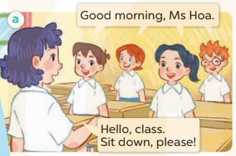  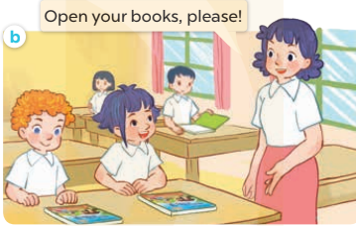  - Play the audio twice (sentence by sentence). Correct their pronunciation where necessary.  - Have Ss to practice the dialogue  - T invites a few pairs to the front of the class to practice.  - T checks pronunciation for ss.  Activity 3 2. Listen, point and say.  *Aims: Ss will be able to correctly say the words and use ……. , please! to give instructions  *Procedure:  * Model sentences:  - T asks Ss look at picture a and helps Ss know the structure from the dialogue.  - T introduces new structure for Ss.  - T explains, models and gives meaning.  -Have Ss repeat the model sentences.  *Drill pictures  - Elicit the school thing and the character in each picture.  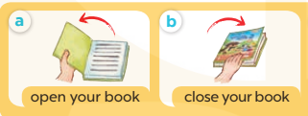  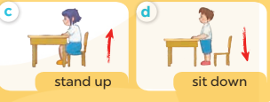  - Have S point at Picture a, listen to the recording and repeat the phrase  (open your book).  - Follow the same procedure with the other three pictures.  - Point at the bubble and Picture a and have S listen and repeat after the  recording (Open your book, please!).  - Have pairs practise saying ______, please! with Pictures b, c and d.  - Invite a few pairs to point at the pictures and give instructions for the class to act out  Activity 4. Let’s talk.  *Aims: Ss will be able to enhance the correct use of ………., please! to give instructions  *Procedure:  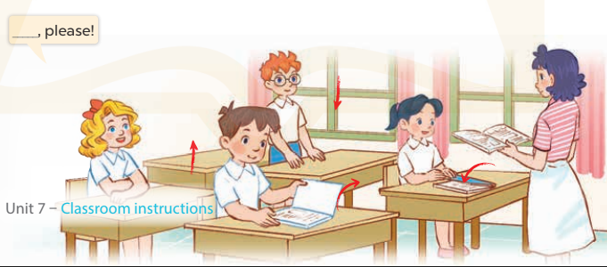  - Have Ss look at the picture and elicit the question and the answer in context.  + A picture of a classroom in which pupils are asking the teacher for her permission to  (open the book / close the book / stand up / sit down)  - Put Ss work in pairs to give and respond to instructions. Go around the classroom to offer support while they are acting out the instructions.  - Invite some pairs of Ss to the front of the class to act out the instructions.  *Consolidation  *Aims: Ss will be able consolidate and wrap up the content of the lesson.  *Procedure:  - T asks ss to answer the following questions:  + What have you learnt from the lesson today?  +What are the core values of the lesson? (if the teacher can take from the lesson).  - T review the vocabulary and model sentences.  - T praises some Ss who are hardworking / active/ good…. as well as encourage others to try more.  - Learn the vocabulary and model sentences by heart  - Prepare the new lesson: Unit 7, Lesson 1 (4,5,6). | - Ss sing and dance the song  - Ss open their books  -Ss listen and answer  - - Ss listen and repeat  + Choral repetition (3 times).  + Individual repetition (3 ss)  - Ss take note  - Ss look, remember and write  -Look at the pictures and say  + In picture a: Class says: Good morning, Ms Hoa. Lucy answers: Hello, class. Sit down, please!  + In picture b: Ms Hoa says: Open your books, please!  -Ss listen and repeat in chorus (twice)  -Ss work in pairs to practice  -Ss practice the dialogue  -Ss listen  -Ss look at the picture and answer.  -Ss listen  -Ss listen and repeat  -Ss repeat to the place  - Ss look, listen and answer  + Picture a: a book opening  + Picture b: a book closing  + Picture c: a girl about to stand up  + Picture d: a boy about to sit down  -Ss listen and repeat  -Ss practice  -Ss listen and repeat  -Ss practice  -Ss point, say nd do action  -Ss look at the picture and answer  -Ss work in pairs  -Ss act out the instructions.  -Ss answer the questions  - Ss listen  -Ss listen and clap their hands  -Ss listen and take note
D. ADJUSTMENTS (if necessary):
………………………………………………………………………………………….…..……………………………………………………………………………...………………………………………….…..……………………………………………………………………………….……………………………………………………………………...

