Week 11 Preparing date: November …..,
Period 43 Teaching date: November …..,

Unit 6: Our school
Lesson 3 (4, 5, 6)
A. OBJECTIVES:
By the end of the lesson, Ss will be able to:
1. Knowledge:
- read and write about a school;
- make a poster to introduce their school to a new pupil.
- Vocabulary: Review
- Skills: speaking, listening, reading and writing.
2. Competences:
- Critical Thinking: self-introduce
- Co-operation: ready to help friends in pair work/ group work.
- Self-control and independent learning: perform listening tasks.
3. Attitude/ Qualities:
- Kindness: Help partners to complete learning tasks.
- Honesty: tell the truth about feelings and emotions.
- Diligence: complete learning tasks.
B. TEACHING AIDS:
- Teacher: Teacher’s guide Pages 88, 89; website sachmem.vn, posters, laptop, pictures, textbook, lesson plan, TV or projector.
- Students: Pupil’s book Page 49, notebooks, workbooks, school things.
C. PROCEDURES:
Stages/Time | Teacher’s activities | Students’ activities
1.Warm- up:  (5’)  2.Practice: (8’)  3.Production: (19’)  4. Homework. (3’) | Game: “Chant”  *Aims: to review the vocabulary and structure about greet and respond to greetings.  *Procedure:  - Ask Ss chant and do the actions in Unit 6, Lesson 3 page 48 in groups.  - Give point for the groups and encourage them.  - Say “Open your book page 49” and look at “Unit 6, Lesson 3 (4, 5, 6)”.  Activity 1. Read and complete:  *Aims: Ss will be able to read and choose the words to complete the text.  *Procedure:  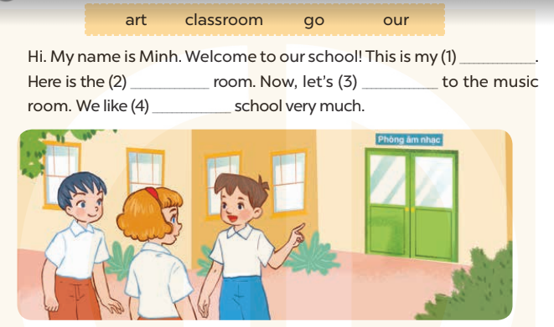  - Elicit and introduce the context.  + Minh is introducing his school to his friends.  - Have Ss read aloud the words to fill in.  - Model the first blank with Ss to make sure that they know how to do the task.  - Give Ss enough time to complete the text.  - Check the answers as a class.  - Have Ss read the text aloud.  Key: 1. classroom 2. art  3. go 4. our  Activity 2. Let’s write  *Aims: Ss will be able to read and complete a gapped paragraph to introduce their school.  *Procedure:  -Model the first gap and ask Ss what the missing word is.  - Have Ss write their answers.  - Give Ss time to write the answers.  - Have some Ss read their completed paragraph aloud.  Key: Pupils’ answer  Activity 3. Project.  *Aims: Ss will be able to introduce the school to a new pupil.  *Procedure:  - Point at the sample poster and explain that the Ss is going to introduce his school to some friends.  - Have Ss show the photos or pictures that they have prepared for the project.  - Revise some structures and vocabulary that Ss need for their presentations.  +Hello/ Hi, class. Im’……  +Welcome to my school. This is….  +This is….and that’s……  + Now, let’s go to the…..  - Give Ss time to practise their presentations by themselves.  - Give Ss time to use their posters to practise presenting within their groups.  - Select a few pupils to give their presentations in front of the class.  - Have Ss go around their school to introduce some school rooms to their friends. One group introduces the school, and others act as new pupils.  *Consolidation  *Aims: Ss will be able consolidate and wrap up the content of the lesson.  *Procedure:  - T asks ss to answer the following questions:  + What have you learnt from the lesson today?  +What are the core values of the lesson? (if the teacher can take from the lesson).  - T praises some Ss who are hardworking / active/ good…. as well as encourage others to try more.  - Prepare the new lesson: Unit 7, Lesson 1 (1, 2, 3). | - Ss listen and chant  - Ss open their books  - Ss look at the pictures and answer  -Ss read the words  -Ss fill in the gap  -Ss complete the text  -Ss check their answer  -Ss read aloud  -Ss listen and answer  -Ss write the first gap  -Ss write  -SS read aloud  -Ss listen  -Ss show the picture  -Ss listen and note  -Ss practise  -Ss present the poster  -Ss present in front of the class  -Ss go around their school to introduce some school rooms to their friends.  -Ss answer the questions  -Ss listen and clap their hands  -Ss listen and take note
D. ADJUSTMENTS (if necessary):
………………………………………………………………………………………….…..……………………………………………………………………………...…………

