Week 11 Preparing date: November …..,
Period 42 Teaching date: November …..,

Unit 6: Our school
Lesson 3 (1, 2, 3)
A. OBJECTIVES:
By the end of the lesson, Ss will be able to:
1. Knowledge:
- correctly pronounce the sounds of the letters pl and cl in isolation, in the words playground and classroom, and in the sentences Let's go to the playground. and Is that your classroom
- listen and circle the correct words.
- Vocabulary: Review
- Skills: speaking, listening, reading and writing.
2. Competences:
- Co-operation: ready to help friends in pair work/ group work.
- Sociability: Talk to each other, say good words to others.
3. Attitude/ Qualities:
- Kindness: Help partners to complete learning tasks.
- Honesty: tell the truth about feelings and emotions
B. TEACHING AIDS:
- Teacher: Teacher’s guide Pages 88, 89; audio Tracks 64, 65, 66; website sachmem.vn, posters, laptop, pictures, textbook, lesson plan, TV or projector.
- Students: Pupil’s book Page 48, notebooks, workbooks, school things.
C. PROCEDURES:
Stages/Time | Teacher’s activities | Students’ activities
1.Warm- up:  (5’)  2. Presentation  (9’)  3.Practice: (19’)  4. Homework. (2’) | Game: Pass the ball  *Aims: to create a friendly and active atmosphere in the class to beginning the lesson.  *Procedure:  - Divide the class into 3 teams.  - Each team has 1 sticky ball.  - Play the music, Ss in each team take turns to pass the ball.  + After the music ends, 3 Ss have the ball – stand up and say the name, using the sentence model.  - Say “Open your book page 48” and look at “Unit 6, Lesson 3 (1,2,3)”.  Activity 1. Listen and repeat:  *Aims: Ss will be able to correctly pronounce the sounds of the letters pl and cl in isolation, in the words playground and classroom, and in the sentences Let's go to the playground. and Is that your classroom?  *Procedure:  - T gives instruction to the letter pl and cl, playground and classroom, and in the sentences Let's go to the playground. and Is that your classroom?  - Play the recording for the letter cl, pl.  - Encourage Ss to point at the letter/ word/ sentence while listening.  - Play the recording again and encourage Ss to listen and repeat. - Do this several times until Ss feel confident.  - T calls some Ss to practice.  - T gives feedbacks.  Activity 2. Listen and circle.  *Aims: Ss will be able to identify the target words playground and classroom while listening.  *Procedure:  - Elicit the sentences and the gap-fill options.  - T ask Ss to guess the answers.  + T writes Ss’guessing on the board.  - Listen to the tape:  + Play the recording  + Play the recording again and get Ss to swap books with their partners.  + Play the recording again to check answers together as a class.  + Write the answers on the board for Ss to correct their answers. Then checks Ss’ guessing.  - Play the recording, sentence by sentence, for the class to listen and repeat in chorus.  - Invite one or two Ss to stand up and read the completed sentences.  Key: 1.b 2.c  Activity 3. Let’s chant  *Aims: Ss will be able to say the chant with the correct rhythm and pronunciation.  *Procedure:  - Introduce the title and lyrics of the chant.  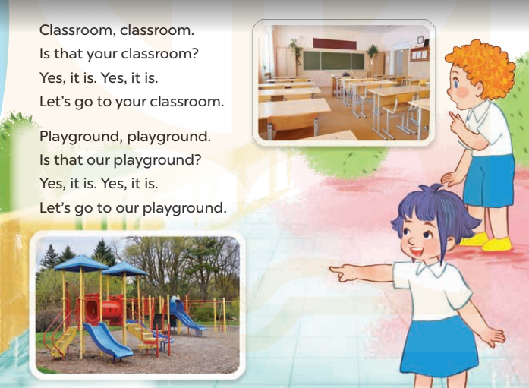  - Play the recording for Ss to listen to the whole chant.  + Have them repeat the title and lyrics line by line.  + Ask Ss to attend to the sounds of the letters pl and cland the words playground and classroom.  - Play the recording all the way through for Ss to listen to pronunciation and melody.  - Play the recording line by line for Ss to listen and repeat  - Play the recording for Ss to chant and clap along.  - Ask Ss to practice chant and clap along in pairs or groups.  - Invite groups to the front of the classroom to perform the chant  -T gives feedback.  *Consolidation  *Aims: Ss will be able consolidate and wrap up the content of the lesson.  *Procedure:  - T asks ss to answer the following questions:  + What have you learnt from the lesson today?  +What are the core values of the lesson? (if the teacher can take from the lesson).  - T praises some Ss who are hardworking / active/ good…. as well as encourage others to try more.  - Practice the chant more.  - Prepare a poster about their school in order to introduce their school to a new pupil.  - Prepare the new lesson: Unit 6, Lesson 3 (4,5,6). | - Ss listen  -Ss play game  - Ss open their books  - Ss recognize the differences about color of letter  - - Ss listen  - Ss listen and point  - Ss listen again and repeat  -Ss listen again and repeat  -Ss practice  -Ss listen  -Ss listen and say:  + Number 1: Let’s go to the …....  + Number 2: Is that our ……?  -Ss guess the answers  - Ss listen to the tape and circle  - Ss listen again, circle and swap books with their partners.  - Ss check their answers and guessing  -Ss listen and repeat.  -Ss read the sentences  - Ss look and listen.  -Ss listen to the chant  - Ss listen and repeat line by line without clap their hands  -Ss note the sounds, words  -Ss listen to melody of the chant  - Ss listen and chant line by line.  - Ss chant and clap along.  - Ss work in groups (two groups) to chant  -Ss perform in front of the class.  -Ss listen  -Ss listen.  -Ss answer the questions  -Ss listen and clap their hands  -Ss listen and take note

D. ADJUSTMENTS (if necessary):
………………………………………………………………………………………….…..……………………………………………………………………………...………………………………………….…..……………………………………………………………………………….……………………………………………………………………...

