Week 11 Preparing date: November …..,
Period 41 Teaching date: November …..,

Unit 6: Our school
Lesson 2 (4, 5, 6)
A. OBJECTIVES:
By the end of the lesson, Ss will be able to:
1. Knowledge:
- listen to and understand simple exchanges in relation to the topic “Our school”
- read some sentences and match them with the correct pictures.
- practise the target sentence pattern by playing the game Guess the place.
- Vocabulary: Review
- Skills: speaking, listening, reading and writing.
2. Competences:
- Critical Thinking: self-introduce
- Co-operation: ready to help friends in pair work/ group work.
- Self-control and independent learning: perform listening tasks.
3. Attitude/ Qualities:
- Kindness: Help partners to complete learning tasks.
- Honesty: tell the truth about feelings and emotions.
- Diligence: complete learning tasks.
B. TEACHING AIDS:
- Teacher: Teacher’s guide Pages 85, 86; audio Tracks 63; website sachmem.vn, posters, laptop, pictures, textbook, lesson plan, TV or projector.
- Students: Pupil’s book Page 47, notebooks, workbooks, school things.
C. PROCEDURES:
Stages/Time | Teacher’s activities | Students’ activities
1.Warm- up:  (5’)  2.Practice: (27’)  3. Homework. (3’) | Game: Slap the board  *Aims: to create a friendly and active atmosphere in the class to beginning the lesson.  *Procedure:  - Divide class into 2 groups  - How to play:  + Each group chooses five Ss to play.  + Class will read aloud.  + Look at the picture, listen and slap the picture you heard.  + Who faster will get 1 mark.  + Which group with higher mark is the winner.  - T gives feedback.  - Say “Open your book page 47” and look at “Unit 6, Lesson 2 (4,5,6)”.  Activity 1. Listen and number:  *Aims: Ss will be able to listen and understand four communicative contexts in which pupils make suggestions to go to different places at school  *Procedure:  - Elicit the word for the place in each picture  - Point at the pictures respectively to explain the context.  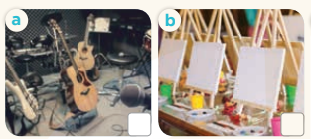    - T ask Ss to guess the answers.  + T writes Ss’guessing on the board.  - Listen to the tape:  + Play the recording  + Play the recording again and get Ss to swap books with their partners.  + Play the recording again to check answers together as a class.  + Write the answers on the board for Ss to correct their answers. Then checks Ss’ guessing.  - Play the recording, sentence by sentence, for the class to listen and repeat in chorus.  Key: 1. c 2. b 3. d 4. a  Activity 2. Read and match  *Aims: Ss will be able to read some sentences and match them with the correct pictures.  *Procedure:  - Get Ss to look at the pictures and identify the places in the pictures.  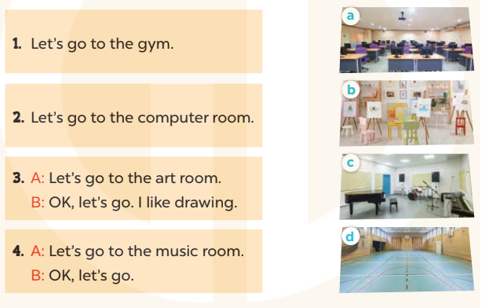  - Have Ss look at the four dialogues and the pictures. Elicit and model with picture 1  + Ask Ss to read the sentence 1 in chorus.  + Ask Ss to match sentence 1 with the correct picture  -Have Ss work in pairs and complete the sentences 2, 3, 4.  - Ask a few Ss to stand up and read the sentences aloud.  -T gives feedbacks.  Key:  1. d 2. a 3. b 4. c  Activity 3. Let’s play  *Aims: Ss will be able to practise the target sentence pattern by playing the game Guess the place.  *Procedure:  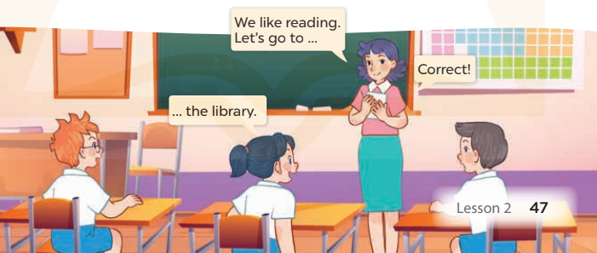  - Hold up a flash card for library and say: We like reading. Let's go to ....  - Elicit the school room to complete the sentence.  - Show Ss the flash card and have them repeat the word and the sentence.  - Hold up another flash card and continue with the game.  - Divide the class into two teams.  + Each team in turn plays the game. If Ss in a team can guess the correct picture, they get a star.  + After three or four rounds, the team with the most stars is the winner.  + Give the team a fun prize.  *Consolidation  *Aims: Ss will be able consolidate and wrap up the content of the lesson.  *Procedure:  - T asks ss to answer the following questions:  + What have you learnt from the lesson today?  +What are the core values of the lesson? (if the teacher can take from the lesson).  - T praises some Ss who are hardworking / active/ good…. as well as encourage others to try more.  - Practice part 5 again.  - Prepare the new lesson: Unit 6, Lesson 3 (1,2,3). | - Ss read the words  - Ss play game  -Ss play game  - Ss open their books  -Look at the pictures and say:  + Picture a: a music room + Picture b: an art room  + Picture c: a gym  + Picture d: a computer room  -Ss guess the answers  - Ss listen to the tape and write  - Ss listen again, write and swap books with their partners.  - Ss check their answers and guessing  -Ss listen and repeat.  -Ss look at the picture and say  -Ss look and answer  -Ss read  -Ss say and match  -Ss work in pairs and macth  -Ss read aloud  - Ss listen  -Ss play game  -Ss play game  -Ss answer the questions  -Ss listen and clap their hands  -Ss listen and take note
D. ADJUSTMENTS (if necessary):
………………………………………………………………………………………….…..……………………………………………………………………………...………………………………………….…..……………………………………………………………………………….……………………………………………………………………...

